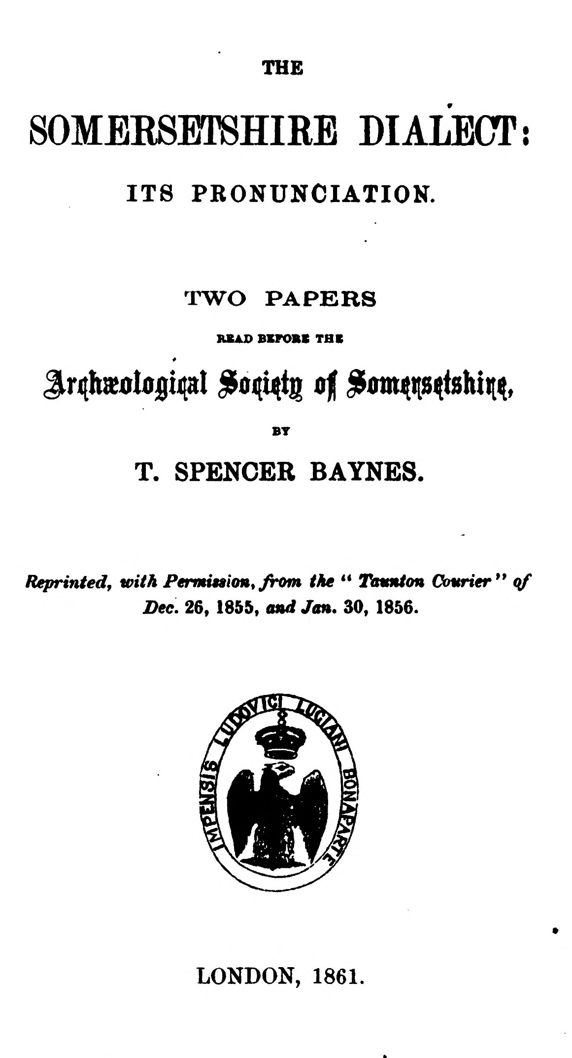
(delwedd C3662) (tudalen 000a)
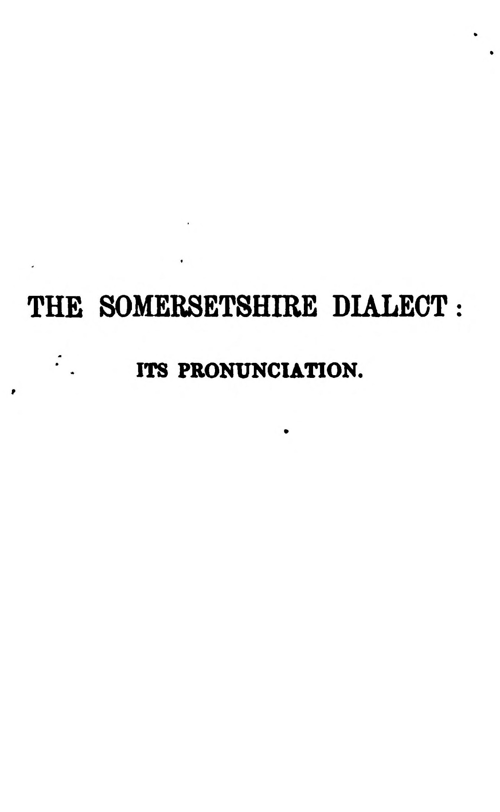  (delwedd C3663) (tudalen 000b) | THE SOMERSETSHIRE DIALECT  ITS PRONUNCIATION.  THE  SOMEESEmHIRE DIALECT:  ITS PRONUNCIATION. TWO PAPERS  HSAO BKFOBt THE BY  T. SPENCER BAYNES.  Reprinted, with Penrnnion^ from the " T\nmt(m Cowrier** qf Dec, 26, 1855, and Jan. 30, 1856.  LONDON, 1861.
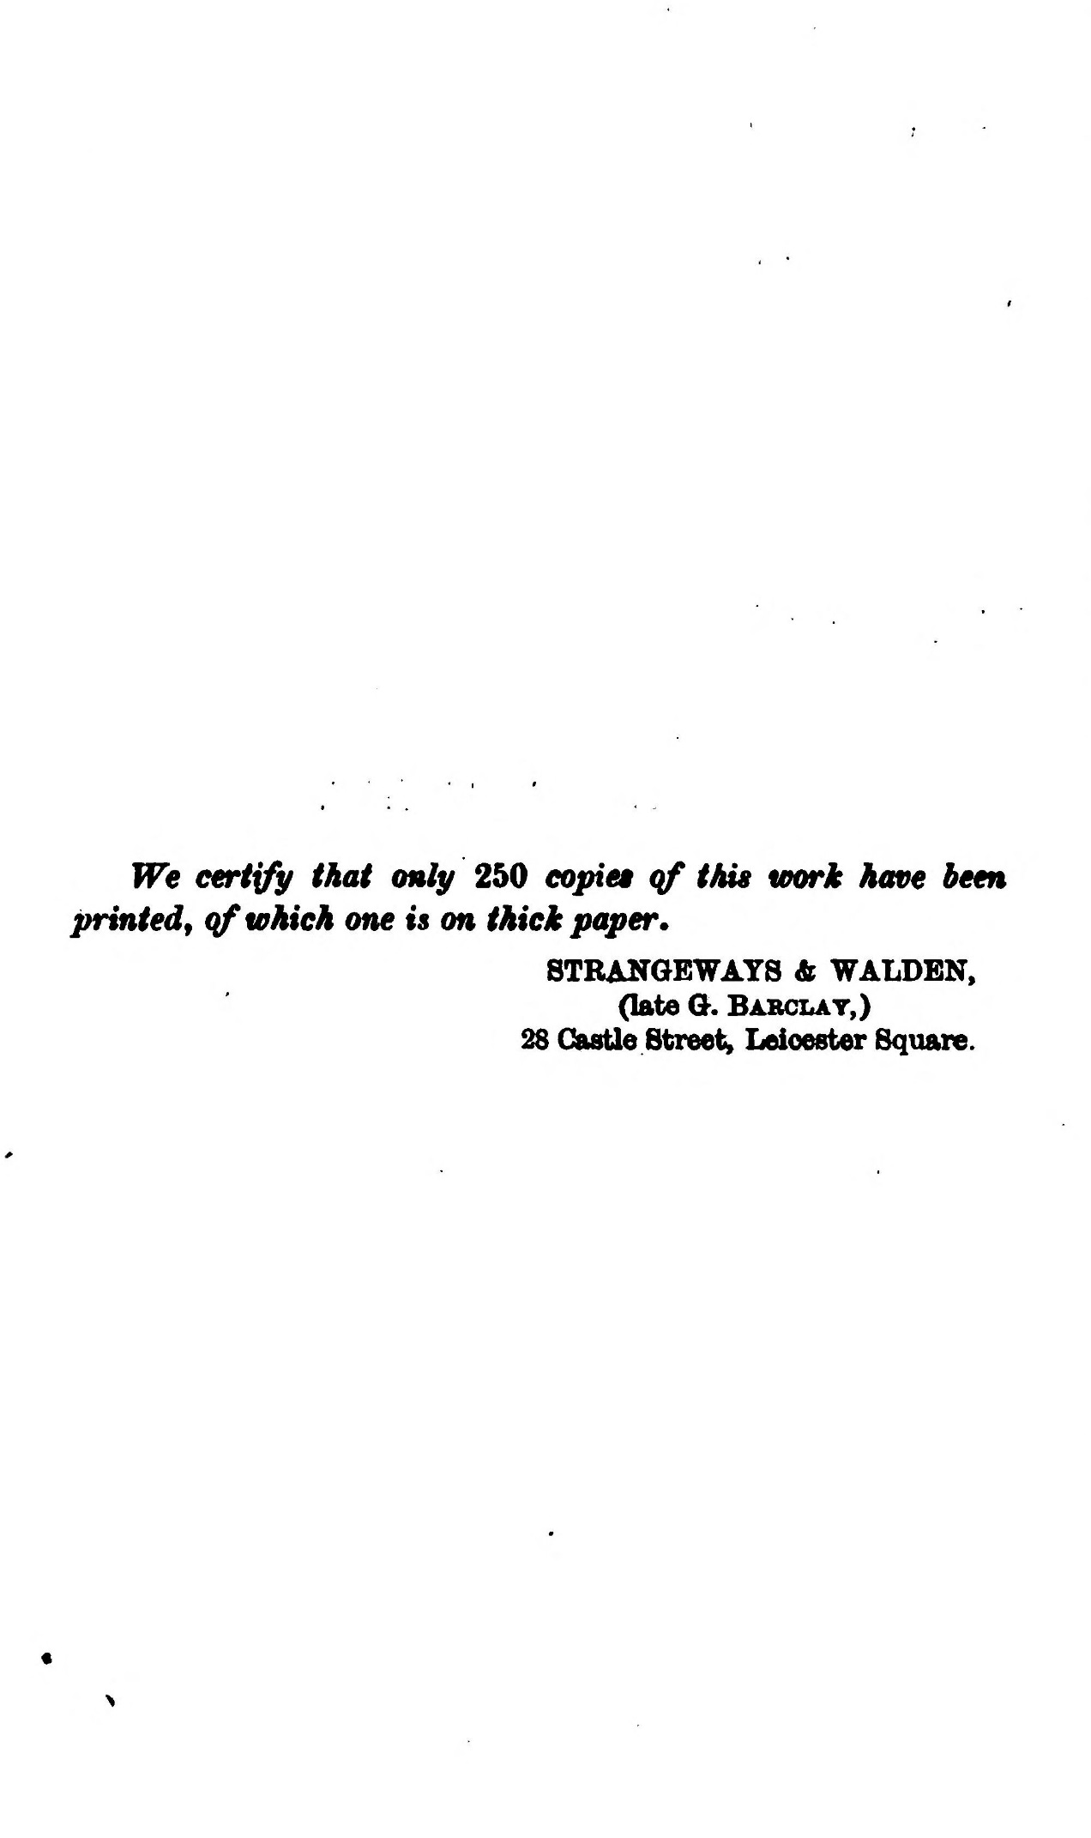  (delwedd C3664) (tudalen 000c) | We certify ^^^^ only 250 copiee qf this work have been printed, qf which one is on thick paper.  STRANGBWATS ft WALDBN, (late G. Babclat,) 28 OasUe Street^ Leicester Square.
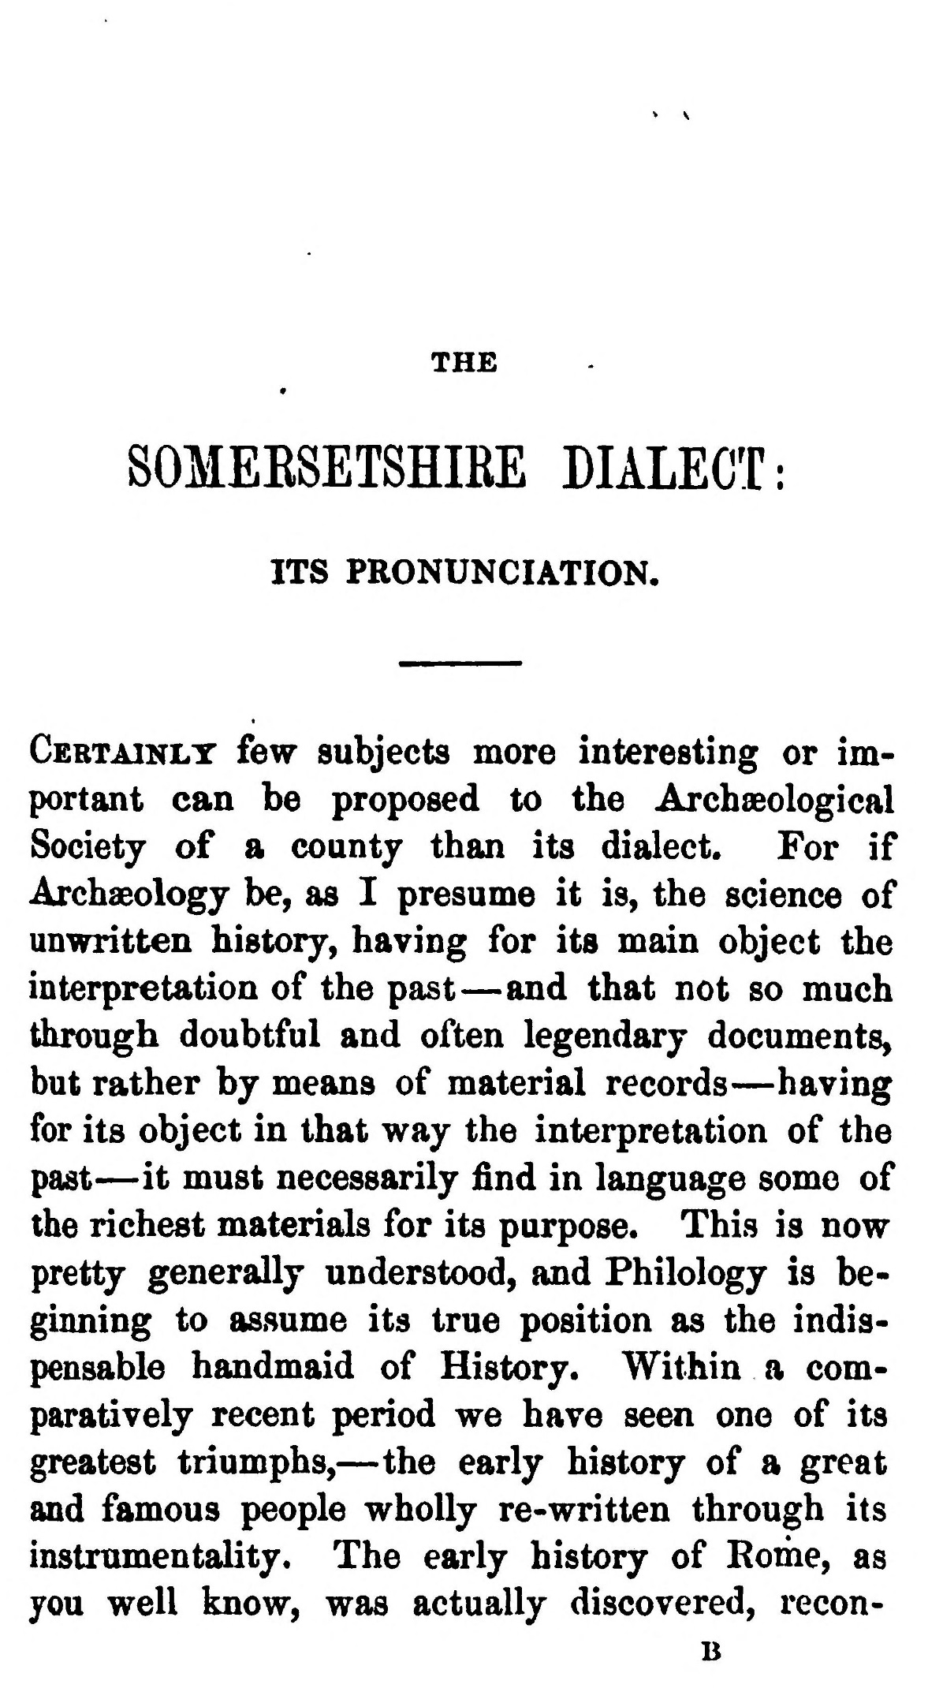  (delwedd C3665) (tudalen 001) | THE SOMEKSETSHIRE DIALECT:  ITS PRONUNCIATION.  Certainlt few subjects more interesting or important can be proposed to the Archaeological Society of a county than its dialect. For if Archaeology be, as I presume it is, the science of unwritten history, having for its main object the interpretation of the past — and that not so much through doubtful and often legendary documents, but rather by means of material records — having for its object in that way the interpretation of the past — it must necessarily find in language some of the richest materials for its purpose. This is now pretty generally understood, and Philology is beginning to assume its true position as the indispensable handmaid of History. Within a comparatively recent period we have seen one of its greatest triumphs, — the early history of a great and famous people wholly re-written through its instrumentality. The early history of Rome, as you well know, was actually discovered, recon-  B
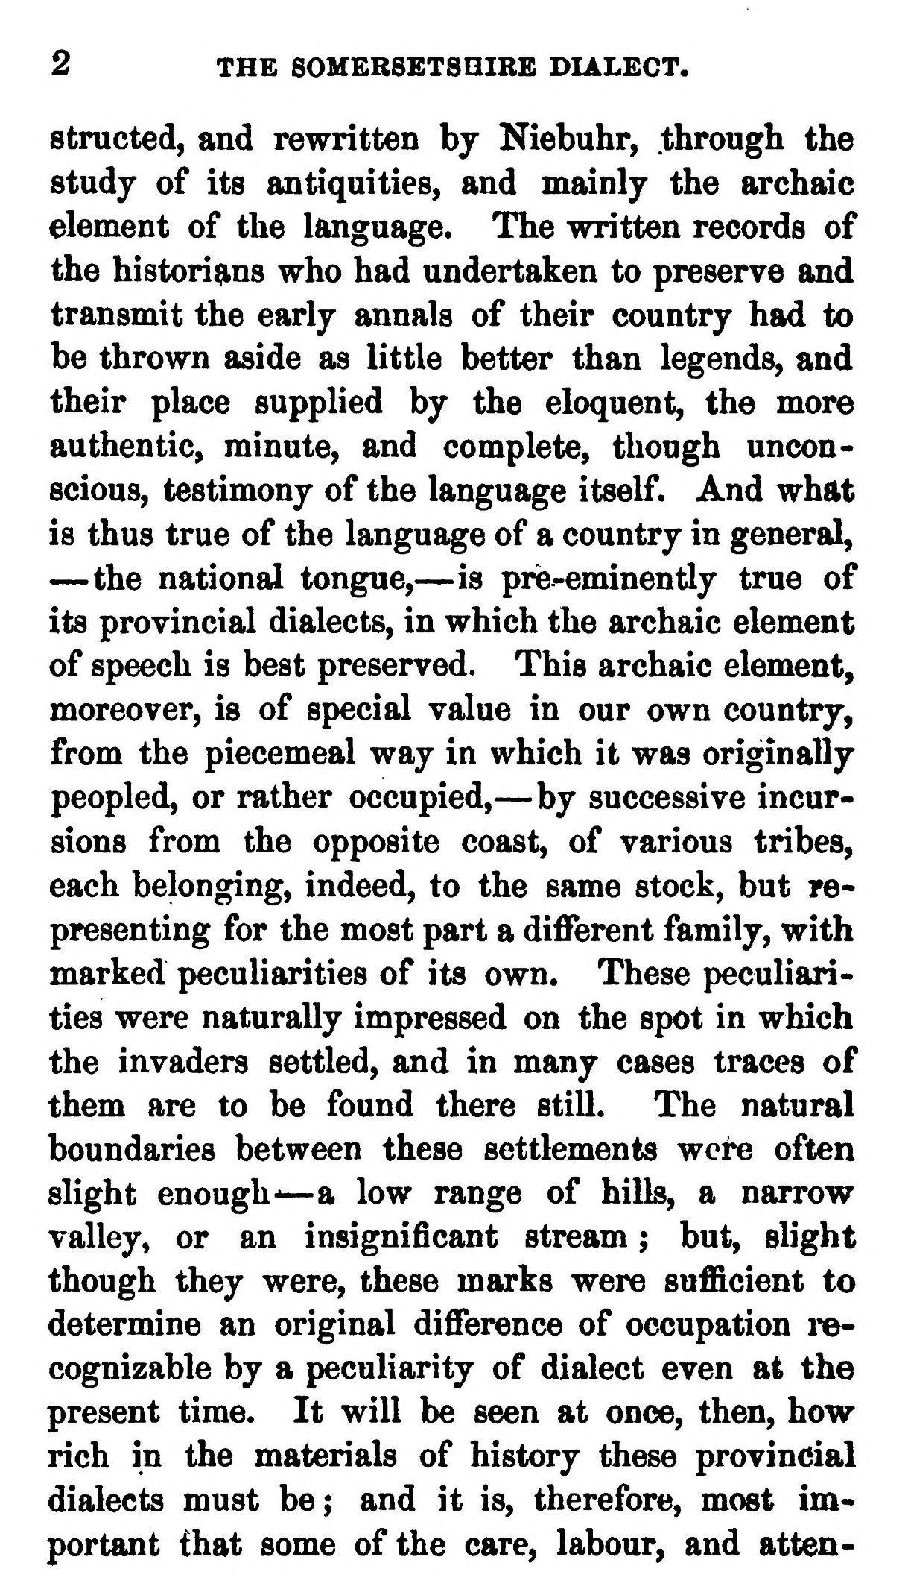  (delwedd C3666) (tudalen 002) | 2 THE SOMERSETSHIRE DIALECT.  structed, and rewritten by Niebuhr, through the study of its antiquities, and mainly the archaic element of the language. The written records of the historians who had undertaken to preserve and transmit the early annals of their country had to be thrown aside as little better than legends, and their place supplied by the eloquent, the more authentic, minute, and complete, though unconscious, testimony of the language itself. And what is thus true of the language of a country in general, — the national tongue, — is pre-eminently true of its provincial dialects, in which the archaic element of speech is best preserved. This archaic element, moreover, is of special value in our own country, from the piecemeal way in which it was originally peopled, or rather occupied, — by successive incursions from the opposite coast, of various tribes, each belonging, indeed, to the same stock, but representing for the most part a different family, with marked peculiarities of its own. These peculiarities were naturally impressed on the spot in which the invaders settled, and in many cases traces of them are to be found there still. The natural boundaries between these settlements wct*e often slight enough- — a low range of hills, a narrow valley, or an insignificant stream ; but, slight though they were, these marks were sufficient to determine an original difference of occupation i-ecognizable by a peculiarity of dialect even at the present time. It will be seen at once, then, how rich in the materials of history these provincial dialects must be; and it is, therefore, most important that some of the care, labour, and atten-
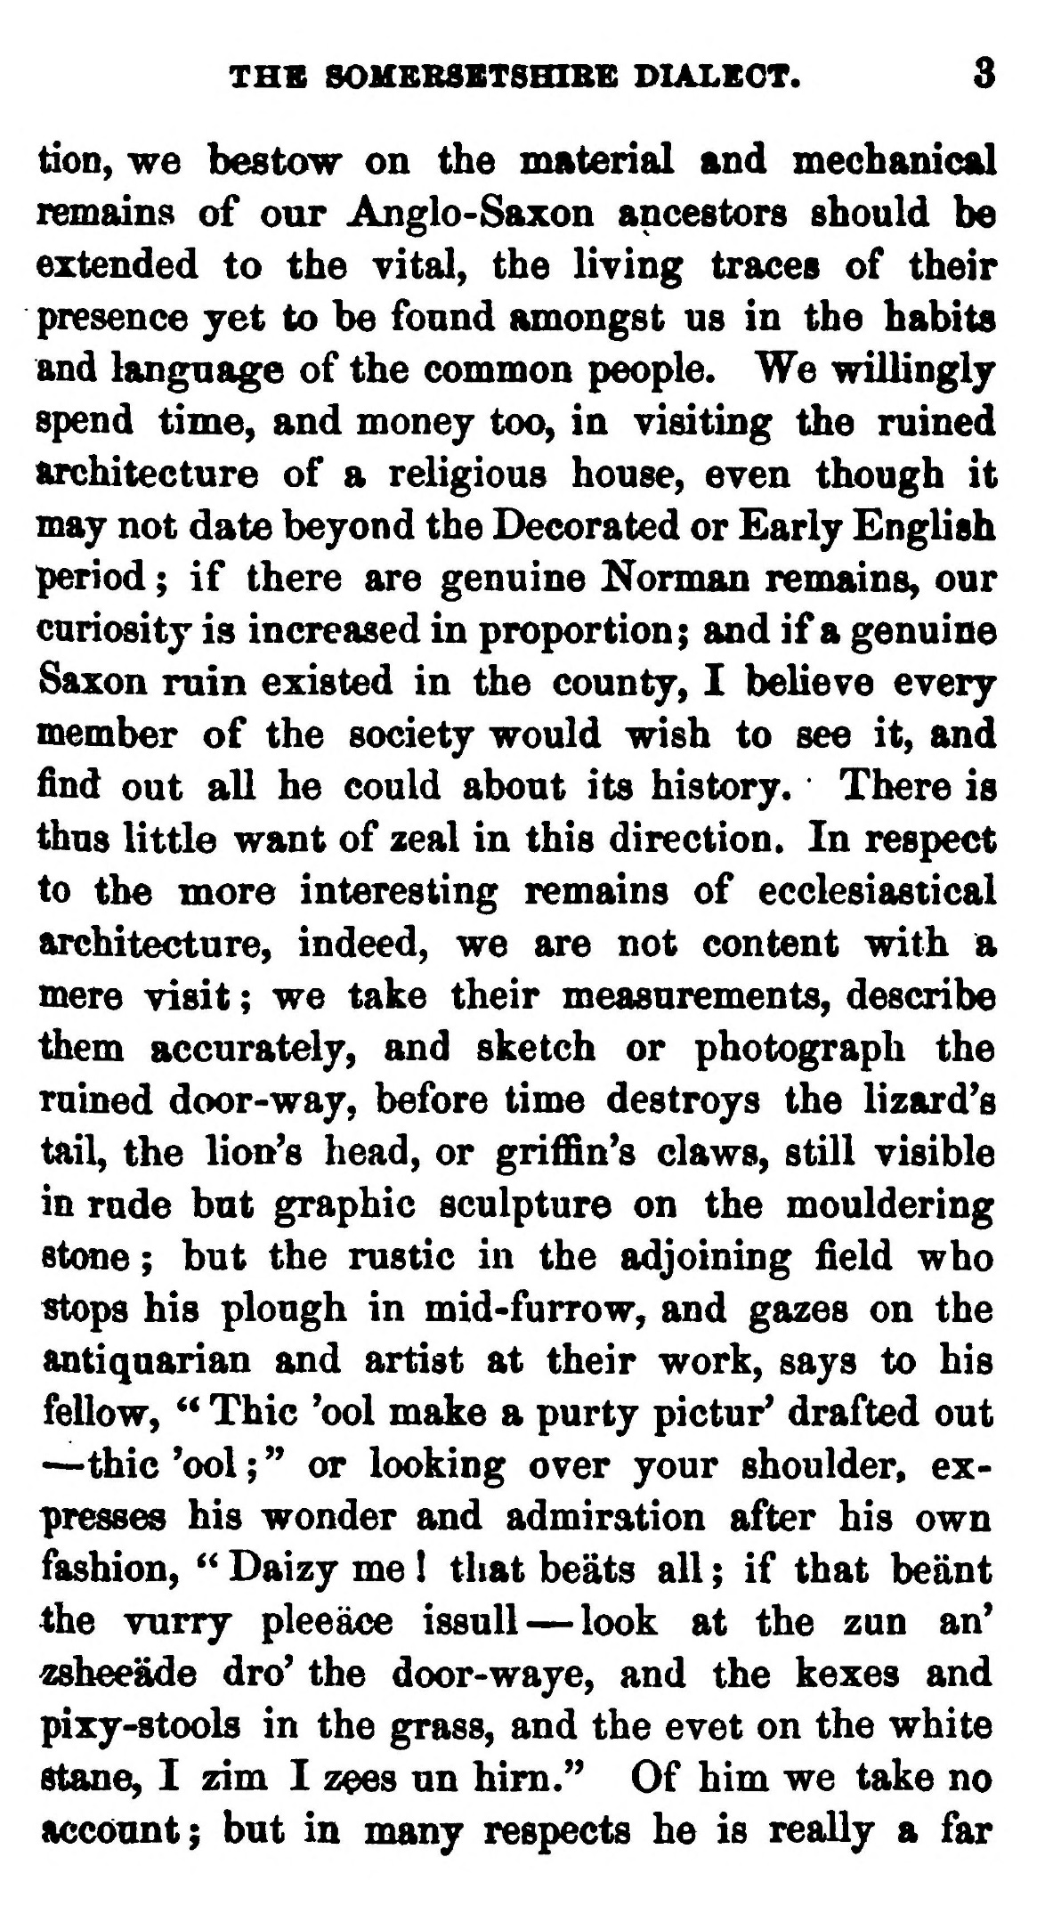  (delwedd C3667) (tudalen 003) | THS 80MBBSBTSHIBE DIALEOT. 3  don, we bestow on the material and meobanical remains of our Anglo-Saxon ancestors should be extended to the vital, the Hying traces of their presence yet to be found amongst us in the habits and language of the common people. We willingly spend time, and money too, in visiting the ruined architecture of a religious house, even though it may not date beyond the Decorated or Early English period ; if there are genuine Norman remains, our curiosity is increased in proportion; and if a genuine Saxon ruin existed in the county, I believe every member of the society would wish to see it, and find out all he could about its history. There is thus little want of zeal in this direction. In respect to the more interesting remains of ecclesiastical architecture, indeed, we are not content with a mere visit ; we take their measurements, describe them accurately, and sketch or photograph the ruined door-way, before time destroys the lizard's tail, the lion's head, or griffin's claws, still visible in rude but graphic sculpture on the mouldering stone ; but the rustic in the adjoining field who stops his plough in mid-furrow, and gazes on the antiquarian and artist at their work, says to his fellow, " Thic 'ool make a purty pictur* drafted out — thic 'ool ; " or looking over your shoulder, expresses his wonder and admiration after his own fashion, " Daizy me I that beats all ; if that beant the vurry pleeace issuU — look at the zun an' ^hee'dde dro' the door-waye, and the kexes and pixy-stools in the grass, and the evet on the white stane, I zim I zees un him." Of him we take no account; but in many respects he is really a far
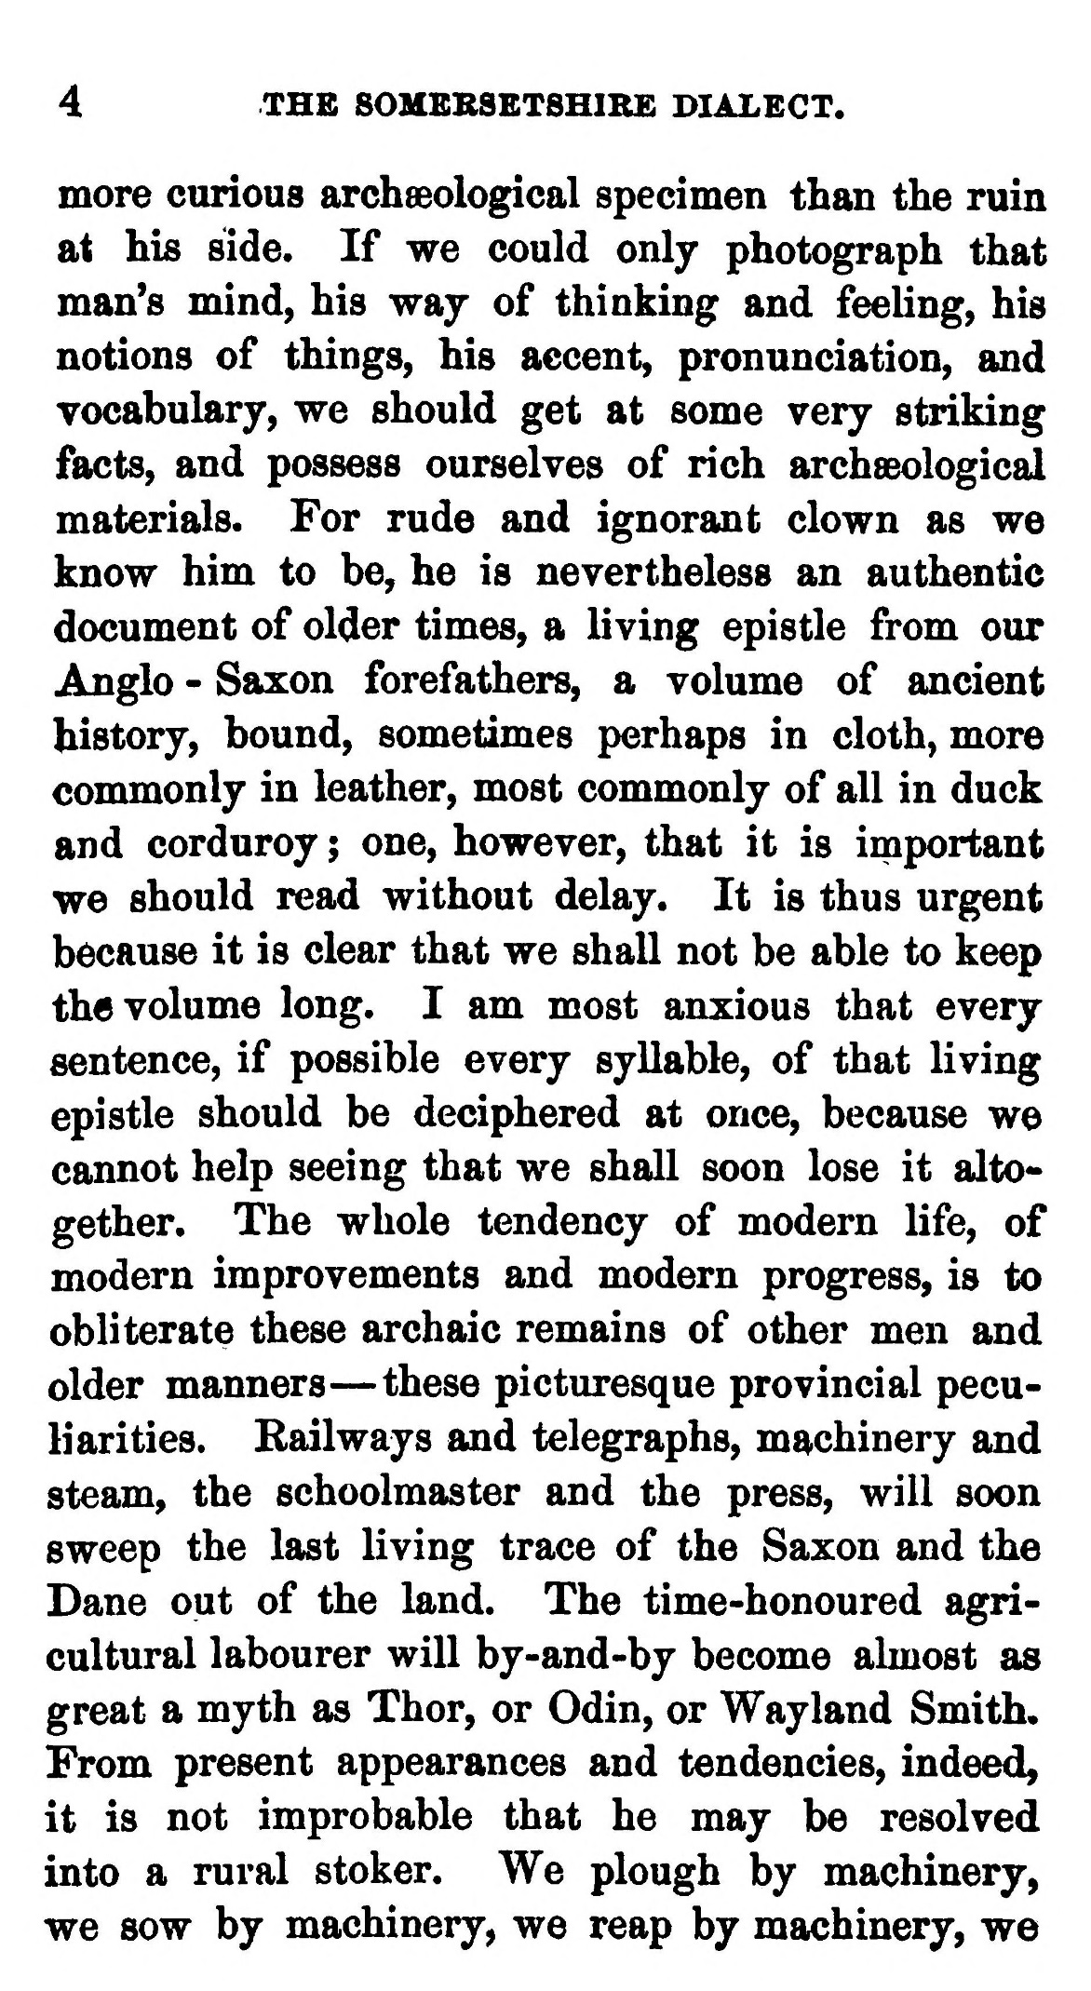  (delwedd C3668) (tudalen 004) | 4 THE SOMBBSBTSHIRE DIALECT.  more curious archaeological specimen than the ruin at his side. If we could only photograph that man's mind, his way of thinking and feehng, his notions of things, his accent, pronunciation, and vocabulary, we should get at some very striking facts, and possess ourselves of rich archsBological materials. For rude and ignorant clown as we know him to be, he is nevertheless an authentic document of older times, a living epistle from our Anglo - Saxon forefathers, a volume of ancient history, bound, sometimes perhaps in cloth, more commonly in leather, most commonly of all in duck and corduroy ; one, however, that it is important we should read without delay. It is thus urgent because it is clear that we shall not be able to keep the volume long. I am most anxious that every sentence, if possible every syllable, of that living epistle should be deciphered at once, because we cannot help seeing that we shall soon lose it altogether. The whole tendency of modern life, of modern improvements and modern progress, is to obliterate these archaic remains of other men and older manners — these picturesque provincial peculiarities. Railways and telegraphs, machinery and steam, the schoolmaster and the press, will soon sweep the last living trace of the Saxon and the Dane out of the land. The time-honoured agricultural labourer will by-and-by become almost as great a myth as Thor, or Odin, or Wayland Smith. From present appearances and tendencies, indeed, it is not improbable that he may be resolved into a rural stoker. We plough by machinery, we sow by machinery, we reap by machinery, we
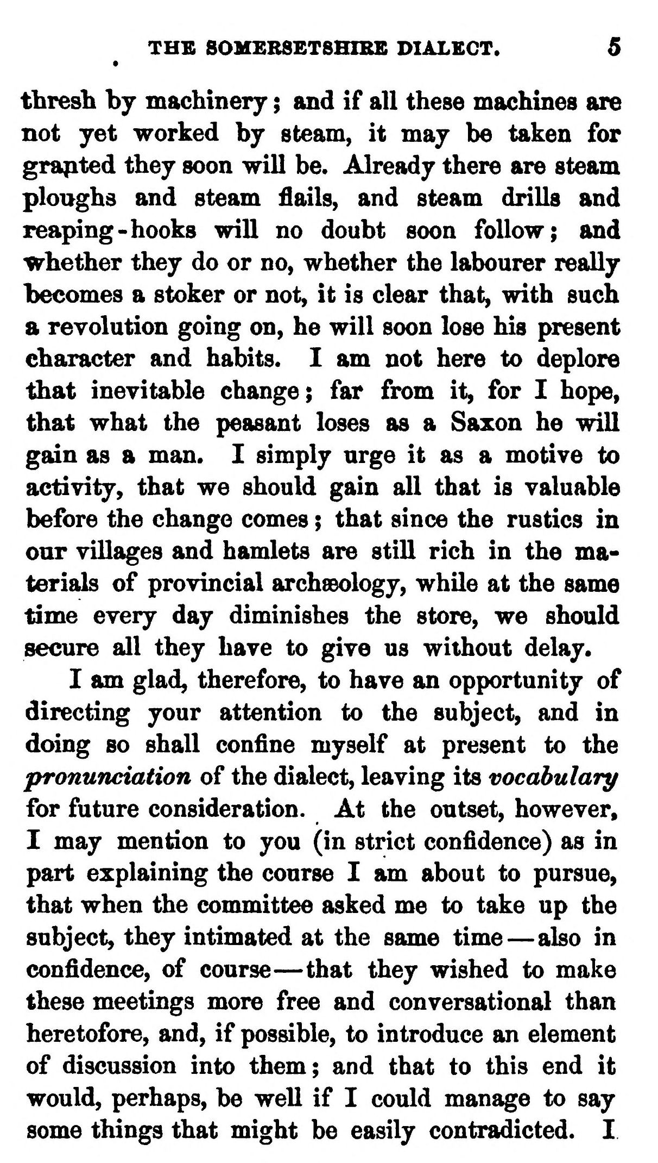  (delwedd C3669) (tudalen 005) | THB SOMER8ET8HIRB DIALECT. 5  tbresh by machinery ; and if all these machines are not yet worked by steam, it may be taken for grapted they soon will be. Already there are steam ploughs and steam flails, and steam drills and reaping-hooks will no doubt soon follow; and whether they do or no, whether the labourer really becomes a stoker or not, it is clear that, with such a revolution going on, he will soon lose his present character and habits. I am not here to deplore that inevitable change; far from it, for I hope, that what the peasant loses as a Saxon he will gain as a man. I simply urge it as a motive to activity, that we should gain all that is valuable before the change comes ; that since the rustics in our villages and hamlets are still rich in the materials of provincial archsBology, while at the same time every day diminishes the store, we should secure all they have to give us without delay.  I am glad, therefore, to have an opportunity of directing your attention to the subject, and in doing BO shall confine myself at present to the pronunciation of the dialect, leaving its vocabulary for future consideration. At the outset, however, I may mention to you (in strict confidence) as in part explaining the course I am about to pursue, that when the committee asked me to take up the subject, they intimated at the same time — also in confidence, of course — that they wished to make these meetings more free and conversational than heretofore, and, if possible, to introduce an element of discussion into them; and that to this end it would, perhaps, be well if I could manage to say some things that might be easily contradicted. I
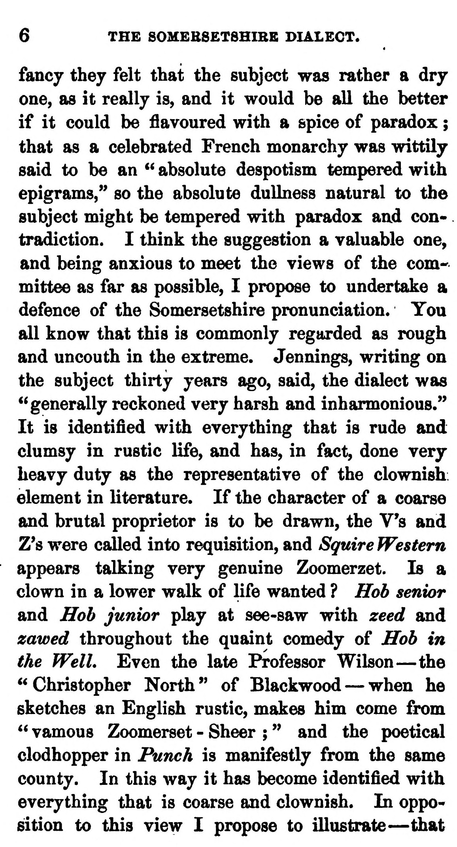  (delwedd C3670) (tudalen 006) | 6 THE SOMEB8ET8HIBB DIALECT.  fancy they felt that the subject was rather a dry one, as it really is, and it would be all the better if it could be flavoured with a spice of paradox ; that as a celebrated French monarchy was wittily said to be an '^ absolute despotism tempered with epigrams," so the absolute dullness natural to the subject might be tempered with paradox and contradiction. I think the suggestion a valuable one, and being anxious to meet the views of the com' mittee as far as possible, I propose to undertake a defence of the Somersetshire pronunciation. You all know that this is commonly regarded as rough and uncouth in the extreme. Jennings, writing on the subject thirty years ago, said, the dialect was "generally reckoned very harsh and inharmonious." It is identified with everything that is rude and clumsy in rustic life, and has, in fact, done very heavy duty as the representative of the clownish element in literature. If the character of a coarse and brutal proprietor is to be drawn, the V's and Z's were called into requisition, and Squire Western appears talking very genuine Zoomerzet. Is a clown in a lower walk of life wanted ? Hob senior and Hob junior play at see-saw with zeed and zawed throughout the quaint comedy of Hob in the Well. Even the late Professor Wilson — the "Christopher North" of Blackwood — when he sketches an English rustic, makes him come from " vamous Zoomerset - Sheer ; " and the poetical clodhopper in Punch is manifestly from the same county. In this way it has become identified with everything that is coarse and clownish. In oppo^ sition to this view I propose to illustrate — that
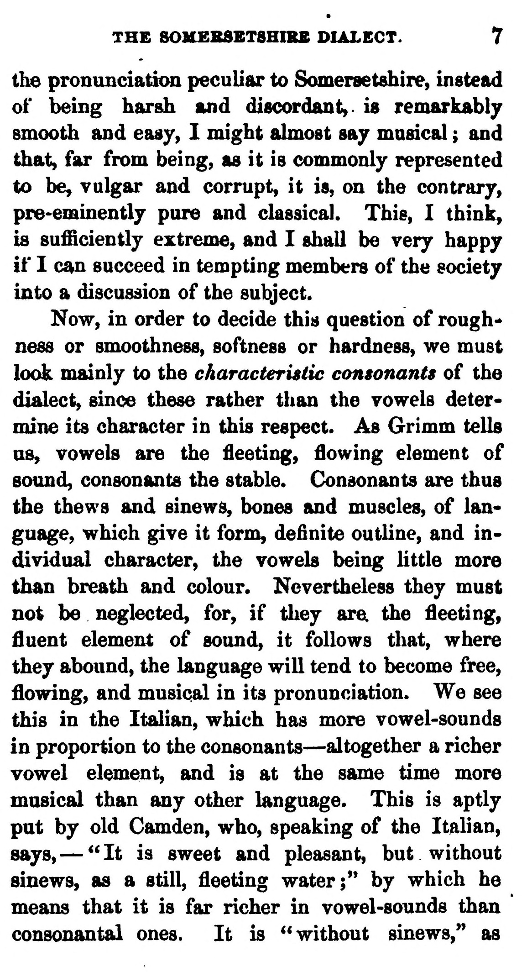  (delwedd C3671) (tudalen 007) | THE SOMERSBTSHIRB DIALECT. 7  the pronunciatkm peculiar to Somersetshire, instead of being harsh and discordant,, is remarkably smooth and easy, I might almost say masical ; and that, far from being, as it is commonly represented to be, vulgar and corrupt, it is, on the contrary, pre-eminently pure and classical. This, I think, is sufficiently extreme, and I shall be very happy if I can succeed in tempting members of the society into a discussion of the subject.  Now, in order to decide this question of roughness or smoothness, softness or hardness, we must look mainly to the characteristic consonants of the dialect, since these rather than the vowels determine its character in this respect. As Grimm tells us, vowels are the fleeting, flowing element of sound, consonants the stable. Consonants are thus the thews and sinews, bones and muscles, of language, which give it form, definite outline, and individual character, the vowels being little more than breath and colour. Nevertheless they must not be neglected, for, if they are the fleeting, fluent element of sound, it follows tliat, where they abound, the language will tend to become free, flowing, and musical in its pronunciation. We see this in the Italian, which has more vowel-sounds in proportion to the consonants — altogether a richer vowel element, and is at the same time more masical than any other language. This is aptly put by old Camden, who, speaking of the Italian, says, — " It is sweet and pleasant, but without sinews, as a still, fleeting water;" by which he means that it is far richer in vowel-sounds than consonantal ones. It is "without sinews," as
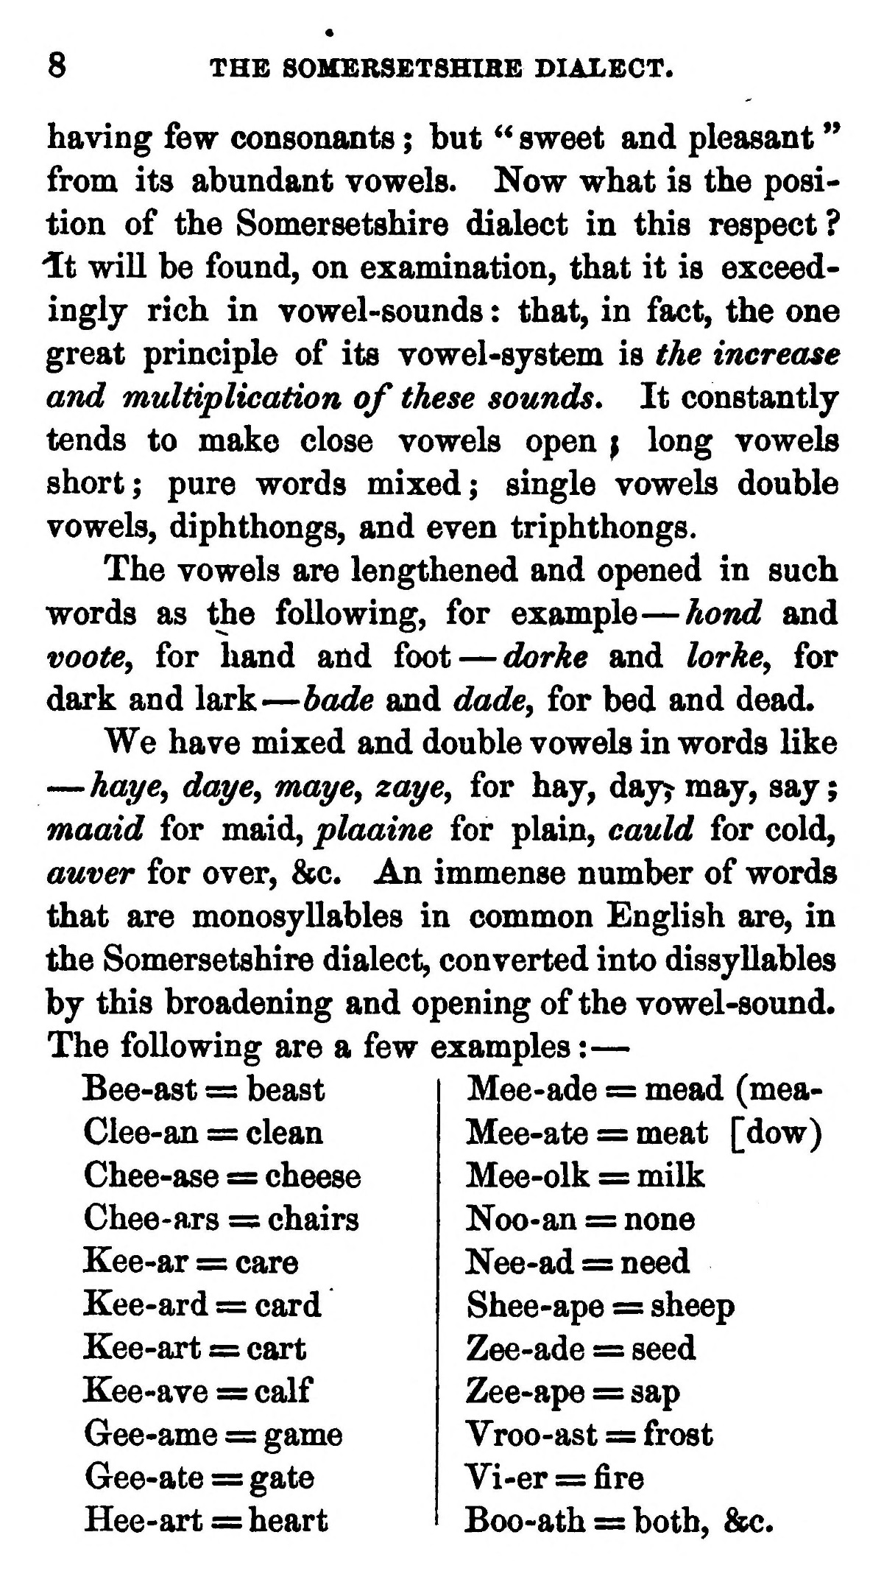  (delwedd C3672) (tudalen 008) | 8  THE SOMERSBTSHIBB DIALECT.  having few consonants ; but ^^ sweet and pleasant " from its abundant vowels. Now what is the position of the Somersetshire dialect in this respect ? 'It will be found, on examination, that it is exceedingly rich in vowel-sounds : that, in fact, the one great principle of its vowel-system is the increase and multiplication of these sounds* It constantly tends to make close vowels open \ long vowels short; pure words mixed; single vowels double vowels, diphthongs, and even triphthongs.  The vowels are lengthened and opened in such words as the following, for example — hond and vootCy for hand and foot — dorke and lorke^ for dark and lark — bade and dade^ for bed and dead.  We have mixed and double vowels in words like — haye, daycy mayCy zaye, for hay, dayy may, say; maaid for maid, plaaine for plain, cauld for cold, auver for over, &c. An immense number of words that are monosyllables in common English are, in the Somersetshire dialect, converted into dissyllables by this broadening and opening of the vowel-sound. The following are a few examples : —  Bee-ast = beast Clee-an = clean Chee-ase = cheese Chee-ars = chairs Kee-ar = care Kee-ard = card Kee-art = cart Kee-ave =: calf Gee-ame = game Gee-ate = gate Hee-art = heart  Mee-ade = mead (mea- Mee-ate = meat [dow) Mee-olk = milk Noo-an = none Nee-ad = need Shee-ape = sheep Zee-ade = seed Zee-ape = sap Vroo-ast = frost Vi-er = fire Boo-ath = both, &c.  /
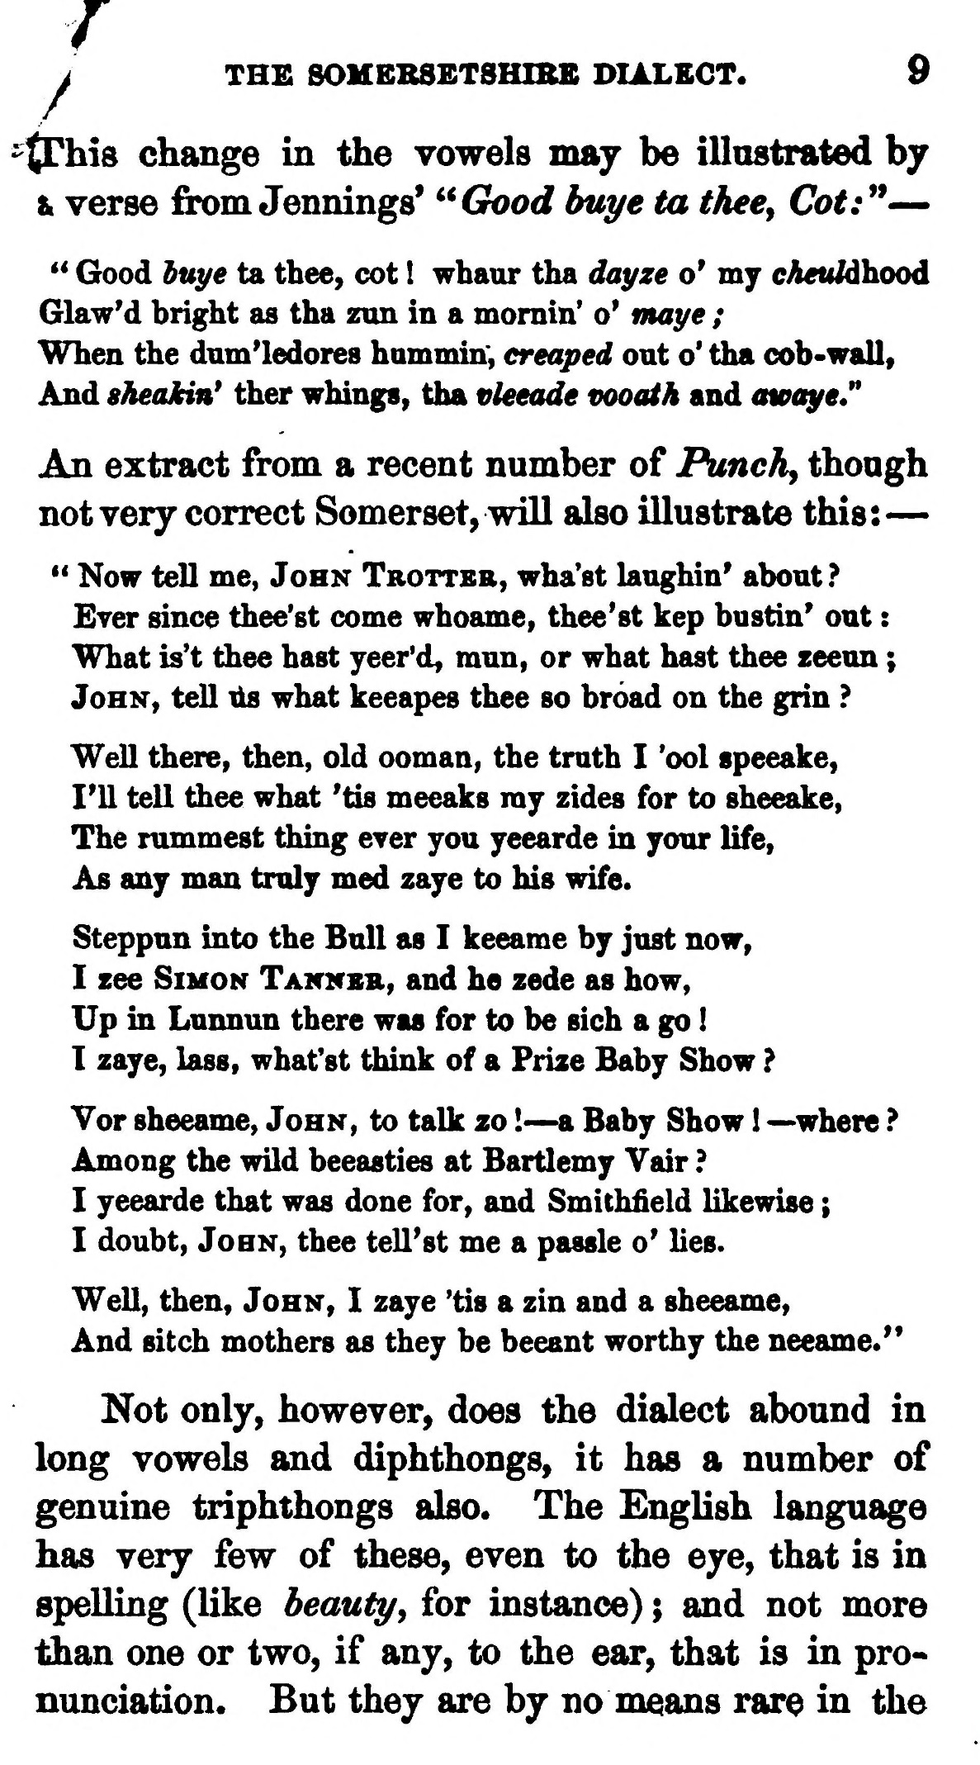  (delwedd C3673) (tudalen 009) | i THE 80HBRSETSHIBE DIALECT. 9  -tThis change in the vowels may be illustrated by Ik verse firom Jennings' ^^Good buys ta thee, Cot:^* —  ** Good buye ta thee, cot ! whaur tha dayze o* my cheuldhood Glaw'd bright as tha zun in a mornin' o' fnaye ; When the dum'ledores hammin; ereaped out o' tha cob-wall. And sheakin* ther whings, tha vleeade vooath and awaye" An extract from a recent number of Punchy thoagh not very correct Somerset, will also illustrate this: —  " Now tell me, John Trottbr, wha'st laughin' about ? Ever since thee'st come whoame, thee'st kep bustin' oat : What is't thee hast yeer'd, mun, or what hast thee zeeun ; John, tell lis what keeapes thee so broad on the grin ?  Well there, then, old ooman, the truth I 'ool speeake, I'll tell thee what 'tis meeaks ray zides for to sheeake, The rummest thing ever you yeearde in your life, As any man truly med zaye to his wife.  Steppun into the Bull as I keeame by just now, I zee Simon Tannsb., and he zede as how, Up in Lunnun there was for to be sich a go ! I zaye, lass, what'st tiiink of a Prize Baby Show ?  Vor sheeame, John, to talk zo ! — a Baby Show 1 ~where ? Among the wild beeasties at Bartlemy Vair ? I yeearde that was done for, and Smichfield likewise ; I doubt, John, thee tell'st me a passle o' lies.  Well, then, John, I zaye 'tis a zin and a sheeame.  And sitch mothers as they be beeant worthy the neeame."  Not only, however, does the dialect abound in long vowels and diphthongs, it has a number of genuine triphthongs also. The English language has very few of these, even to the eye, that is in spelling (like beauty, for instance) ; and not more than one or two, if any, to the ear, that is in pronunciation. But they are by no means rare in the
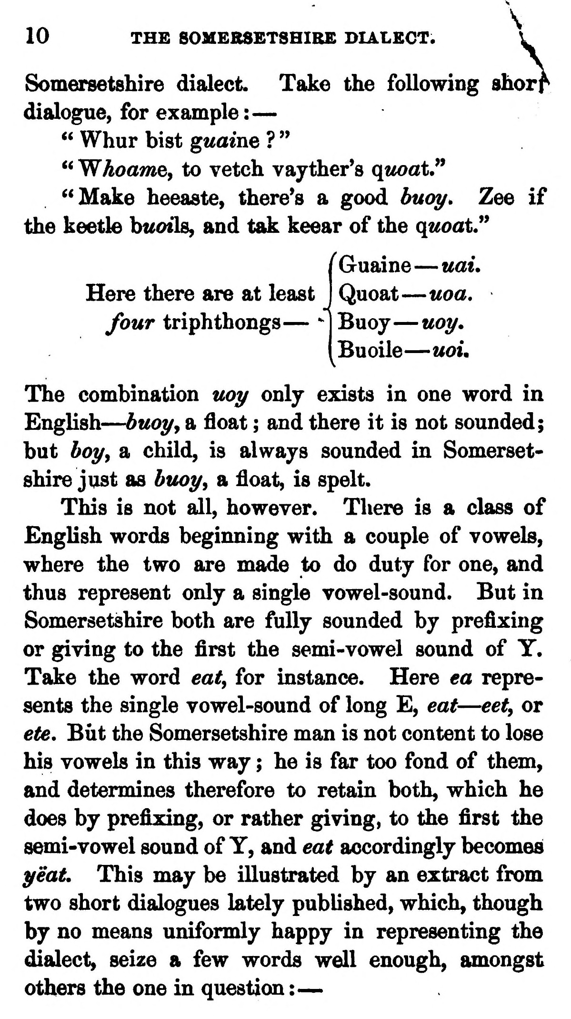  (delwedd C3674) (tudalen 010) | 10 THE SOMERSETSHIRE DIALECT. I  Somersetshire dialect Take the following shorf  dialogue, for example : — " Whur bist guaine ? " " Whoamey to vetch vayther's qtwatJ^ ^<Make heeaste, there's a good buot/» Zee if  the keetle bt^oils, and tak keear of the quoat"  Guaine — uai. Here there are at least four triphthongs — "  Quoat — uoa.  Buoy — Moy.  Buoile — uoi.  The combination twy only exists in one word in English — buot/y a float ; and there it is not sounded; but boy, a child, is always sounded in Somersetshire just as btu>t/y a float, is spelt.  This is not all, however. There is a class of English words beginning with a couple of vowels, where the two are made to do duty for one, and thus represent only a single vowel-sound. But in Somersetshire both are fully sounded by prefixing or giving to the first the semi-vowel sound of Y. Take the word eat, for instance. Here ea represents the single vowel-sound of long E, eat — eet, or ete. But the Somersetshire man is not content to lose his vowels in this way ; he is far too fond of them, and determines therefore to retain both, which he does by prefixing, or rather giving, to the first the semi-vowel sound of Y, and eat accordingly becomes ^eat. This may be illustrated by an extract from two short dialogues lately published, which, though by no means uniformly happy in representing the dialect, seize a few words well enough, amongst others the one in question : —
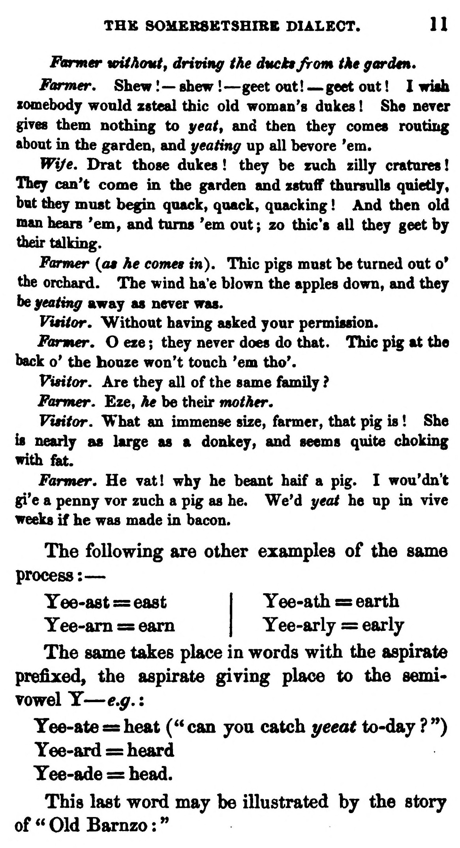  (delwedd C3675) (tudalen 011) | THE SOMERSETSHIRE DIALECT. 1 1  Fcarmer without^ driving the ducktjrom the garden.  Former, Shew !— shew ! — geet out! — .geet out ! I wiab xomebody would Z8teal thic old woman's dukes ! She neyer gives them nothing to yeat^ and then they comes routing about in the garden, and geating up all hevore *em.  Wi/e. Drat those dukes ! they be zuch zilly cratures ! They can't come in the garden and zstuff thursulls quietly, but tiiey must begin quack, quack, quacking ! And then old man hears 'em, and turns 'em out; zo thic*s all they geet by tfadrtslking.  Farmer {as he cornea in), Thic pigs must be turned out o' the orchard. The wind ha*e blown the apples down, and they be geating away as never was.  Vititor, Without having asked your permission.  Fanner. O eze ; they never does do that. Thic pig at the back o' the bouze won't touch 'em tho'.  Visitor. Are they all of the same family ?  Farmer. Eze, he be their mother.  Visitor. What an immense size, farmer, that pig is ! She is nearly as large as a donkey, and seems quite choking with fet.  Farmer. He vat I why he beant haif a pig. I wou'dn't gi'e a penny vor zuch a pig as he. We'd geat he up in vive weeks if he was made in bacon.  The following are other examples of the same process: —  Yee-ast = east I Yee-ath = earth  Yee-am = earn | Yee-arly = early  The same takes place in words with the aspirate prefixed, the aspirate giving place to the semi* vowel Y — e,g, : Yee-ate = heat (" can you catch yeeat to-day ? **) Yee-ard = heard Yee-ade = head. This last word may be illustrated by the story of^OldBarnzo:"
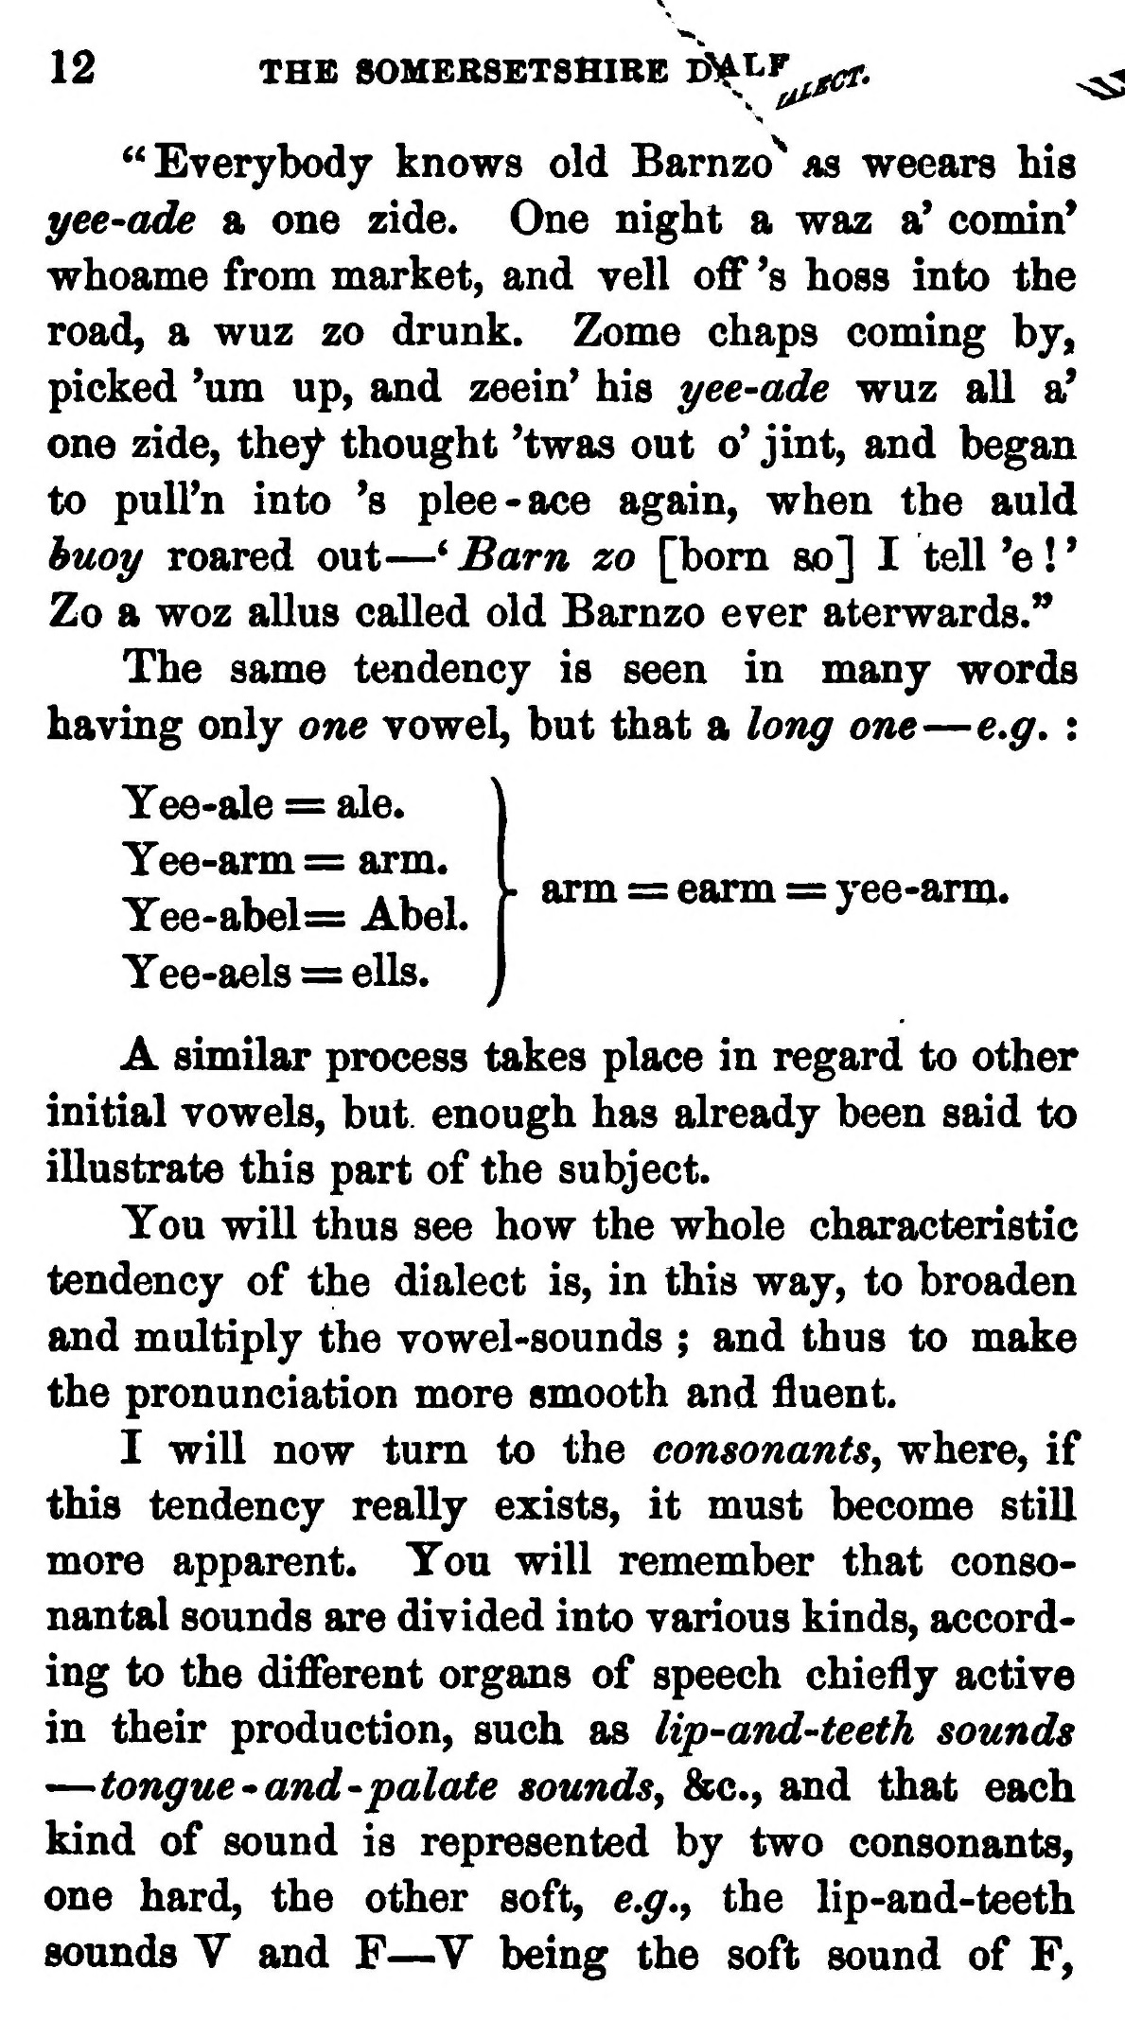  (delwedd C3676) (tudalen 012) | 12 THE SOMERSETSHIRE D^LF^. ^^^  " Everybody knows old Barnzo^ as weears his yee-ade a one zide. One night a waz a' comin* whoame from market, and veil off 's boss into the road, a wuz zo drunk. Zome chaps coming by, picked 'um up, and zeein' his yee-ade wuz all a' one zide, they thought 'twas out o' jint, and began to pull'n into 's plee-ace again, when the auld huoy roared out — * Barn zo [bom so] I tell 'e ! ' Zo a woz alius called old Barnzo ever aterwards.**  The same tendency is seen in many words having only one vowel, but that a long one — e*g. :  Yee-ale = ale.  Yee-arm = arm. Yee-abel= Abel. Yee-aels = ells.  arm = earm = yee-arm.  A similar process takes place in regard to other initial vowels, but enough has already been said to illustrate this part of the subject.  You will thus see how the whole characteristic tendency of the dialect is, in this way, to broaden and multiply the vowel-sounds ; and thus to make the pronunciation more smooth and fluent.  I will now turn to the consonants, where, if this tendency really exists, it must become still more apparent. You will remember that consonantal sounds are divided into various kinds, according to the different organs of speech chiefly active in their production, such as lip-and-teeth sounds — tongue "and -palate sounds, &c., and that each kind of sound is represented by two consonants, one hard, the other soft, e,g., the lip-and-teeth sounds V and F — V being the soft sound of F,
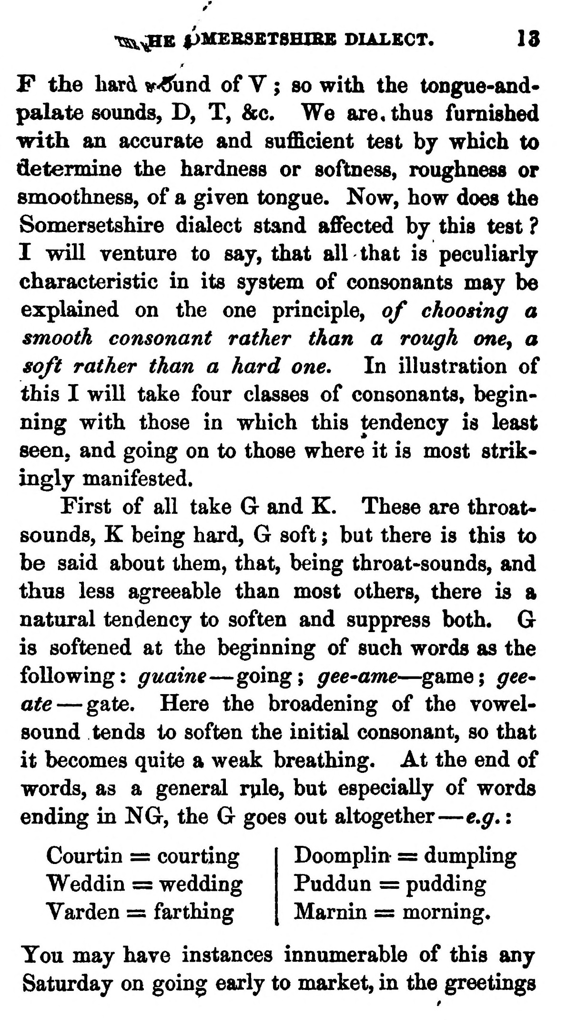  (delwedd C3677) (tudalen 013) | /  T^^B pMEBSBTSHIBB DIALECT. 13  F the hard v-Cund of V ; so with the tongue-and-palate sounds, D, T, &c. We are, thus furnished with an accurate and sufficient test bj which to determine the hardness or softness, roughness or smoothness, of a given tongue. Now, how does the Somersetshire dialect stand affected by this test ? I will venture to say, that all that is peculiarly characteristic in its system of consonants may be explained on the one principle, of choosing a smooth consonant rather than a rough one^ a soft rather than a hard one. In illustration of this I will take four classes of consonants, beginning with those in which this tendency is least seen, and going on to those where it is most strikingly manifested.  First of all take G and K. These are throat-sounds, K being hard, G soft ; but there is this to be said about them, that, being throat-sounds, and thus less agreeable than most others, there is a natural tendency to soften and suppress both. G is softened at the beginning of such words as the following: guaine — going; gee-ame — ^game; gee^ ate — gate. Here the broadening of the vowel-sound tends to soften the initial consonant, so that it becomes quite a weak breathing. At the end of words, as a general rule, but especially of words ending in NG, the G goes out altogether — e,g, :  Courtin = courting Weddin = wedding Varden = farthing  Doomplin = dumpling Puddun = pudding Marnin = morning.  You may have instances innumerable of this any Saturday on going early to market, in the greetings
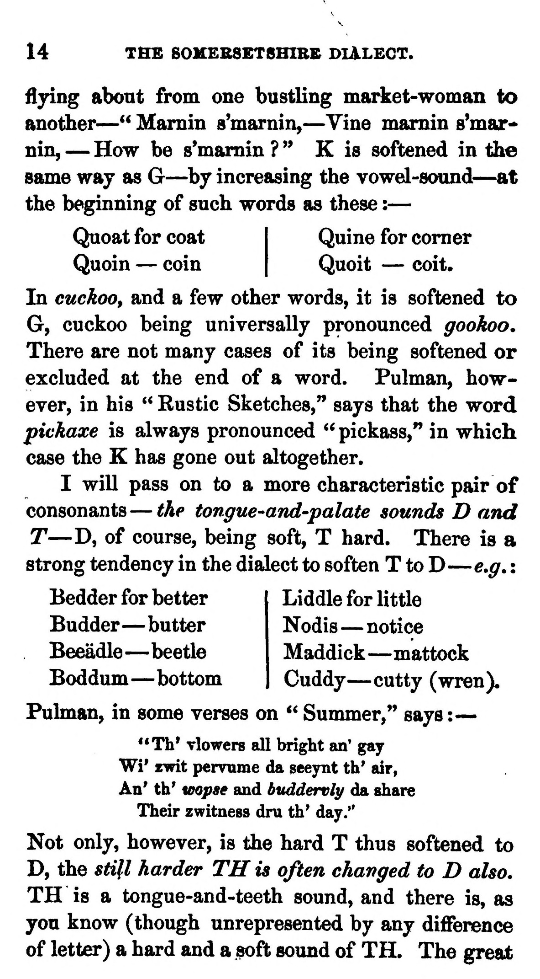  (delwedd C3678) (tudalen 014) | 14 THS S0MEBSET8HIBK DIALECT.  fljdng about from one bustling market-woman to another — " Mamin s'marnin, — Vine mamin s'mar-*> nin, — How be s'mamin ? " K is softened in the same way as G — by increasing the vowel-sound — at the beginning of such words as these : —  Quoat for coat Quoin — coin  Quine for comer Quoit — coit.  In cuckoo^ and a few other words, it is softened to G, cuckoo being universally pronounced gookoo. There are not many cases of its being softened or excluded at the end of a word. Pulman, however, in his " Rustic Sketches," says that the word pickaxe is always pronounced " pickass," in which case the K has gone out altogether.  I will pass on to a more characteristic pair of consonants — the tongue^and-palate sounds D and T — D, of course, being soft, T hard. There is a strong tendency in the dialect to soften T to D — e,g, :  Bedder for better Budder — butter Beeadle — beetle Boddum — bottom  Liddle for little Nodis — notice Maddick — mattock Cuddy — cutty (wren). Pulman, in some verses on " Summer," says : —  **Th' Tlowers all bright an' gay Wi* zwit pervume da seeynt th' air, An' th' wopse and buddervly da share  Their zwitness dru th' day."  Not only, however, is the hard T thus softened to D, the still harder TH is often changed to D also. TH is a tongue-and-teeth sound, and there is, as you know (though unrepresented by any difference of letter) a hard and a soft sound of TH. The great
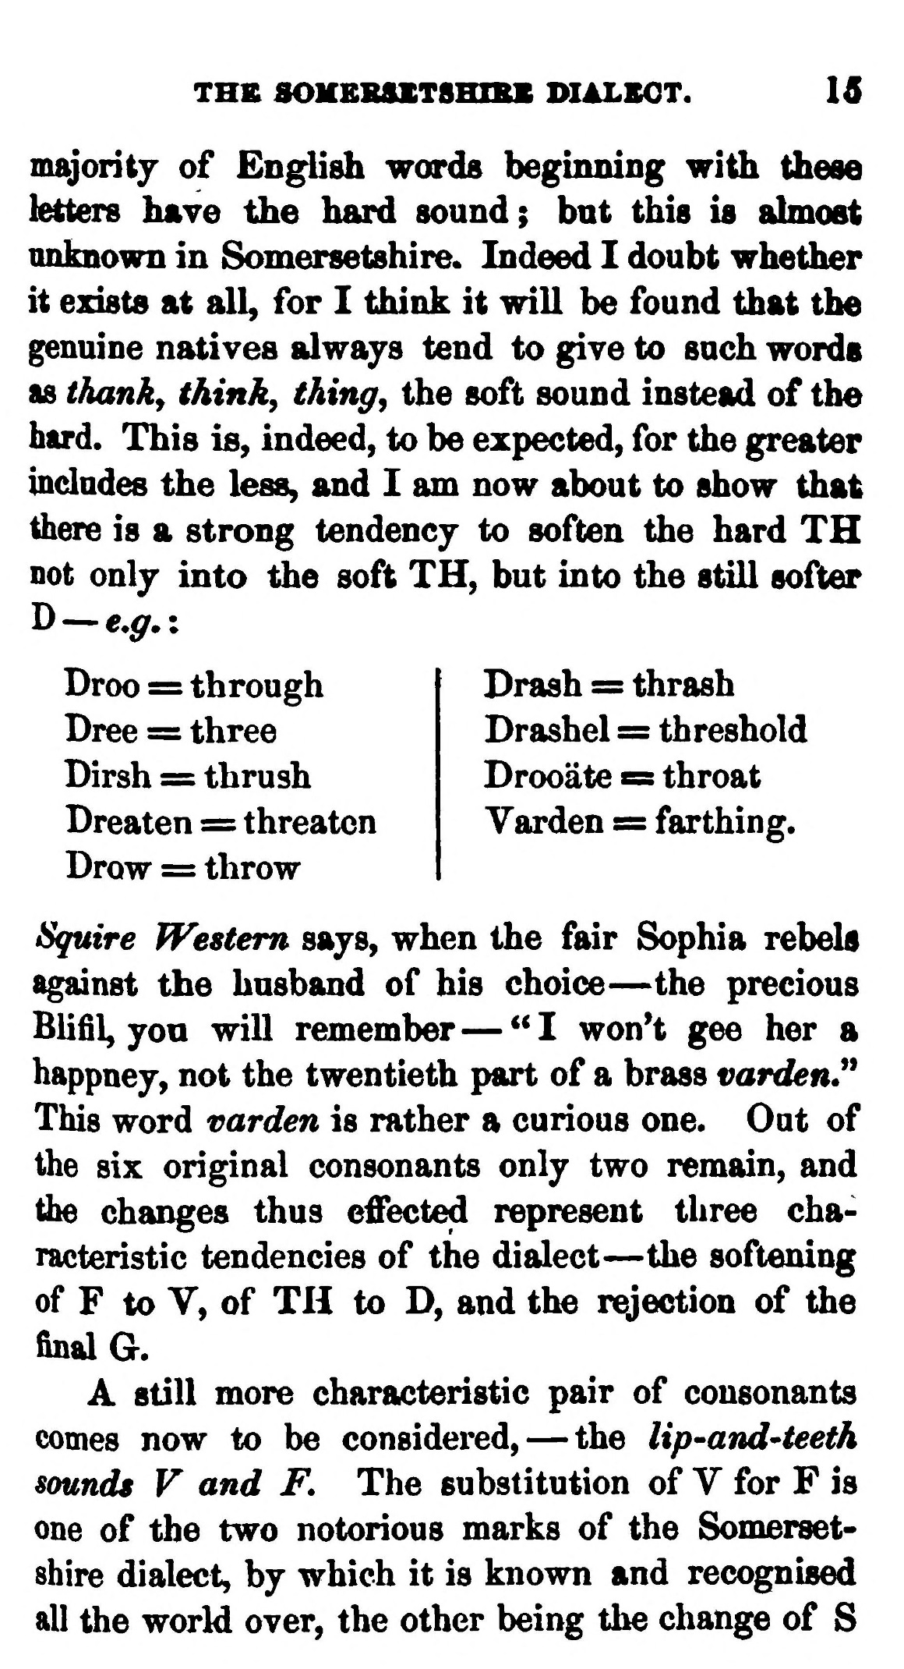  (delwedd C3679) (tudalen 015) | THS SOMBSSXT8HIBK DIALSOT. 15  majority of English words beginning with these liters have the hard sound; but this is ahnoat unknown in Somersetshire. Indeed I doubt whether it exists at all, for I think it will be found that the genuine natives always tend to give to such words as thanky think, thing, the soft sound instead of the hard. This is, indeed, to be expected, for the greater indndes the less, and I am now about to show that there is a strong tendency to soften the hard TH not only into the soft TH, but into the still softer  Droo = through Dree = three Dirsh = thrush Dreaten = threaten Drow = throw  Drash = thrash Drashel = threshold Drooate = throat Varden = farthing.  Squire Western says, when the fair Sophia rebels against the husband of his choice — the precious Blifil, yon will remember — "I won't gee her a happney, not the twentieth part of a brass var<Ien" This word varden is rather a curious one. Out of the six original consonants only two remain, and the changes thus effected represent three characteristic tendencies of the dialect — the softening of F to V, of TH to D, and the rejection of the final a.  A still more characteristic pair of consonants comes now to be considered, — the lip-and'teeth sounds V and F. The substitution of V for F is one of the two notorious marks of the Somersetshire dialect, by which it is known and recognised all the world over, the other being the change of S
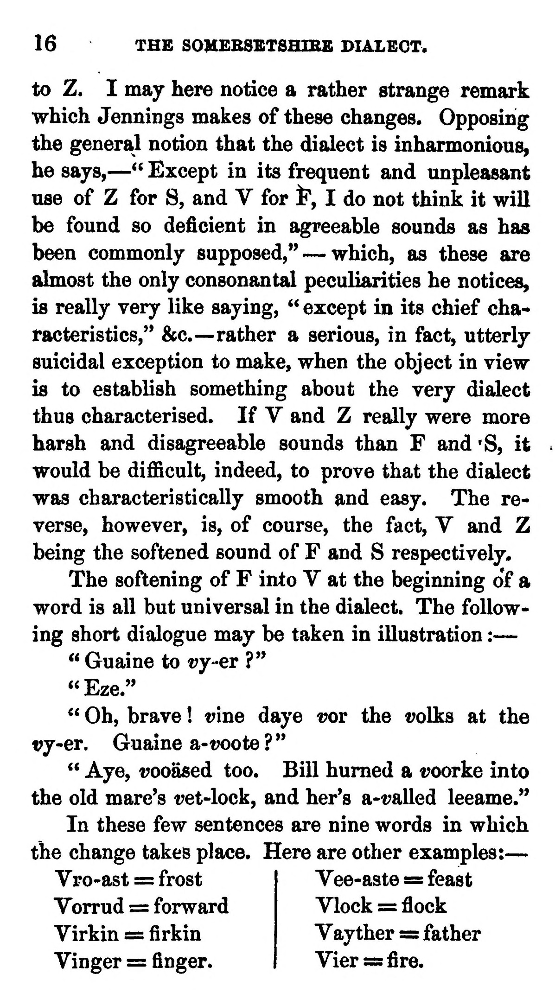  (delwedd C3680) (tudalen 016) | 16 THE SOMEBSBTSHIBE PIALEOT.  to Z. I may here notice a rather strange remark which Jennings makes of these changes. Opposing the general notion that the dialect is inharmonious, he says, — " Except in its frequent and unpleasant use of Z for S, and V for i", I do not think it will be found so deficient in agreeable sounds as has been commonly supposed," — which, as these are almost the only consonantal peculiarities he notices, is really very like saying, " except in its chief characteristics,'* &c.— rather a serious, in fact, utterly suicidal exception to make, when the object in view is to establish something about the very dialect thus characterised. If V and Z really were more harsh and disagreeable sounds than F and 'S, it would be difficult, indeed, to prove that the dialect was characteristically smooth and easy. The reverse, however, is, of course, the fact, V and Z being the softened sound of F and S respectively.  The softening of F into V at the beginning o'f a word is all but universal in the dialect. The following short dialogue may be taken in illustration : —  " Guaine to t?y-er ?"  "Eze."  " Oh, brave ! vine daye t?or the volks at the t?y-er. Guaine a-voote ? "  " Aye, vooased too. Bill humed a voorke into the old mare's ret-lock, and her's a-t?alled leeame."  In these few sentences are nine words in which the change takes place. Here are other examples: —  Vro-ast = frost Yorrud = forward Virkin = firkin Vinger = finger.  Vee-aste = feast Vlock = flock Vayther == father Vier = fire.
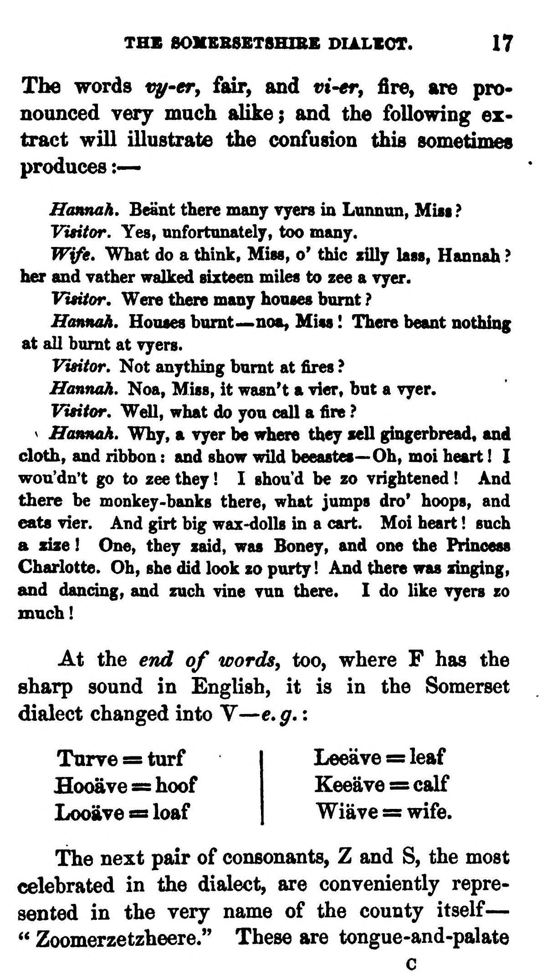  (delwedd C3681) (tudalen 017) | THE 801IBBSBT8HIBE DIALVOT. 17  The words vy^er, fair, and rt-er, fire, are pronoanced very much alike; and the following extract will illustrate the confusion this sometimes produces :—  Hannah. Beant there many vyers in Lunnun, Mist ?  Visitor. Yes, unfortunately, too many.  Wife. What do a think, Miss, o' thic xilly lass, Hannah ? her and yather walked sixteen miles to zee a vyer.  Vmtor, Were there many houses humt ?  Hannah, Houses burnt— -noa, Miss ! There beant nothing at all burnt at vyers.  Visitor. Not anything burnt at fires ?  Hannah. Noa, Miss, it wasn't a vier, but a vyer.  Visitor. Well, what do you call a fire ? V Hannah. Why, a vyer be where they sell gingerbread, and cloth, and ribbon : and show wild beeastes— Oh, moi heart ! I wouldn't go to zee they ! I shou'd be zo Trightened ! And there be monkey-banks there, what jumps dro' hoops, and eats Tier. And girt big wax-dolls in a cart. Moi heart ! such a size ! One, they zaid, was Boney, and one the Princess Charlotte. Oh, she did look zo purty! And there was zinging, and dandng, and zuch vine Yun there. I do like vyers zo much!  At the end of words, too, where F has the sharp sound in English, it is in the Somerset dialect changed into V — e. g. :  Turve = turf Hooave = hoof LooiiTe « loaf  Leeave = leaf Keeave = calf Wiave = wife.  The next pair of consonants, Z and S, the most celebrated in the dialect, are conveniently represented in the very name of the county itself — " Zoomerzetzheere." These are tongue-and-palate  c
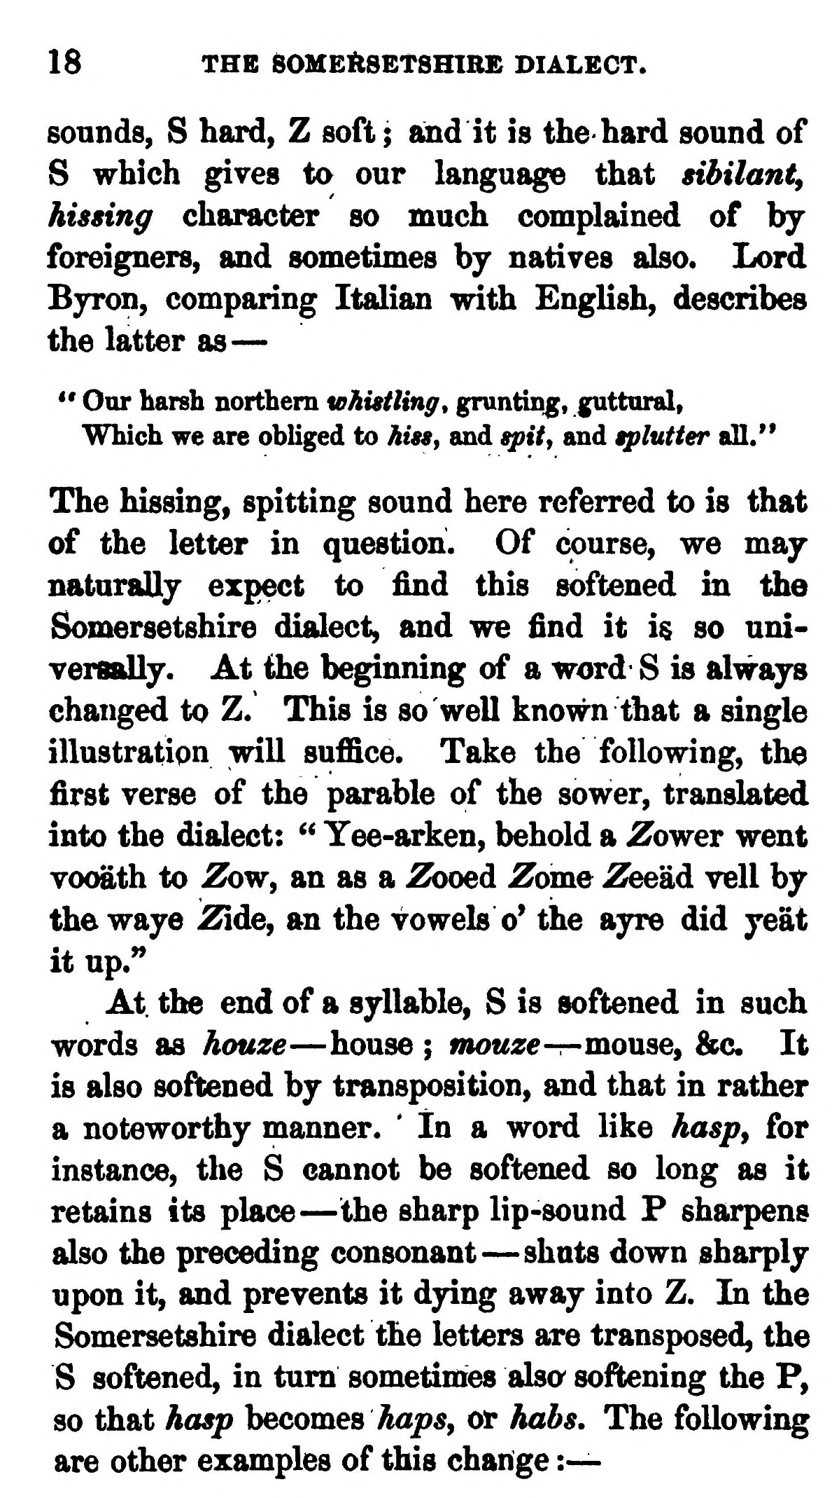  (delwedd C3682) (tudalen 018) | 18 THE 60MEftSETSHIR£ DIALECT.  sounds, S hard, Z soft; and it is the hard sound of S which gives to our language that sibilant^ hissing character so much complained of by foreigners, and sometimes by natives also. Lord Bjron, comparing Italian with English, describes the latter as —  " Our harsh northern whistling^ gruntmg, guttural, Which we are obliged to hiss, and spity and tplutter all."  The hissing, spitting sound here referred to is that of the letter in question. Of course, we may naturally expect to find this softened in the Somersetshire dialect, and we find it is so universally. At the beginning of a word S is always changed to Z. This is so well known that a single illustration will suffice. Take the following, the first verse of the parable of the sower, translated into the dialect: ^^ Yee-arken, behold a Zower went vo<MLth to Zbw, an as a Zooed Zome ZeeM veil by the waye Zide, an the vowels o' the ayre did yeat it up.**  At. the end of a syllable, S is softened in such words as hauze — house ; mouze -r-monse^ &c. It is also softened by transposition, and that in rather a noteworthy manner. * In a word like hasp, for instance, the S cannot be softened so long as it retains its place — the sharp lip-sound P sharpens also the preceding consonant — shuts down sharply upon it, and prevents it dying away into Z. In the Somersetshire dialect the letters are transposed, the S softened, in turn sometimes alsa softening the P, so that hasp hecomea haps, or habs. The following are other examples of this change :—
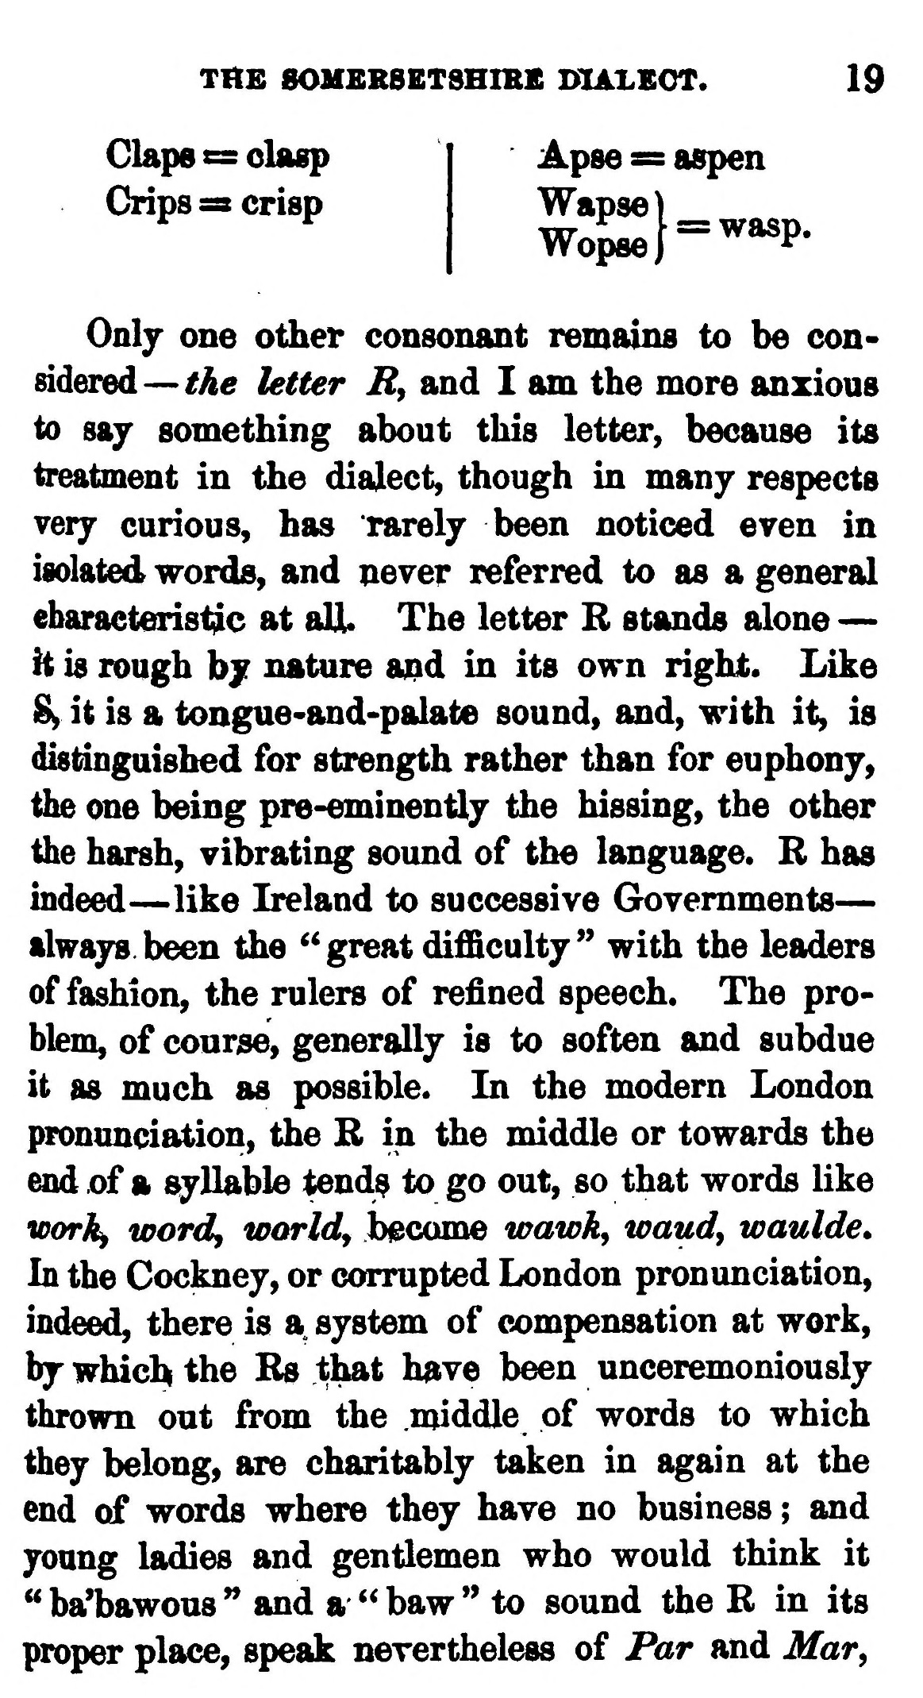  (delwedd C3683) (tudalen 019) | THE SOMBRSETSHIBS DIALECT. 19  Claps ss: olasp Crips sa crisp  Apse s= aspen  Only one other consonant remains to be considered—Me letter R, and I am the more anxious to saj something about this letter, because its treatment in the dialect, though in many respects very curious, has rarely been noticed even in isolated words, and never referred to as a general ebaracteris^c at all. The letter R stands alone — h is rough by nature a^d in its own right. Like 8y it is a tongue-and-palate sound, and, with it, is distinguished for strength rather than for euphony, the one being pre-eminently the hissing, the other the harsh, vibrating sound of the language. R has indeed — like Ireland to successive Governments — always been the ^' great difficulty" with the leaders of fashion, the rulers of refined speech. The problem, of course, generally is to soften and subdue it as much as possible. In the modern London pronunciation, the R in the middle or towards the end of a syllable tend? to go out, so that words like wark^ wordy worldy become wawk^ waudy waulde* In the Cockney, or corrupted London pronunciation, indeed, there is a system of compensation at work, by which the Rs that have been unceremoniously thrown out from the middle of words to which they belong, are charitably taken in again at the end of words where they have no business ; and young ladies and gentlemen who would think it " baHbawous " and a " baw " to sound the R in its proper place, speak nevertheless of Par and Mar,
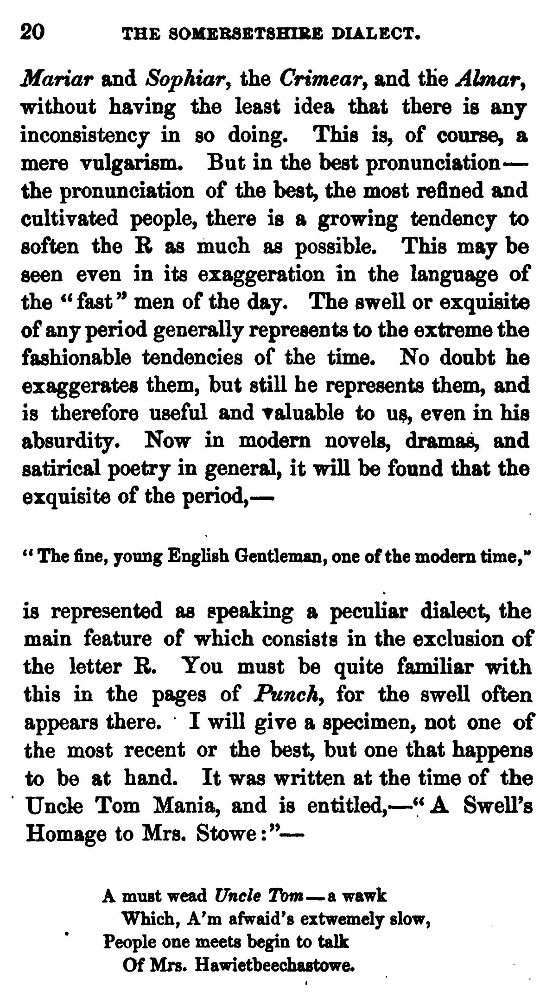  (delwedd C3684) (tudalen 020) | 20 THE SOMEBSBT8HIK£ BIALECT.  Mariar and Sophiar, the Crimear^ and the Almar^ without having the least idea that there is any inconsistencj in so doing. This is, of course, a mere vulgarism. But in the best pronunciation — the pronunciation of the best, the most refined and cultivated people, there is a growing tendency to soften the B as much as possible. This may be seen even in its exaggeration in the language of the *' fast " men of the day. The swell or exquisite of any period generally represents to the extreme the fashionable tendencies of the time. No doubt he exaggerates them, but still he represents them, and is therefore useful and valuable to u^, even in his absurdity. Now in modem novels, dramas, and satirical poetry in general, it will be found that the exquisite of the period, —  ** The fine, young English Gentleman, one of the modem time,"  is represented as speaking a peculiar dialect, the main feature of which consists in the exclusion of the letter B. You must be quite familiar with this in the pages of Punchy for the swell often appears there. I will give a specimen, not one of the most recent or the best, but one that happens to be at hand. It was written at the time of the Uncle Tom Mania, and is entitled, — "A Swell's Homage to Mrs. Stowe:" —  A must wead Uncle Tom — a wawk Which, A'm afv^aid's eztwemely slow,  People one meets begin to talk Of Mrs. Hawietbeechastowe.
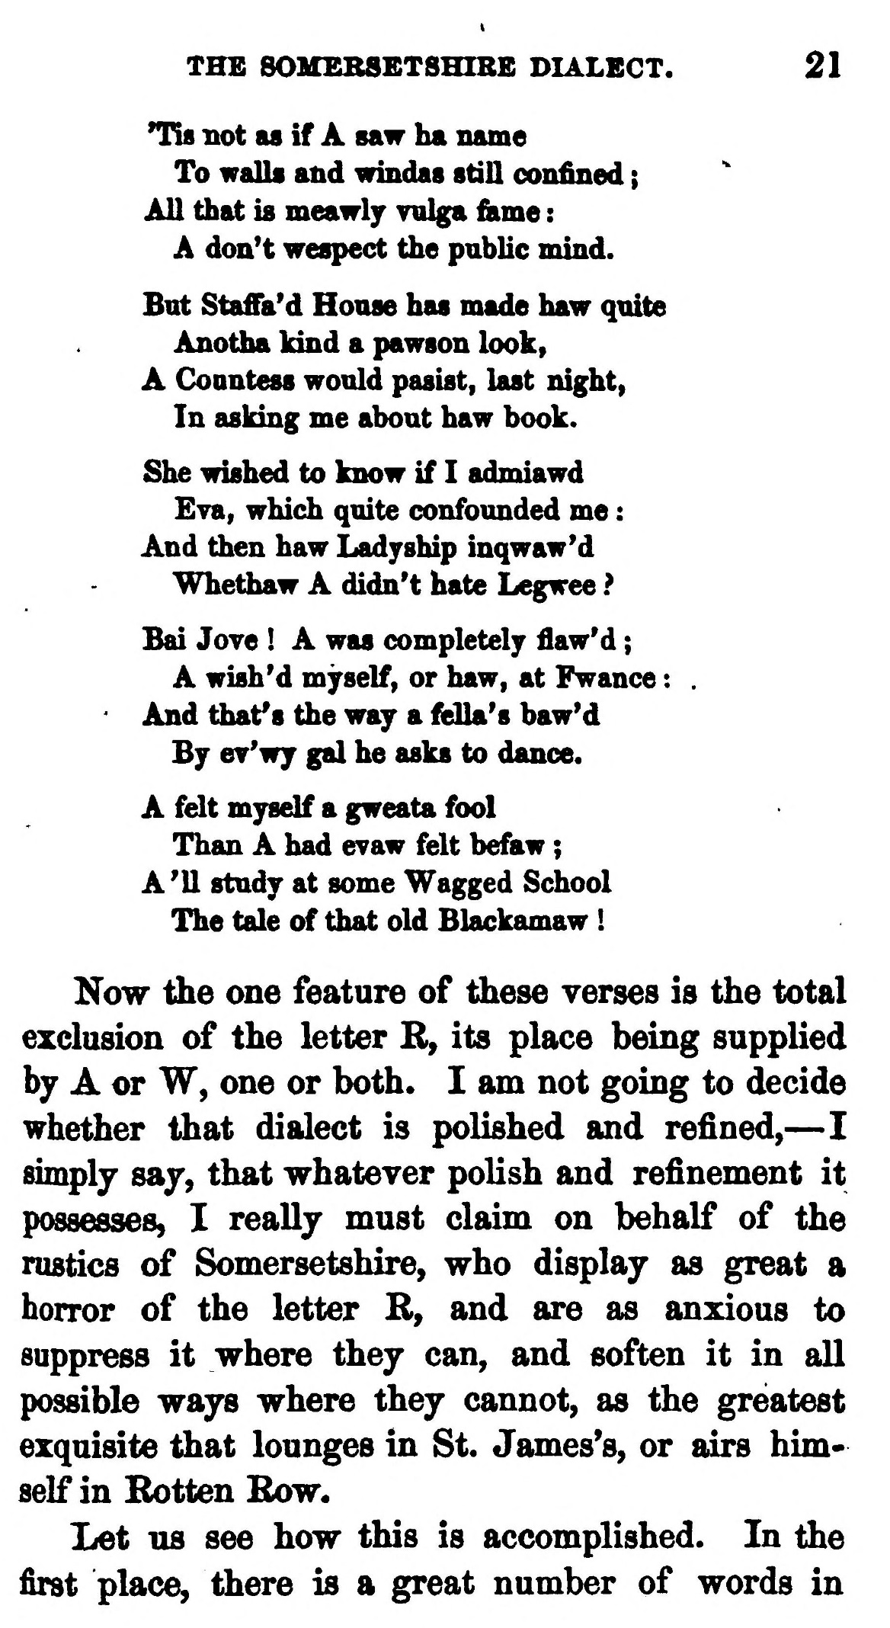  (delwedd C3685) (tudalen 021) | THE 80MEB8BT8HIBE DIALECT. 21  Tis not as if A saw ha name  To walls and windas stiU confined ; All that is meawly vnlga fiime :  A don't wespect the public mind.  But Staffa'd House has made haw quite  Anotha land a pawson look, A CoDutess would pasist, last night,  In asking me about haw book.  She wished to know if I admiawd  Eva, which quite confounded me : And then haw Ladyship inqwaw'd  Whethaw A didn't hate Legwee ?  Bai Jore ! A was completely flaw'd ;  A wish'd myself, or haw, at Fwance : . And thaf s the way a fella's baw'd  By er'wy gal he asks to dance.  A felt myself a gweata fool  Than A had evaw felt befaw ; A'U study at some Wagged School  The tale of that old Blackamaw !  Now the one feature of these verses is the total exclusion of the letter B, its place being supplied by A or W, one or both. I am not going to decide whether that dialect is polished and refined, — I simply saj, that whatever polish and refinement it possesses, I really must claim on behalf of the rustics of Somersetshire, who display as great a horror of the letter B, and are as anxious to suppress it where they can, and soften it in all possible ways where they cannot, as the greatest exquisite that lounges in St. James's, or airs himself in Botten Bow.  Let US see how this is accomplished. In the first place, there is a great number of words in
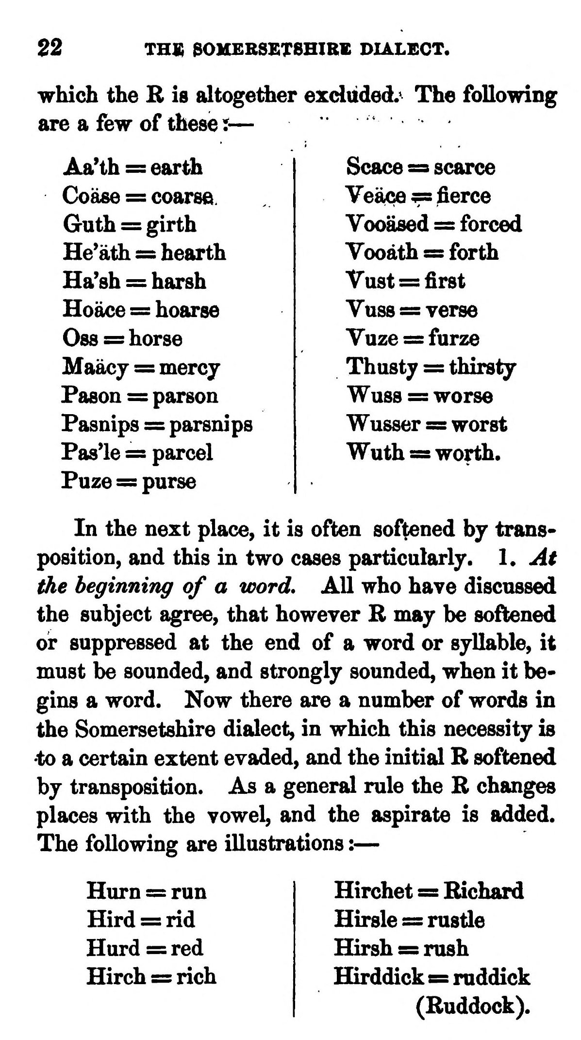  (delwedd C3686) (tudalen 022) | 22  THJB 30HEBSET8HIRE DIALECT.  which the B is altogether exdiided.' The following are a few of these? —  Aa'th = earth Coase = coarse. Guth = girth He'ath = hearth Ha'sh = harsh Hoace = hoarse Oss =5 horse Maacy = mercy PasoQ = parson Pasnips = parsnips Pas'le = parcel Puze = purse  Scace =3 scarce Veace ^ flerce Yooased = forced Vooath s=s forth Vast = first Vuss = verse Vuze = furze Thusty = thirsty Wuss = worse Wusser = worst Wuth =s worth.  In the next place, it is often softened by transposition, and this in two cases particularly. I. At the beginning of a word. All who have discussed the subject agree, that however B may be softened or suppressed at the end of a word or syllable, it must be sounded, and strongly sounded, when it begins a word. Now there are a number of words in the Somersetshire dialect, in which this necessity is •to a certain extent evaded, and the initial B softened by transposition. As a general rule the B changes places with the vowel, and the aspirate is added. The following are illustrations : —  Hurn = run Hird = rid Hurd = red Hirch = rich  Hirchet s= Bichard Hirsle = rustle Hirsh = rush Hirddick s rnddick (Buddock).
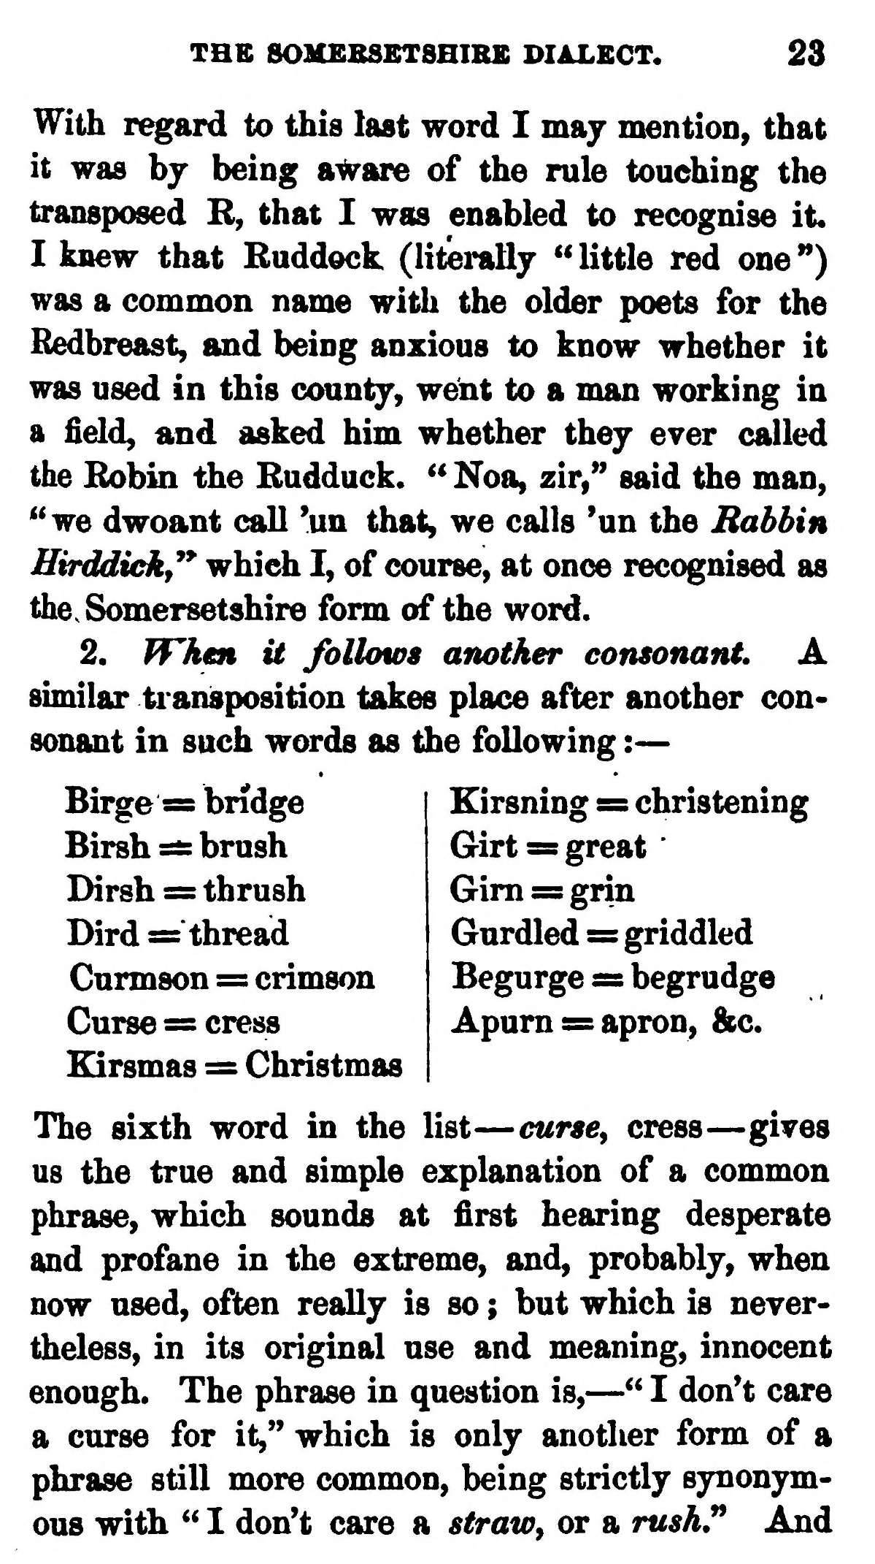  (delwedd C3687) (tudalen 023) | THB 80MEBSET8HIRS DIALECT. 23  With regard to this last word I may mention, that it was hj being a^are of the rule touching the transposed R, that I was enabled to recognise it. I knew that Ruddock (literally "little red one") was a common name with the older poets for the Redbreast, and being anxious to know whether it was used in this county, went to a man working in a field, and asked him whether they ever called the Robin the Rudduck. " Noa, zir," said the man, ''we dwoant call 'un that, we calls 'un the Bobbin Hirddickf^* which I, of course, at once recognised as the. Somersetshire form of the word.  2. When it follows another consonant. A similar transposition takes place after another consonant in such words as the following : —  Birge s= bridge Birsh =£: brush Dirsh = thrush Dird = thread Curmson = crimson Curse = cress Kirsmas = Christmas  Kirsning == christening Girt = great Gim s= grin Gurdled = griddled Begurge s=s begrudge Apum = apron, &c.  The sixth word in the list — curscy cress — gives us the true and simple explanation of a common phrase, which sounds at first hearing desperate and profane in the extreme, and, probably, when now used, often really is so ; but which is nevertheless, in its original use and meaning, innocent enough. The phrase in question is, — " I don't care a curse for it," which is only another form of a phrase still more common, being strictly synonymous with " I don't care a straw^ or a rush,^ And
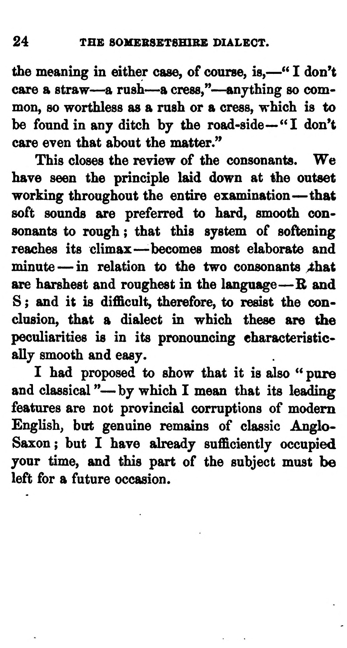  (delwedd C3688) (tudalen 024) | 24 THE S0MESSET8HIRB DIALECT.  the meaning in either case, of course, is, — '* I don't care a straw — a rush — a cress," — anything so common, so worthless as a rush or a cress, which is to be found in any ditch by the road-side— "I don't care even that about the matter."  This closes the review of the consonants. We have seen the principle laid down at the outset working throughout the entire examination — that soft sounds are preferred to hard, smooth consonants to rough ; that this system of softening reaches its climax — -becomes most elaborate and minute — in relation to the two consonants ^hat are harshest and roughest in the language — B and S ; and it is difficult, therefore, to resist the conclusion, that a dialect in which these are the peculiarities is in its pronouncing characteristically smooth and easy.  I had proposed to show that it is also ^* pure and classical " — by which I mean that its leading features are not provincial corruptions of modem English^ but genuine remains of classic Anglo-Saxon; but I have already sufficiently occupied your time, and this part of the subject must be left for a future occasion.
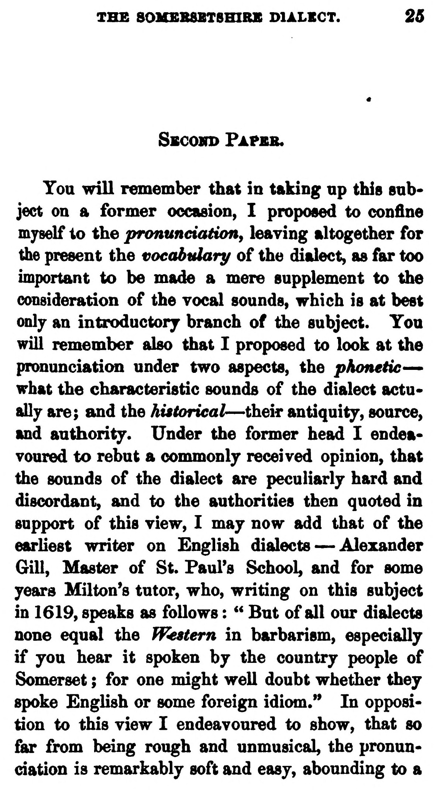  (delwedd C3689) (tudalen 025) | THE 80MEB8BTSHIRB DIALBGT. 26  SBCoin> Pafeb.  You will remember that in taking np this snb* ject on a former occasion, I proposed to confine myself to the pranuneiaHony leaving altogether for the present the voeabtdary of the dialect, as far too important to be made a mere supplement to the consideration of the vocal sounds, which is at best only an introductory branch of the subject. Tou will remember also that I proposed to look at the pronunciaticm under two aspects, the pAonelic— what the characteristic sounds of the dialect actually are; and the historical — their antiquity, source, and authority. Under the former head I endeavoured to rebut a conmionly received opinion, that the sounds of the dialect are peculiarly hard and discordant, and to the authorities then quoted in support of this view, I may now add that of the earliest writer on English dialects — Alexander Gill, Master of St. Paul's School, and for some years Milton's tutor, who, writing on this subject in 1619, speaks as follows : '* But of all our dialects none equal the Western in barbarism, especially if you hear it spoken by the country people of Somerset ; for one might well doubt whether they spoke English or some foreign idiom." In opposition to this view I endeavoured to show, that so far from being rough and unmusical, the pronunciation is remarkably soft and easy, abounding to a
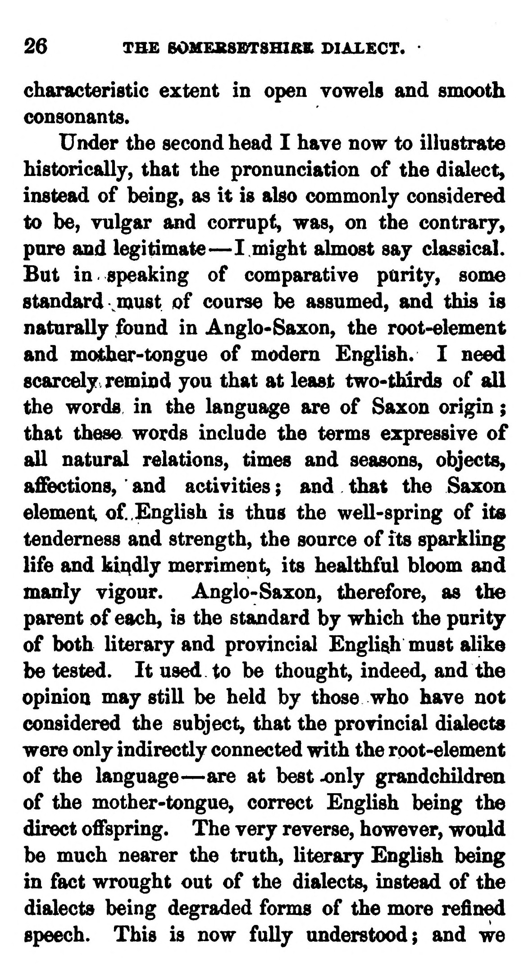  (delwedd C3690) (tudalen 026) | 26 THE fiOMEBSBTSHI&S DIALECT.  characteristic extent in open vowels and smooth consonants.  Under the second head I have now to illustrate historically, that the pronunciation of the dialect, instead of being, as it is also commonly considered to be, vulgar luid corrupt, was, on the contrary, pure and legitimate — I might almost say classical. But in speaking of comparative parity, soma standard vmust of course be assumed, and this is naturally found in Anglo-Saxon, the root-element and mother-tongue of modem English. I need scarcely, remind you that at least two-thirds of all the words in ^e language are of Saxon origin ; that these words include the terms expressive of all natural relations, times and seasons, objects, a£fections, and activities ; and that the Saxon element of English is thus the well-spring of its tenderness and strength, the source of its sparkling life and kindly merriment, its healthful bloom fmd manly vigour. Anglo-Saxon, therefore, as the parent of each, is the standard by which the purity of both literary and provincial English must alike be tested. It used to be thought, indeed, and the opinion may still be held by those who have not considered the subject, that the provincial dialects were only indirectly connected with the root-element of the language — are at best^nly grandchildren of the mother-tongue, correct English being the direct offspring. The very reverse, however, would be much nearer the truth, literary English being in fact wrought out of the dialects, instead of the dialects being degraded forms of the more refined speech. This is now fully understood; and we
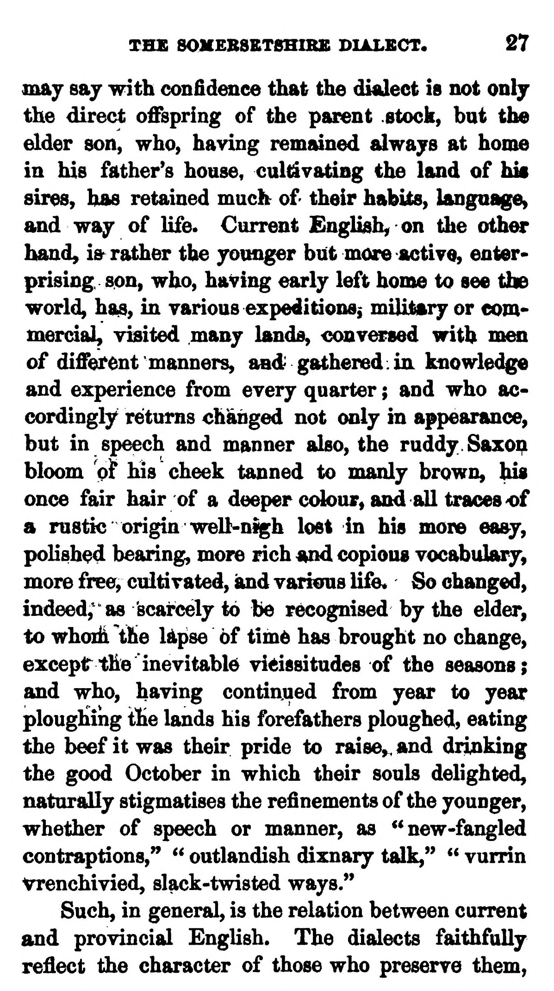  (delwedd C3691) (tudalen 027) | THE 80XEBSET8HIBE DIALECT. 27  mskj saj with confidence that the dialect is not onlj the direct offspring of the parent stock, but the elder son, who, having remiuned alwajs at home in his father's house, culdvatiBg the land of his sires, has retained much of their habits, language, and wa^ of life. Current English, on the other hand^ ifr rather the younger but more active, enterprising son, who, having early left home to see the world, has, in various expeditions^ miUtary or commercial, visited many hmds, conversed with men of different manners, fmd gathered: in knowledge and experience from every quarter ; and who accordingly returns changed not only in appearance, but in speech and manner also, the ruddy. Saxoi^ bloom pi lus cheek tanned to manly brown, his once fair hair of a deeper ccdour, and all traces 'of a rustic origin well-nigh lost in his more easy, polished bearing, more rich and copious vocabulary, more free, cultivated, and various life« So changed, indeed; as scarcely to be recognised by the elder, to whoih the Upse 6f time has brought no change, except the inevitable vieissitudes of the seasons; and who, having continued from year to year ploughing the lands his forefathers ploughed, eating the beef it was their pride to raise,, and drinking the good October in which their souls delighted, naturally stigmatises the refinements of the younger, whether of speech or manner, as "new-fangled contraptions," " outlandish dixnary talk," " vurrin Vrenchivied, slack-twisted ways."  Such, in general, is the relation between current and provincial English. The dialects faithfully reflect the character of those who preserve them,
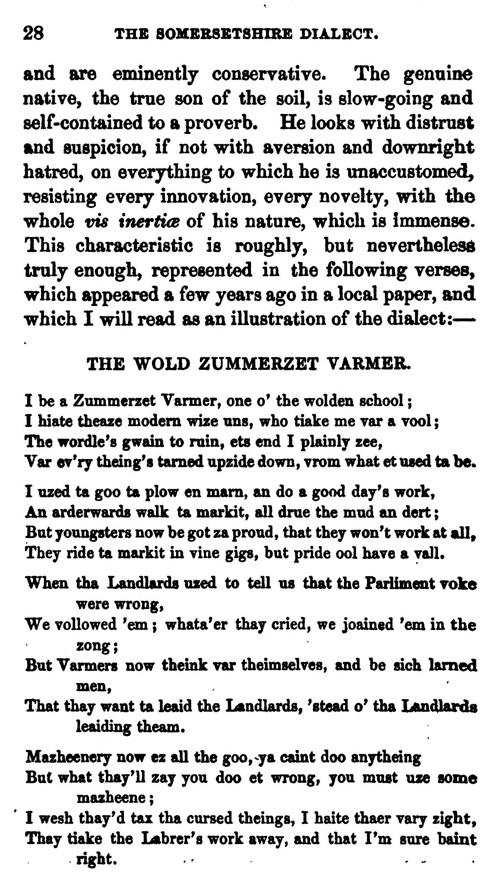  (delwedd C3692) (tudalen 028) | ■■■Mi 28 THE SOMERSETSHIRE DIALECT.  and are eminently conservative. The genuine native, the true son of the soil, is slow-going and self-contained to a proverb. He looks with distrust and suspicion, if not with aversion and downright hatred, on everjthing to which he is unaccustomed, resisting every innovation, every novelty, with the whole vis inertits of his nature, which is immense. This characteristic is roughly, but neverthelesd truly enough, represented in the following verses, which appeared a few years ago in a local paper, and which I will read as an illustration of the dialect: —  THE WOLD ZUMMERZET VARMER.  I be a Zmnmerzet Yarmer, one o' the wolden school ;  I hiate theaze modem wize ons, who tiake me rar a too! ;  The wordle's gwam to rain, ets end I plainly zee,  Var er'ry theing's tamed upzide down, vrom what et used ta be.  I uzed ta goo ta plow en mam, an do a good day's work, An arderwards walk ta markit, aU drae the mnd an dert ; But youngsters now be got za proud, that they won't work at mU» They ride ta markit in vine gigs, but pride ool have a yall.  When tha Landlarda uzed to tell us that the Pariiment roke  were wrong, We vollowed 'em ; whata'er thay cried, we joained 'em in the  zong; But Yarmers now theink var theimselyes, and be sich lamed  men. That thay want ta leaid the Landlards, 'stead o' tha Ijandlards  leaiding theam.  Mazheenery now ez aU the goo,-ya caint doo anytheing  But what thay'll zay you doo et wrong, you must uze some  mazheene ; I wesh thay'd tax tha cursed theings, I haite thaer rary zight, Thay tiake the Labrer's work away, and that I'm sure baint  right. ...
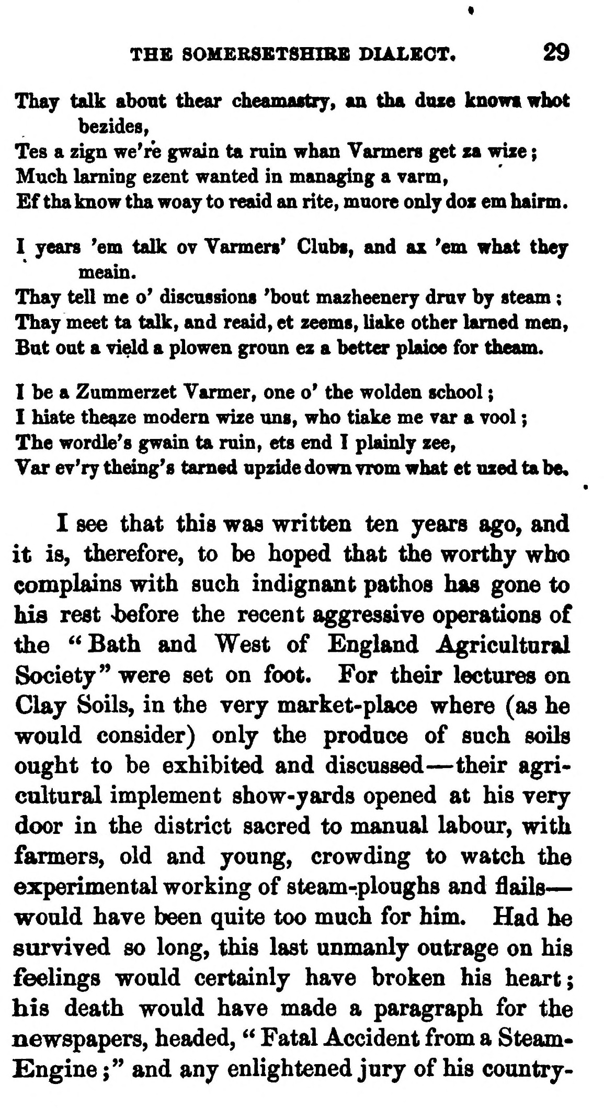  (delwedd C3693) (tudalen 029) | THE SOMEBSETSHIRB DIALECT. 29  TioLj talk about thear cheamastry, an tha dose knowt whot  bezides, Tes a zign we're gwain ta ruin whan Vannera get za wize ; Much Isuming ezent wanted in managing a varm, £f tha know tha woay to reaid an rite, muore only doz em hairm.  I years 'em talk ov Yarmers' Clubi, and az 'em what they  meain. Thay tell me o' discussions 'bout mazheenery dray by steam ; Thay meet ta talk, and reaid, et zeems, Hake other lamed men, But out a Tield a plowen groan ez a better plaice for theam.  I be a Zummerzet Tarmer, one o' the wolden school ;  I hiate thei^e modern wize ans, who tiake me var a vool ;  The wordle's gwain ta ruin, ets end I plainly zee,  Var er'ry theing's tamed apzide down yrom what et ozed ta be,  I see that this was written ten years ago, and it is, therefore, to be hoped that the worthy who complains with such indignant pathos has gone to his rest 4t)efore the recent aggressive operations of the ''Bath and West of England Agricultural Society" were set on foot. For their lectures on Clay Soils, in the very market-place where (as he would consider) only the produce of such soils ought to be exhibited and discussed — their agricultural implement show-yards opened at his very door in the district sacred to manual labour, with farmers, old and young, crowding to watch the experimental working of steam-ploughs and flails — would have been quite too much for him. Had he survived so long, this last unmanly outrage on his feelings would certainly have broken his heart; his death would have made a paragraph for the newspapers, headed, '' Fatal Accident from a Steam-Engine ;" and any enlightened jury of his country-
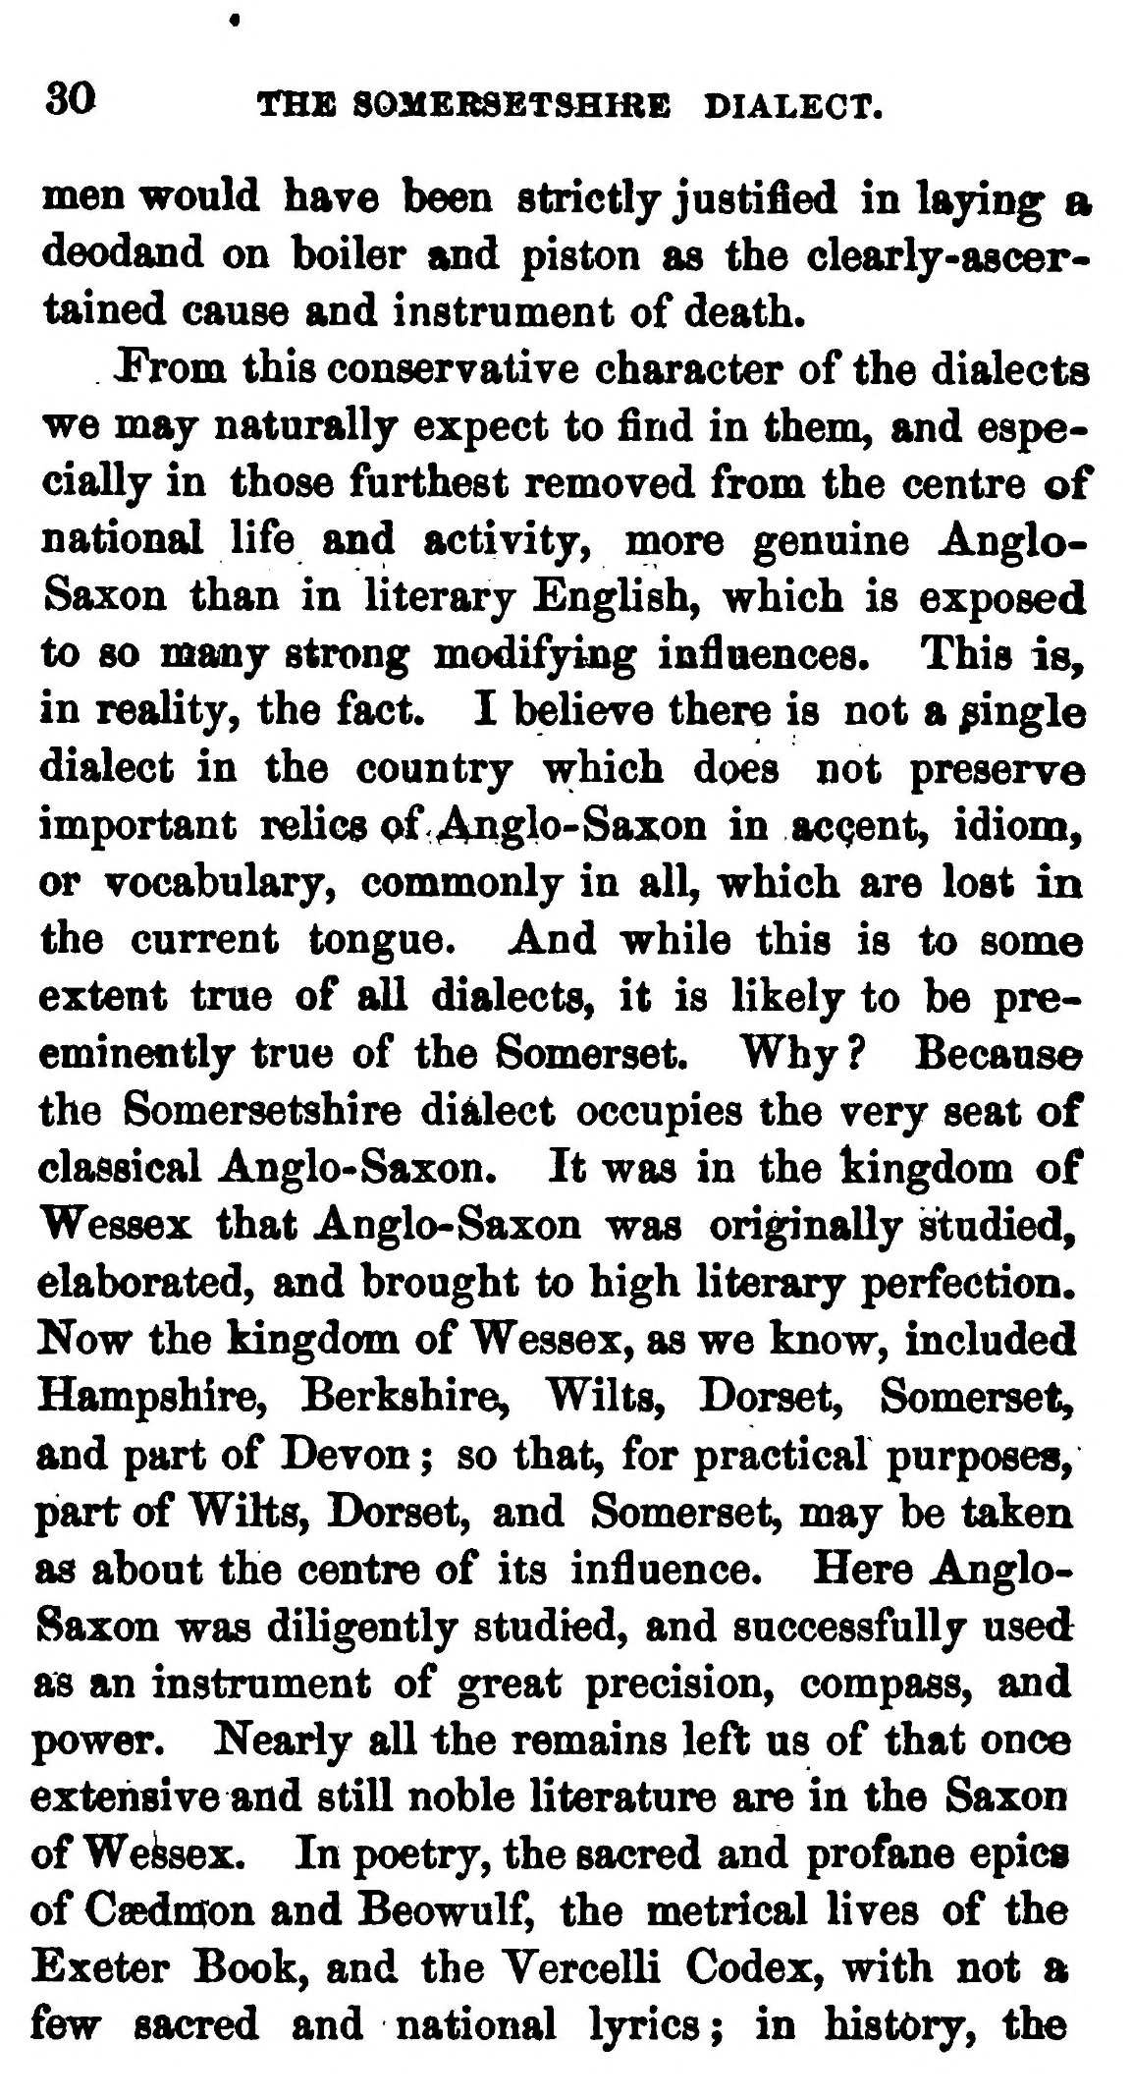  (delwedd C3694) (tudalen 030) | 30 THE SOMEBSET&HHIE DIALECT.  men would have been strictly justified in laying a deodand on boiler and piston as the clearly-ascertained cause and instrument of death.  Prom this conservatiye character of the dialects we may naturally expect to find in them, and especially in those furthest removed from the centre of national life and activity, more genuine Anglo-Saxon than in literary English, which is exposed to so many strong modifjing infiaences. This is, in reality, the fact. I believe there is not a jingle dialect in the country which does not preserve important relics of- Anglo- Saxon in accent, idioniy or vocabulary, commonly in all, which are lost in the current tongue. And while this is to some extent true of all dialects, it is likely to be pre-eminently true of the Somerset. Why ? Because the Somersetshire dialect occupies the very seat of classical Anglo-Saxon. It was in the kingdom of Wessex that Anglo-Saxon was originally studied, elaborated, and brought to high literary perfection. Now the kingdom of Wessex, as we know, included Hampshire, Berkshire, Wilts, Dorset, Somerset, and part of Devon ; so that, for practical purposes, part of Wilts, Dorset, and Somerset, may be taken as about the centre of its infiuence. Here Anglo-Saxon was diligently studied, and successfully used as an instrument of great precision, compass, and power. Nearly all the remains left us of that once extensive and still noble literature are in the Saxon of Weibsex. In poetry, the sacred and profane epics of Gaednron and Beowulf, the metrical lives of the Exeter Book, and the Vercelli Codex, with not a few sacred and national lyrics ; in history, the
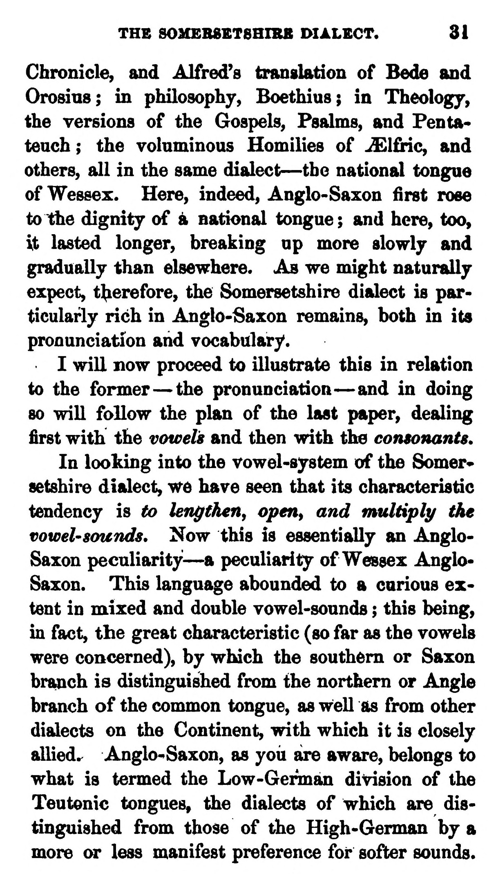  (delwedd C3695) (tudalen 031) | THE SOMEB8ET8HIBB DIALECT. 31  Chronicle, and Alfred's translation of Bede and Oro&ins; in philosophy, Boethius; in Theology, the versions of the Gospels, Psalms, and Pentateuch; the voluminous Homilies of ^l£iic, and others, all in the same dialect — the national tongue of Wessex. Here, indeed, Anglo-Saxon first rose to the dignity of k national tongue ; and here, too, it lasted longer, breaking up more slowly and gradually than elsewhere. As we might naturally expect, tl^erefore, the Somersetshire dialect is particularly rich in Anglo-Saxon remains, both in its pronunciation and vocabulary.  I will now proceed to illustrate this in relation to the former— the pronunciation — and in doing 80 will follow the plan of the last paper, dealing first with the vowels and then with the consonants.  In looking into the vowel-system of the Somer* setshire dialect, we have seen that its characteristic tendency is to lengthen^ open^ and multiply the vowel' sounds. Now this is essentially an Anglo-Saxon peculiarity — a peculiarity of Wessex Anglo-Saxon. This language abounded to a carious extent in mixed and double vowel-sounds ; this being, in fact, the great characteristic (so far as the vowels were concerned), by which the southern or Saxon branch is distinguished from the northern or Angle branch of the common tongue, as well as from other dialects on the Continent, with which it is closely allied.^ Anglo-Saxon, as you are aware, belongs to what is termed the Low-German division of the Teutonic tongues, the dialects of which are distinguished from those of the High-German by a more or less manifest preference for softer sounds.
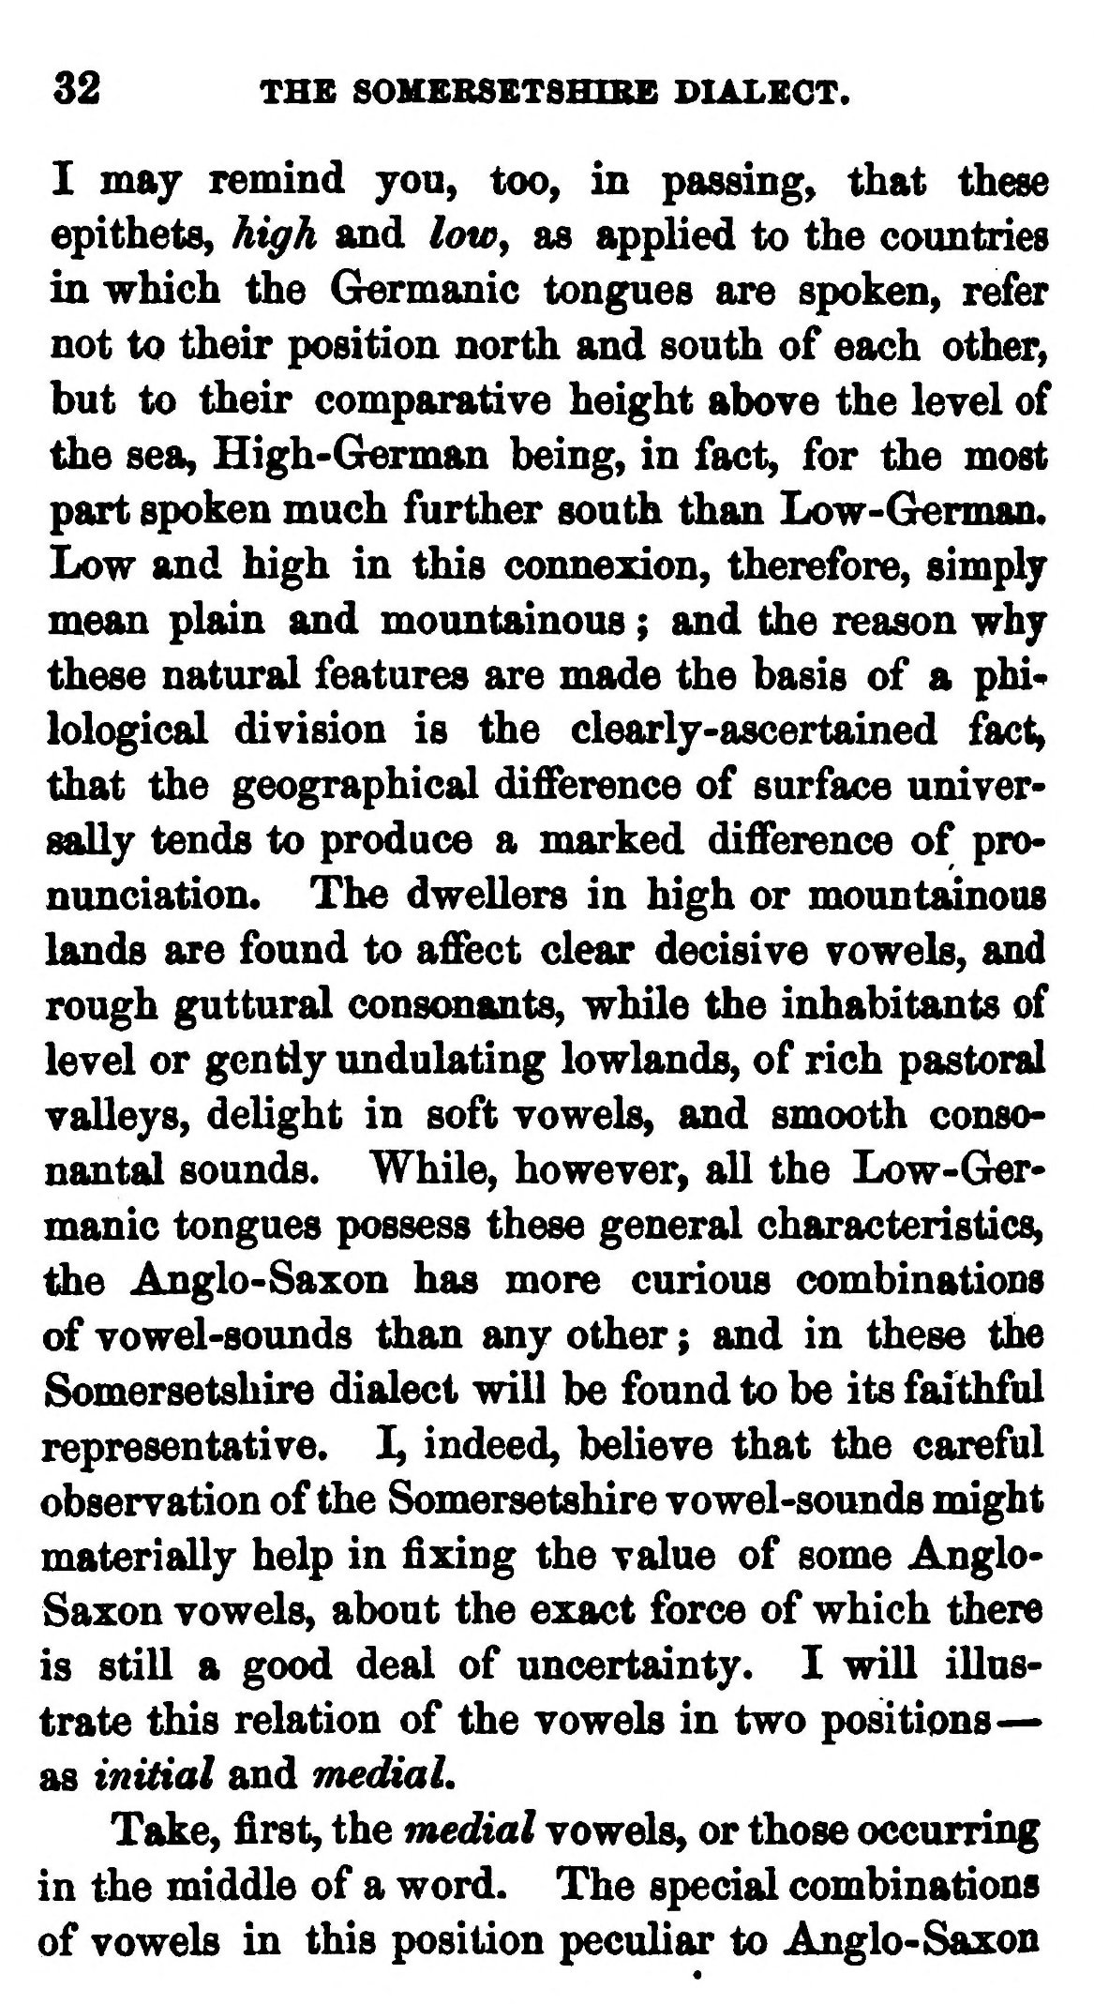  (delwedd C3696) (tudalen 032) | 32 THE SOKEBSETSHIBE DIALECT.  I may remind you, too, in passing, that these epithets, high and lowy as applied to the countries in which the Germanic tongues are spoken, refer not to their position north and south of each other, but to their comparative height above the level of the sea, High-German being, in fact, for the most part spoken much further south than Low-Grerman. Low and high in this connexion, therefore, simply mean plain and mountainous ; and the reason why these natural features are made the basis of a phi* lological division is the clearly-ascertained fact, that the geographical difference of surface universally tends to produce a marked difference of pronunciation. The dwellers in high or mountainous lands are found to affect dear decisive vowels, and rough guttural conscmants, while the inhabitants of level or gendy undulating lowlands, of rich pastoral valleys, delight in soft vowels, and smooth consonantal sounds. While, however, all the Low-Germanic tongues possess these general characteristics, l^e Anglo-Saxon has more curious combinations of vowel-sounds than any other ; and in these the Somersetshire dialect will be found to be its faithful representative. I, indeed, believe that the careful observation of the Somersetshire vowel-sounds might materially help in fixing the value of some Anglo-Saxon vowels, about the exact force of which there is still a good deal of uncertainty. I will illustrate this relation of the vowels in two positions— as initial and mediaL  Take, first, the medial vowels, or those occurring in the middle of a word. The special combinations of vowels in this position peculiar to Anglo-Saxon  J  ^v
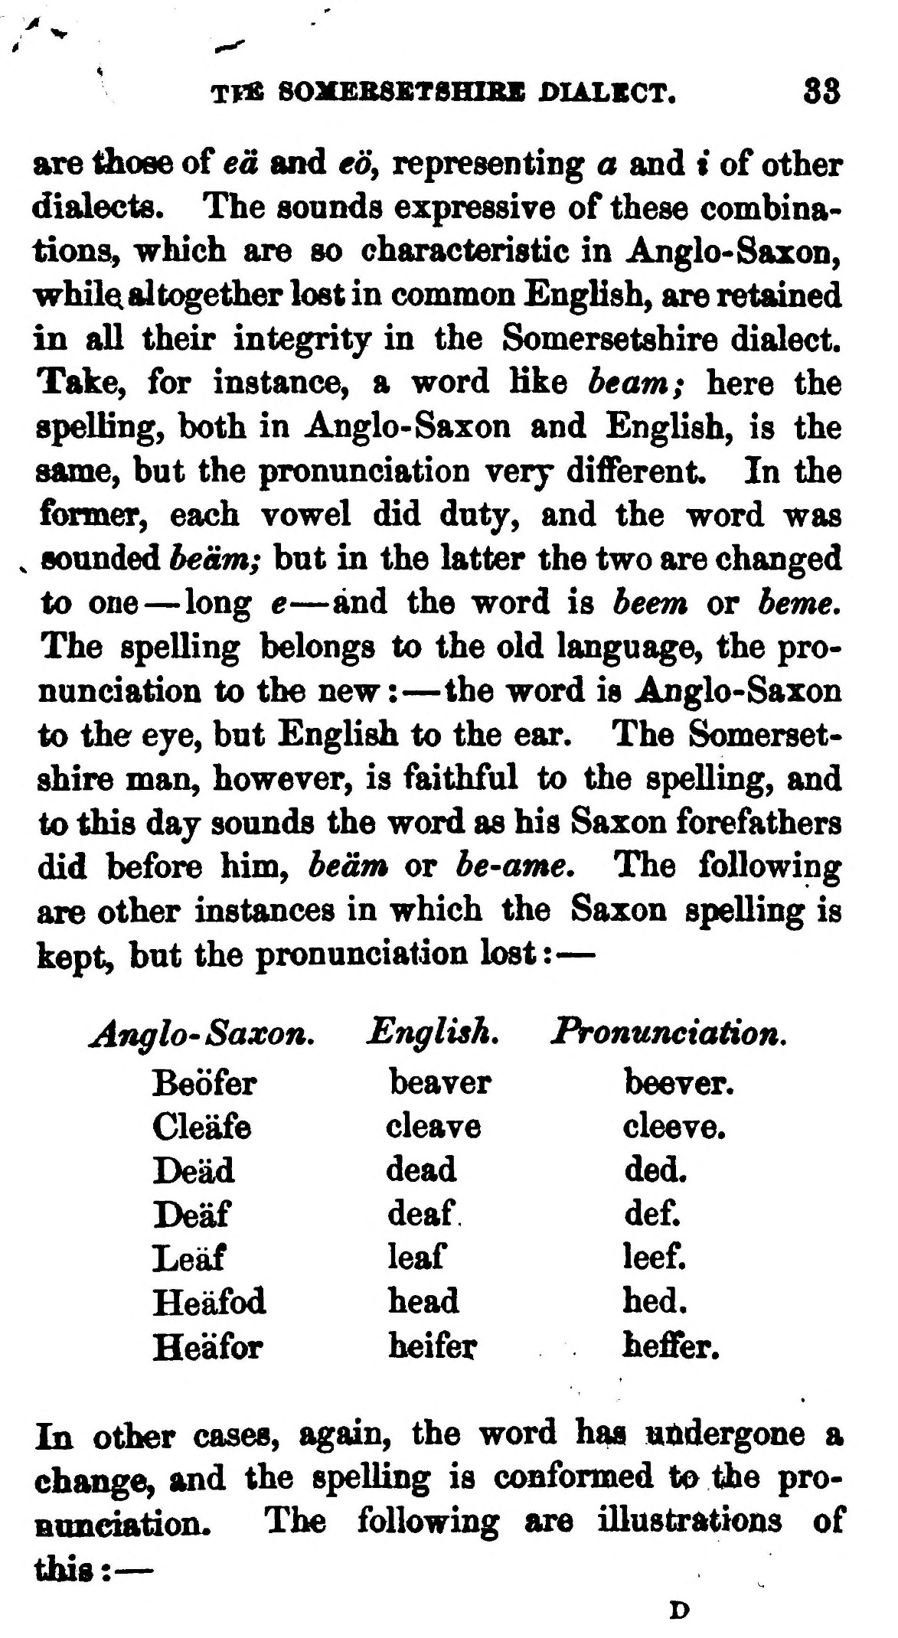  (delwedd C3697) (tudalen 033) | Tf« 80MEB8BTSHISS DliXBCT.  83  are ^ose of ed and eo, representing a and t of other dialects. The sounds expressive of these combinations, which are so characteristic in Anglo-Saxon, whilQ altogether lost in common EngHsh, are retained in all their integrity in the Somersetshire dialect. Take, for instance, a word Kke beam; here the spelling, both in Anglo-Saxon and English, is the same, but the pronunciation very different. In the former, each vowel did duty, and the word was ^ sounded beam; but in the latter the two are changed to one — long e — and the word is beem or beme. The spelling belongs to the old language, the pronunciation to the new: — the word is Anglo-Saxon to the eye, but English to the ear. The Somersetshire man, however, is faithful to the spelling, and to this day sounds the word as his Saxon forefathers did before him, beam or be-ame. The following are other instances in which the Saxon spelling is kept, but the pronunciation lost: —  Anglo-Saxon,  English.  Pronunciatii  Beofer  beaver  beever.  Cleafe  cleave  cleeve.  Dead  dead  ded.  Deaf  deaf  def.  Leaf  leaf  leef.  Heafod  head  hed.  Heafor  heifer  heffer.  I In other cases, again, the word h^ utidergcme a change, and the spelling is omformed to the pro  I nuneiation. The following are illustrations of tlus: —  D
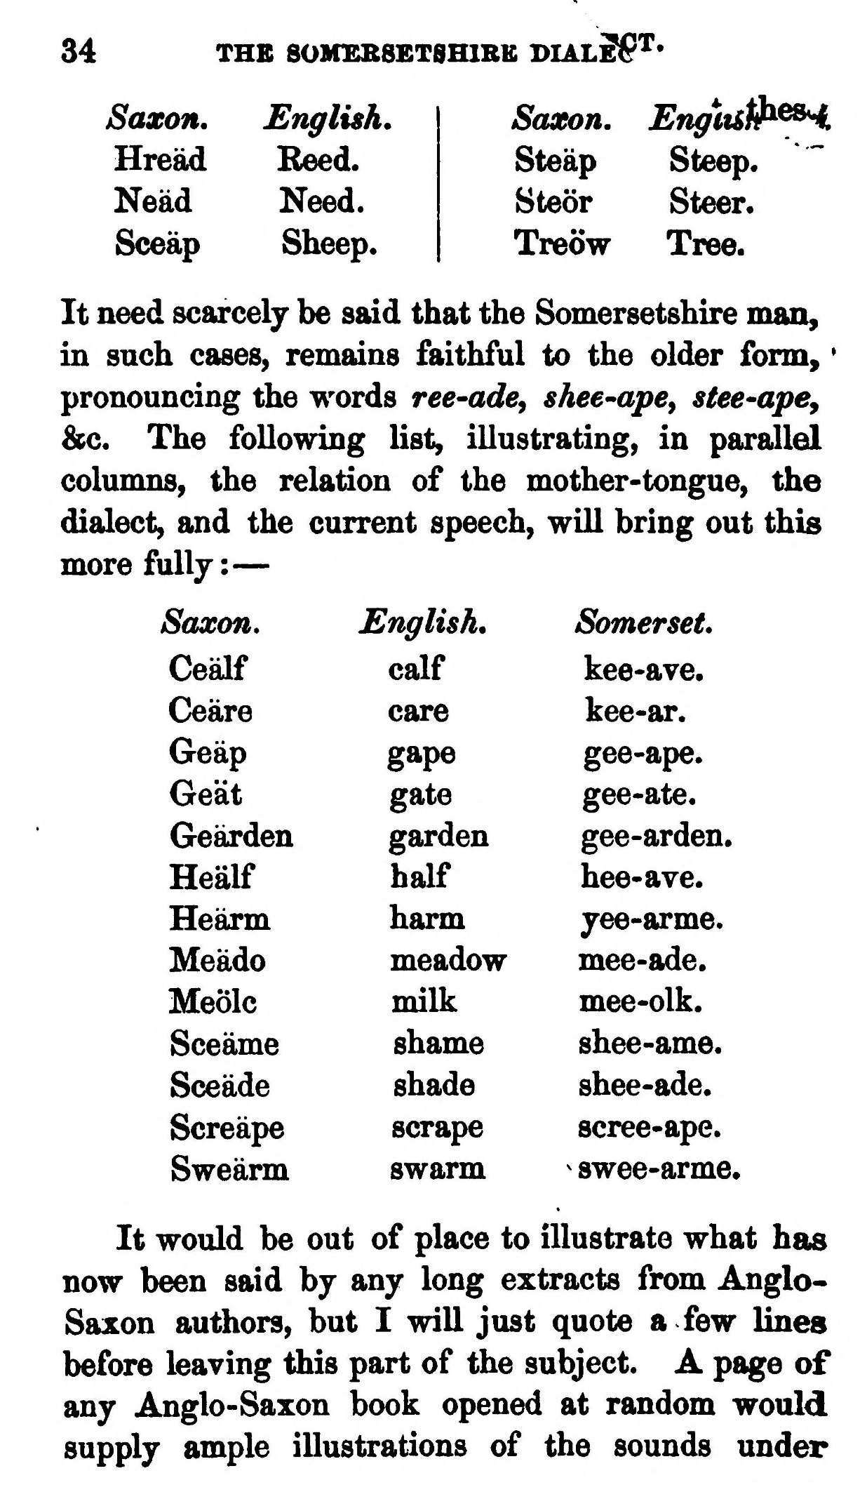  (delwedd C3698) (tudalen 034) | 34  THE 80MEB8ETSH1RE VIAlSS'^'  Saxon.  JSnglish.  Saxon.  Engitst}^^  Hread  Reed.  Steap  Steep.  Nead  Need.  Steor  Steer.  Sceap  Sheep.  Treow  Tree.  It need scarcely be said that the Somersetshire man, in such cases, remains faithful to the older form, * pronouncing the words ree-ade^ shee-ape^ stee-ape, &c. The following list, illustrating, in parallel columns, the relation of the mother-tongue, the dialect, and the current speech, will bring out this more fully: —  Saxon.  English.  Somerset.  Cealf  calf  kee-ave.  Ceare  care  kee-ar.  Geap  gape  gee-ape.  Ge'at  gate  gee-ate.  Gearden  garden  gee-arden.  Healf  half  hee-ave.  Hearm  harm  jee-arme.  Meado  meadow  mee-ade.  Meolc  milk  mee-olk.  Sceame  shame  shee-ame.  Sceade  shade  shee-ade.  Screape  scrape  scree-ape.  Swearm  swarm  ^ swee-arme,  It would be out of place to illustrate what has now been said by any long extracts from Anglo-Saxon authors, but I will just quote a few lines before leaving this part of the subject. A page of any Anglo-Saxon book opened at random would supply ample illustrations of the sounds under
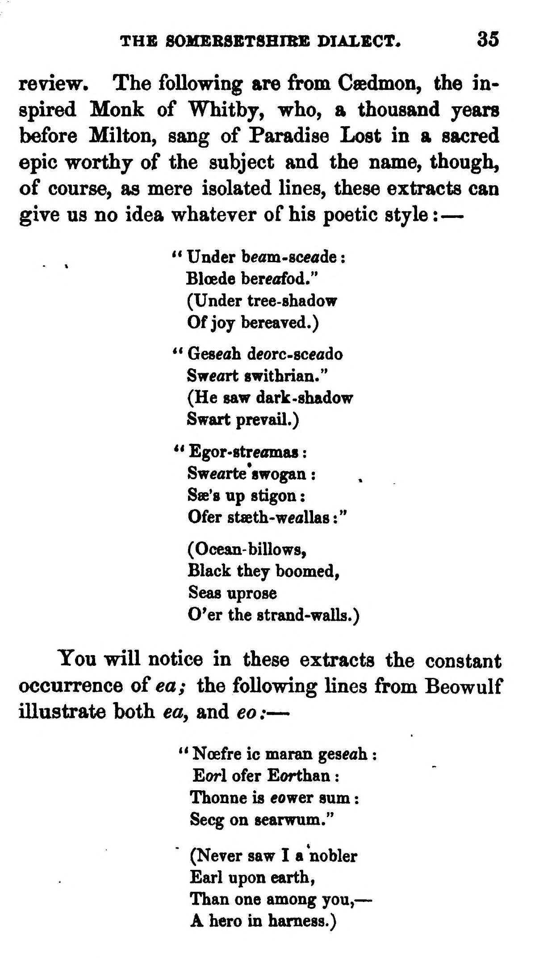  (delwedd C3699) (tudalen 035) | THE S0MEBSBT8HIBE DIALECT* 35  review. The following are from Caedmon, the inspired Monk of Whitby, who, a thousand years before Milton, sang of Paradise Lost in a sacred epic worthy of the subject and the name, though, of course, as mere isolated lines, these extracts can give us no idea whatever of his poetic style : —  « Under beom-sc^ade : Bloede bercflfod." (Under tree-shadow Of joy bereaved.)  ** Geseah deorc-sceado Sweart swithrian." (He saw dark -shadow Swart prevail.)  ** Egor-streomas : Sw«arte*8wogan : Sse's up stigon : Ofer stseth-weallas :"  (Ocean-billows, Black they boomed, Seas uprose O'er the strand-walls.)  You will notice in these extracts the constant occurrence o£ ea; the following lines from Beowulf illustrate both ea, and eo : —  " Noefre ic maran geseah : Eorl ofer Eorthan : Thonne is eower sum : Secg on searwum."  (Never saw I a nobler Earl upon earth, Than one among you, — A hero in harness.)
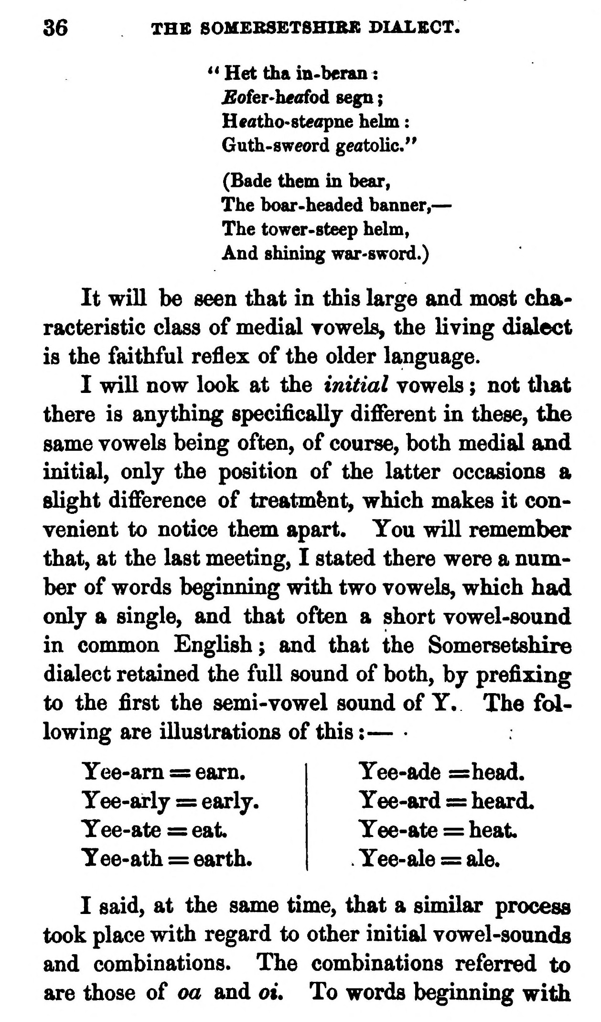  (delwedd C3700) (tudalen 036) | 36 THE SOMEBSETSHIBK DIALECT.  ** Het tha in-beran ^ £ofer-h«afod segn ; Heatho-steopne helm : Guth-sweord gcatolic."  (Bade them m bear, The boar-headed banner, — The tower-steep helm, And shinmg war-sword.)  It will be seen that in this large and most characteristic class of medial Towels, the living dialect is the faithful reflex of the older language.  I will now look at the initial vowels ; not tliat there is anything specifically different in these, the same vowels being often, of course, both medial and initial, only the position of the latter occasions a slight difference of treatment, which makes it convenient to notice them apart. You will remember that, at the last meeting, I stated there were a number of words beginning with two vowels, which had only a single, and that often a short vowel-sound in common English; and that the Somersetshire dialect retained the full sound of both, by prefixing to the first the semi-vowel sound of Y. The following are illustrations of this : — •  Yee-am := earn. Yee-w:ly = early. Yee-ate = eat Yee-ath = earth.  Yee-ade =:head. Yee-ard = heard. Yee-ate = heat . Yee-ale = ale.  I said, at the same time, that a similar process took place with regard to other initial vowel-sounds and combinations. The combinations referred to are those of oa and ot. To words beginning with  mm
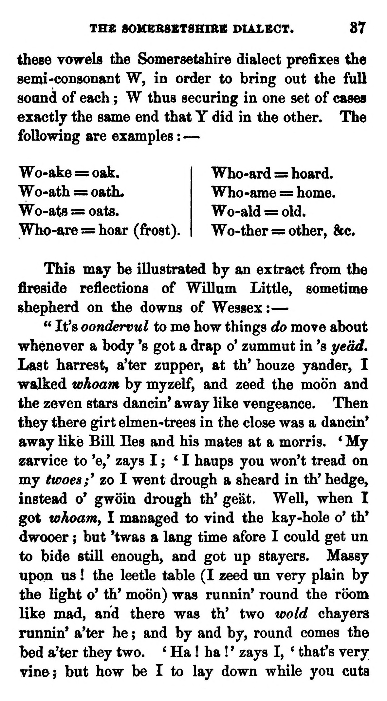  (delwedd C3701) (tudalen 037) | THE SOMEB8BT8HIBB DIALECT. 87  these vowels the Somersetshire dialect prefixes the semi-consonant W, in order to bring out the full sound of each ; W thus securing in one set of cases exactly the same end that Y did in the other. The following are examples : —  Wo-ake = oak. Wo-ath = oath* Wo-ats = oats. Who-are = hoar (frost).  Who-ard = hoard. Who-ame = home. Wo-ald = old. Wo-ther = other, &c.  This may be illustrated by an extract from the fireside reflections of Willum Little, sometime shepherd on the downs of Wessex: —  " It's oondervul to me how things do move about whenever a body 's got a drap o' zummut in 's yedd. Last harrest, a'ter zupper, at th' houze yander, I walked whoam by myzelf, and zeed the moon and the zeven stars dancin' away like vengeance. Then they there girt elmen-trees in the close was a dancin' away like Bill lies and his mates at a morris. ' My zarvice to 'e,' zays I ; ' I haups you won't tread on my twoes;^ zo I went drough a sheard in th' hedge, instead o' gwoin drough th* geat. Well, when I got whoam, I managed to vind the kay-hole o' th* dwooer ; but 'twas a lang time afore I could get un to bide still enough, and got up stayers. Massy upon us ! the leetle table (I zeed un very plain by the light o' th' moon) was runnin' round the room like mad, and there was th' two wold chayers runnin' a'ter he ; and by and by, round comes the bed a'ter they two. ^ Ha ! ha ! * zays I, * that's very vine; but how be I to lay down while you cuts
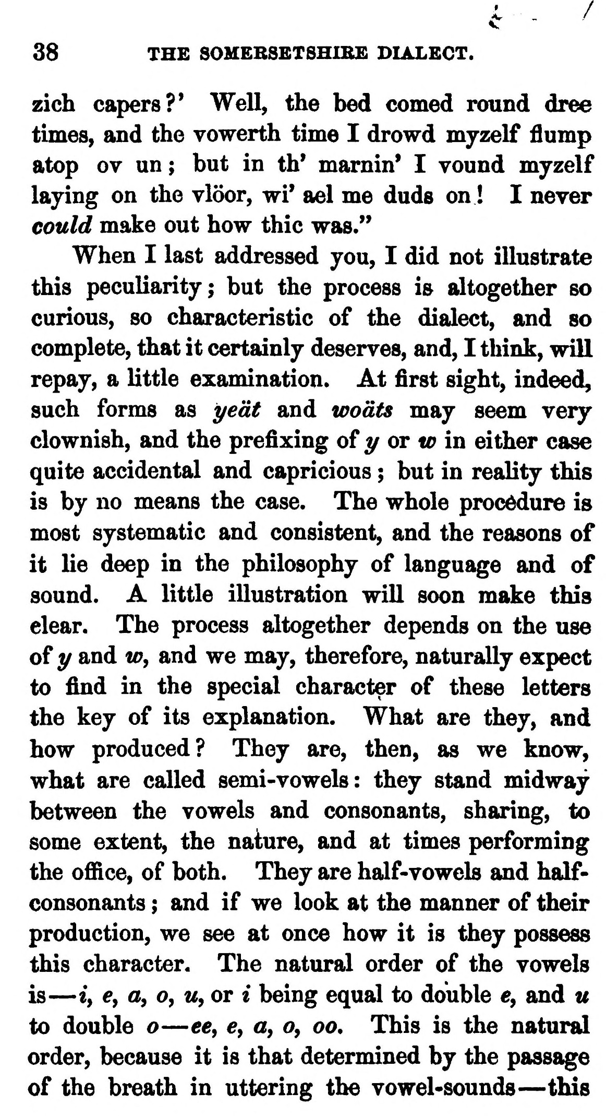  (delwedd C3702) (tudalen 038) | 38 THE SOMEBSBTSHIBE DIALECT.  zich capers?' Well, the bed corned round dree times, and the vowerth time I drowd myzelf flump atop ov un ; but in th' marnin' I vound myzelf laying on the vloor, wi' ael me duds on ! I never could make out how thic was."  When I last addressed you, I did not illustrate this peculiarity; but the process ia altogether so curious, so characteristic of the dialect, and so complete, that it certainly deserves, and, I think, will repay, a little examination. At first sight, indeed, such forms as ye at and wodts may seem very clownish, and the prefixing of y or tr in either case quite accidental and capricious ; but in reality this is by no means the case. The whole procedure is most systematic and consistent, and the reasons of it lie deep in the philosophy of language and of sound. A little illustration will soon make this clear. The process altogether depends on the use of y and tr, and we may, therefore, naturally expect to find in the special character of these letters the key of its explanation. What are they, and how produced? They are, then, as we know, what are called semi-vowels: they stand midway between the vowels and consonants, sharing, to some extent, the nature, and at times performing the office, of both. They are half-vowels and half-consonants ; and if we look at the manner of their production, we see at once how it is they possess this character. The natural order of the vowels is — iy e, o, o, w, or i being equal to double e, and u to double o — ee, e, a, o, oo. This is the natural order, because it is that determined by the passage of the breath in uttering the vowel-sounds — this  f
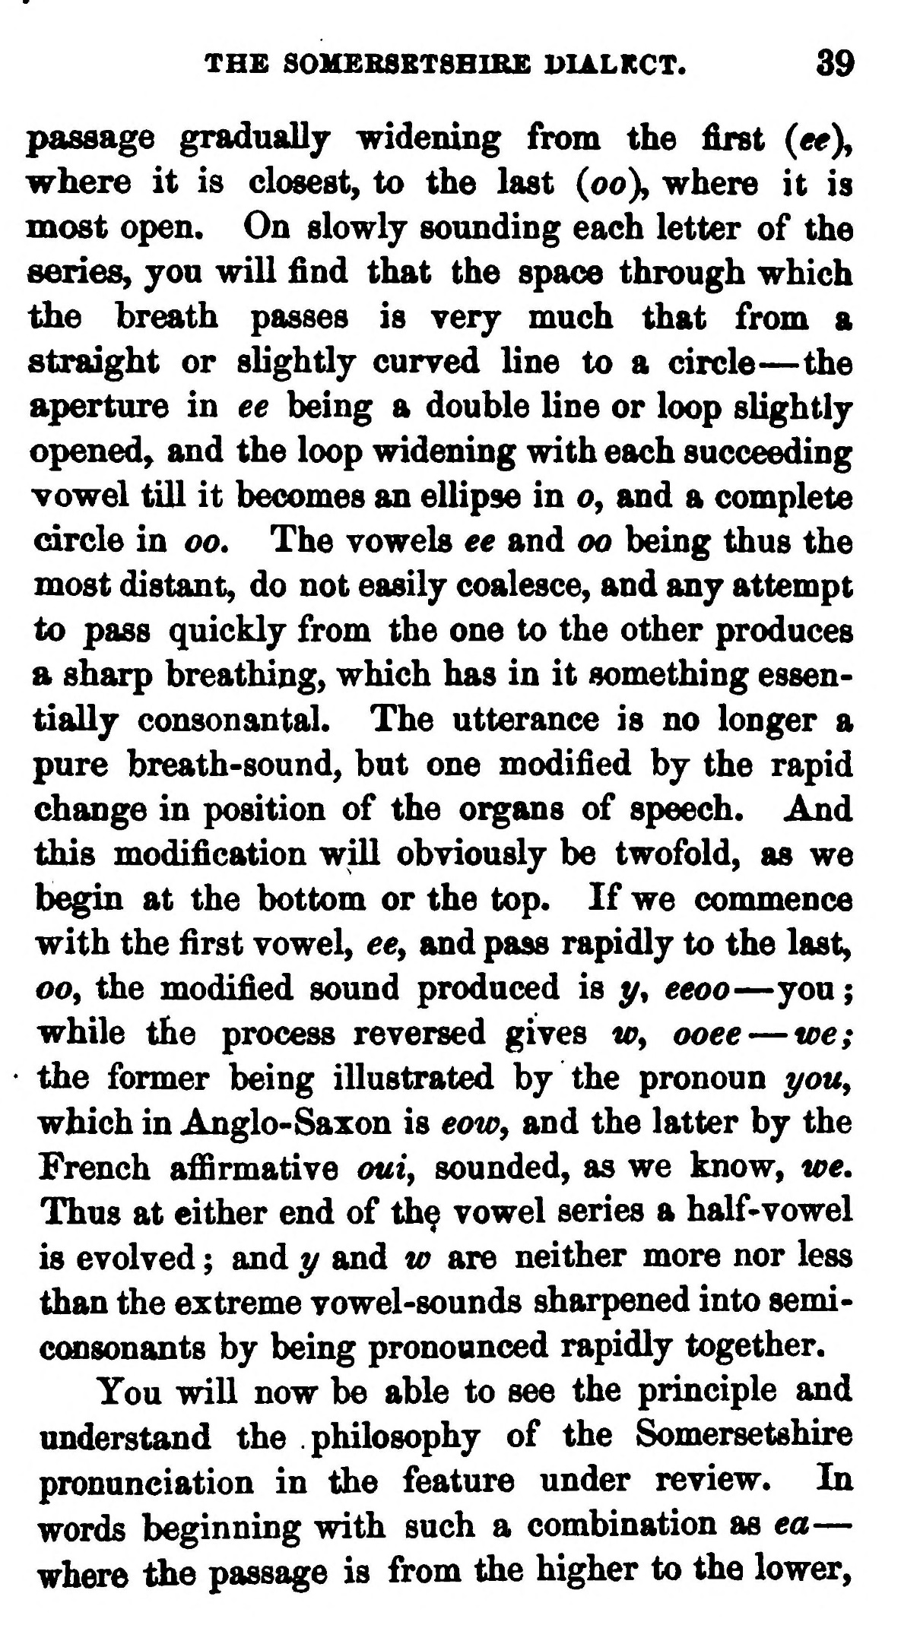  (delwedd C3703) (tudalen 039) | THE SOHEBSRTSBIRE 1>IALRCT. 39  passage gradually widening from the first (ee% where it is closest, to the last (oo)y where it is most open. On slowly sounding each letter of the series, you will find that the space through which the breath passes is very much that from a straight or slightly curved line to a circle — the aperture in ee being a double line or loop slightly opened, and the loop widening with each succeeding vowel till it becomes an ellipse in o, and a complete circle in oo. The vowels ee and oo being thus the most distant, do not easily coalesce, and any attempt to pass quickly from the one to the other produces a sharp breathing, which has in it something essentially consonantal. The utterance is no longer a pure breath-sound, but one modified by the rapid change in position of the organs of speech. And this modification will obviously be twofold, as we begin at the bottom or the top. If we commence with the first vowel, ee, and pass rapidly to the last, oo, the modified sound produced is y, eeoo — you ; while the process reversed gives ir, ooee — toe; ■ the former being illustrated by the pronoun yoUy which in Anglo-Saxon is eaw^ and the latter by the French affirmative oui^ sounded, as we know, we. Thus at cither end of th^ vowel series a half- vowel is evolved ; and y and w are neither more nor less than the extreme vowel-sounds sharpened into semi- consonants by being pronounced rapidly together.  You will now be able to see the principle and understand the philosophy of the Somersetshire pronunciation in the feature under review. In words beginning with such a combination as ea — where the passage is from the higher to the lower.
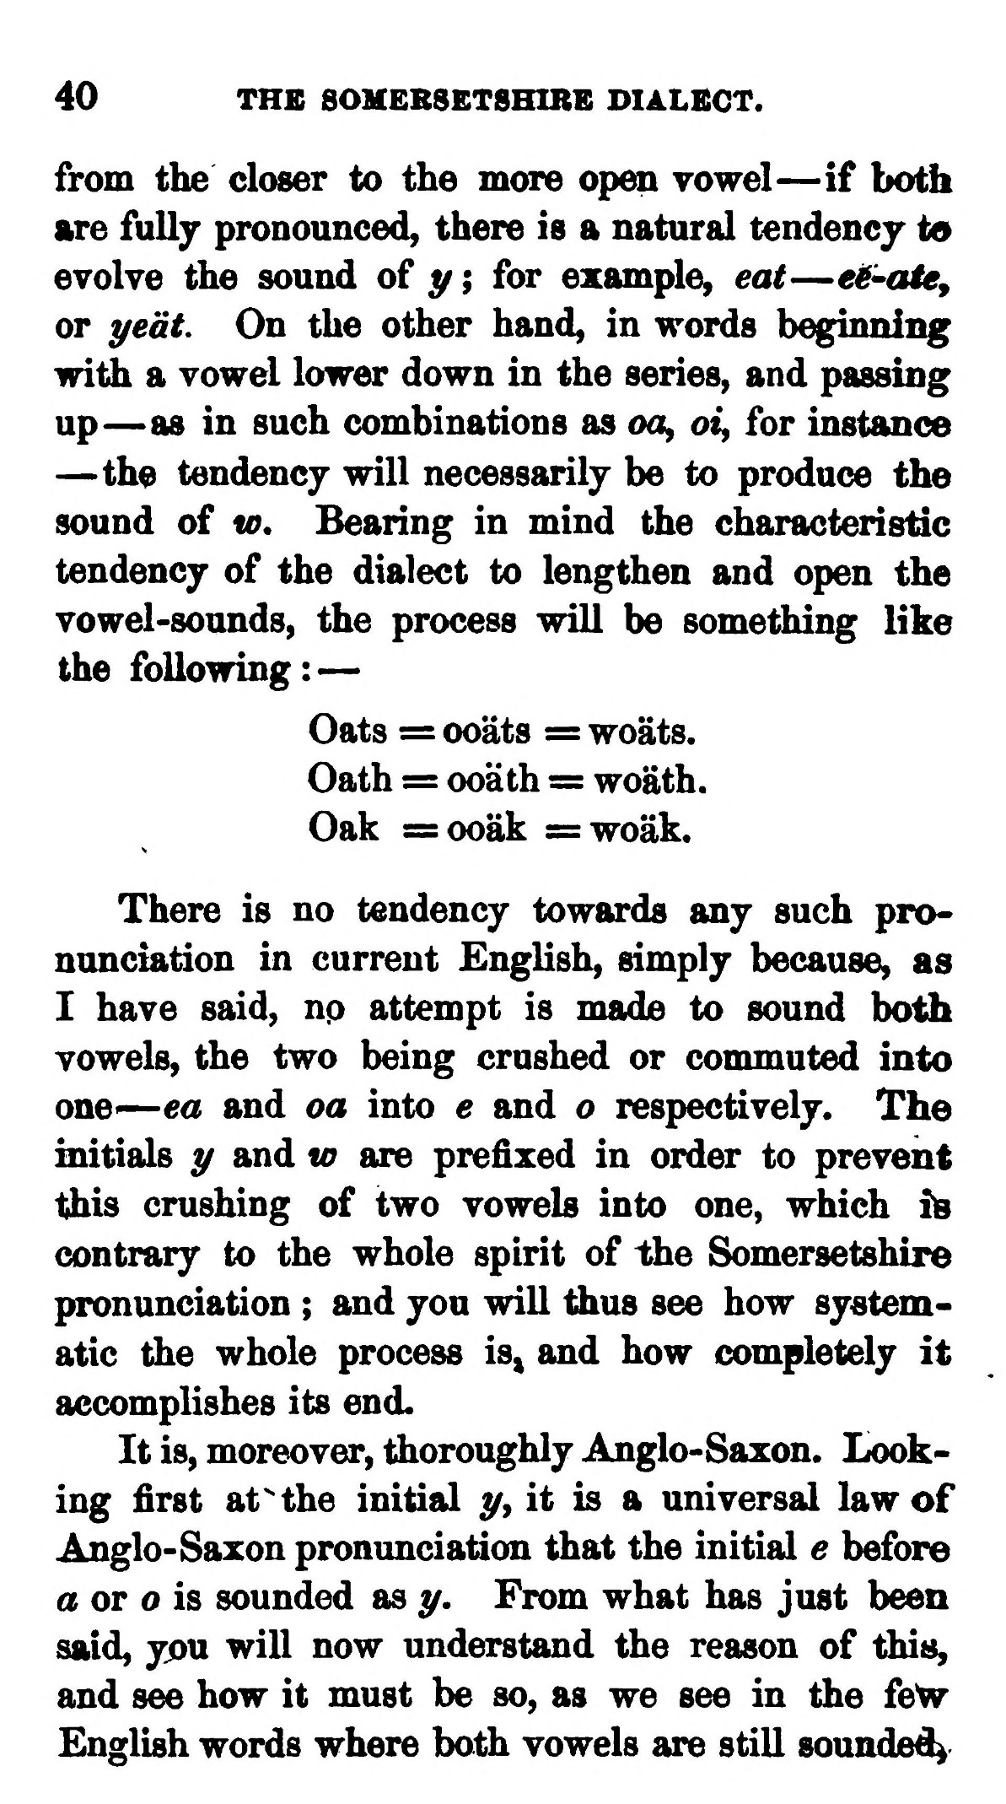  (delwedd C3704) (tudalen 040) | 40 THE 80MEB8ET8HIRE DIALECT.  from the closer to the more open vowel — if both are fully pronounced, there is a natural tendency to evolve the sound of y ; for example, eat — ei'Oie, or t/edt On the other hand, in words beginning wit^ a vowel lower down in the series, and passing up — as in such combinations as oo, ot, for instance — the tendency will necessarily be to produce the sound of w. Bearing in mind the characteristic tendency of the dialect to lengthen and open the vowel-sounds, the process will be something like the following: —  Oats := ooats := woats. Oath = ooath = woath. Oak =ooak =woak.  There is no tendency towards any such pronunciation in current English, simply because, as I have said, np attempt is made to sound both vowels, the two being crushed or commuted into one^ — ea and oa into e and o respectively. The initials y and to are prefixed in order to prevent this crushing of two vowels into one, which ife contrary to the whole spirit of the Somersetshire pronunciation ; and you will thus see how systematic the whole process is^ and how completely it accomplishes its end.  It is, moreover, thoroughly Anglo-Saxon. Looking first at "the initial y, it is a universal law of Anglo-Saxon pronunciation that the initial e before a or o is sounded as y. From what has just been said, you will now understand the reason of this, and see how it must be so, as we see in the fe'w English words where both vowels are still sounded^
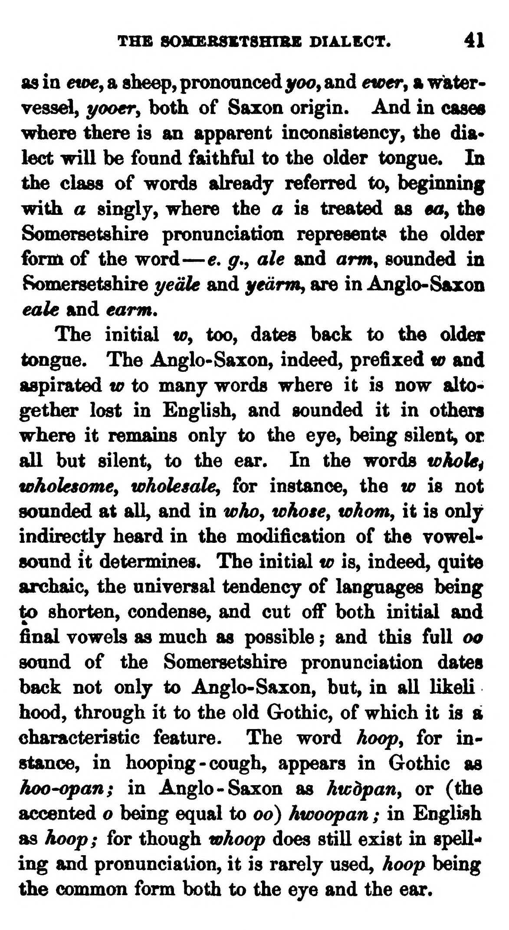  (delwedd C3705) (tudalen 041) | THS SOMBRSST8HIRE DIALECT. 41  as ia €W€y a sbeep, pronounced yoo» and ewer^ a water-vessel, t^ooevy both of Saxon origin. And in cases where there is an apparent inconsistency, the dia* lect will be fonnd faithful to the older tongue. In the class of words already referred to, beginning with a singly, where the a is treated as mt, the Somersetshire pronunciation represents the older form of the word — e, g., ale and arm^ sounded in Somersetshire t/eiile and yedmij are in Anglo-Saxon eale and earm.  The initial w^ too, dates back to tiie older tongue. The Anglo-Saxon, indeed, prefixed w and aspirated w to many words where it is now altogether lost in English, and sounded it in others where it remains only to the eye, being silent, or all but silent, to the ear. In the words whoUi wholesome^ wholesale^ for instance, the w is not sounded at all, and in whoy whose, whom, it is only indirectly heard in the modification of the vowel* sound it determines. The initial w is, indeed, quite archaic, the universal tendency of languages being to shorten, condense, and cut oif both initial and final vowels as much as possible ; and this full oo sound of the Somersetshire pronunciation dates back not only to Anglo-Saxon, but, in all likeli hood, through it to the old Gothic, of which it is a characteristic feature. The word hoop, for instance, in hooping-cough, appears in Gothic as hoo-opan; in Anglo-Saxon as hwdpan, or (the accented o being equal to oo) hwoopan ; in English as hoop; for though whoop does still exist in spells ing and pronunciation, it is rarely used, hoop being the common form both to the eye and the ear.
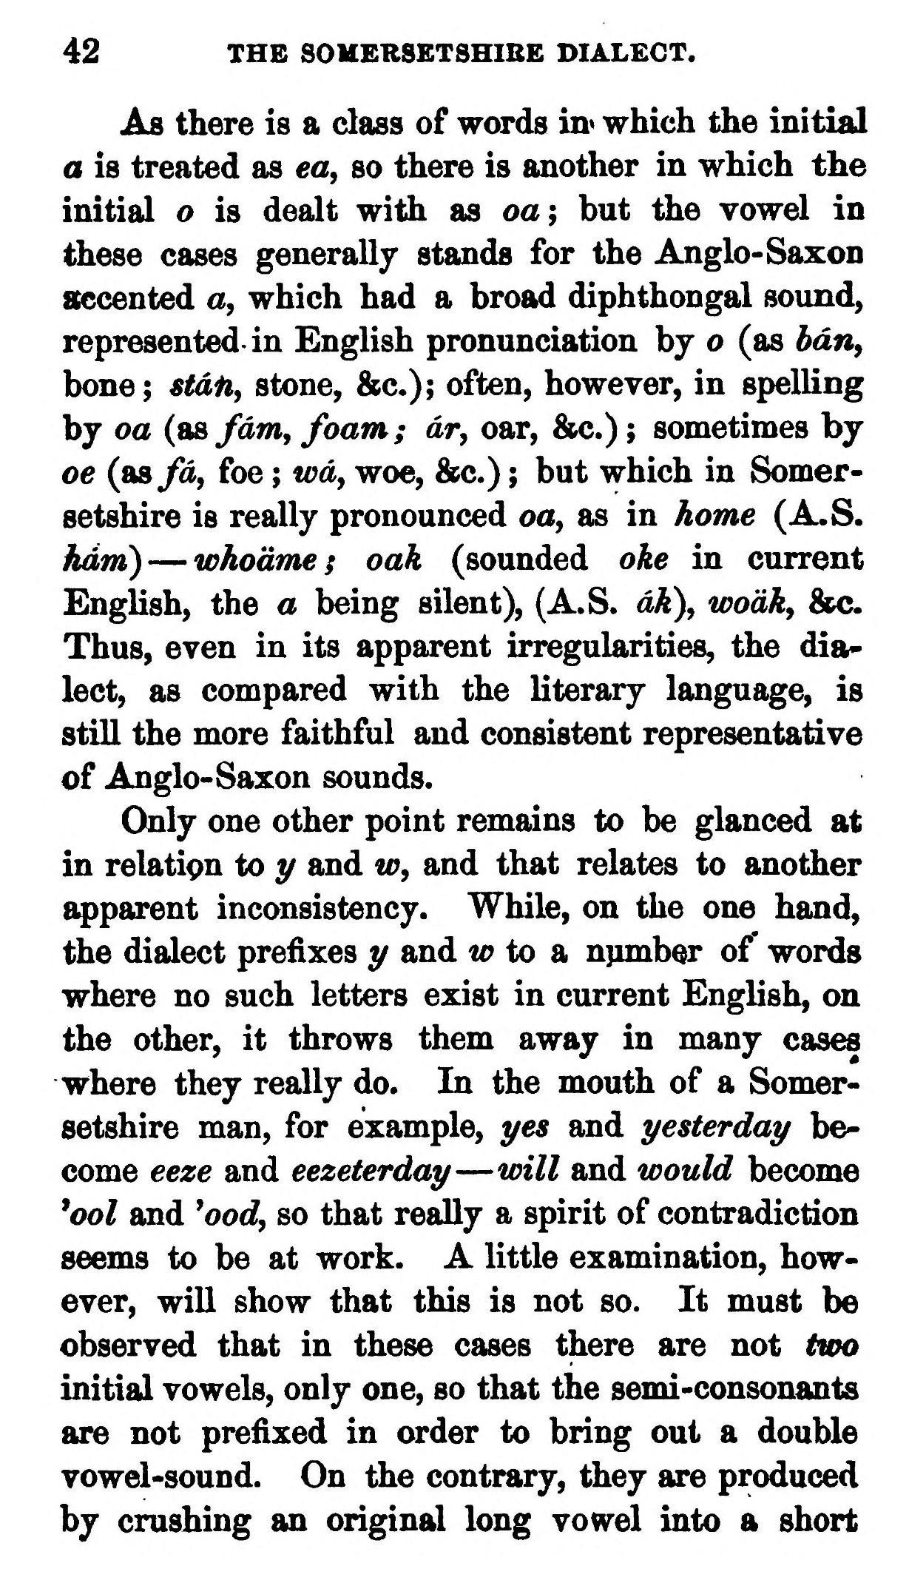  (delwedd C3706) (tudalen 042) | 42 THE SOHERSETSHIBE DIALECT.  As there is a class of words in« which the initial a is treated as ea, so there is another in which the initial o is dealt with as oa; but the vowel in these cases generally stands for the Anglo-Saxon accented a, which had a broad diphthongal sound, represented in English pronunciation by o (as bdn^ bone; stdfi, stone, &c.); often, however, in spelling by oa (a&fdm, foam; dr, oar, &c.) ; sometimes by oe (tisfd, foe ; wd, woe, &c.) ; but which in Somersetshire is really pronounced oa, as in home (A.S. ham) — whodme; oak (sounded oke in current English, the a being silent), (A.S. dk\ wodk, &c. Thus, even in its apparent irregularities, the dia* lect, as compared with the literary language, is still the more faithful and consistent representative of Anglo-Saxon sounds.  Only one other point remains to be glanced at in relati9n to t/ and w, and that relates to another ^parent inconsistency. While, on the one hand, the dialect prefixes t/ and w to b, number of' words where no such letters exist in current English, on the other, it throws them away in many cases where they really do. In the mouth of a Somersetshire man, for example, j/es and yesterday become eeze and eezeterday — will and would become ^ool and ^ood, so that really a spirit of contradiction seems to be at work. A little examination, however, will show that this is not so. It must be observed that in these cases there are not two initial vowels, only one, so that the semi-consonants are not prefixed in order to bring out a double vowel-sound. On the contrary, they are produced by crushing an original long vowel into a short
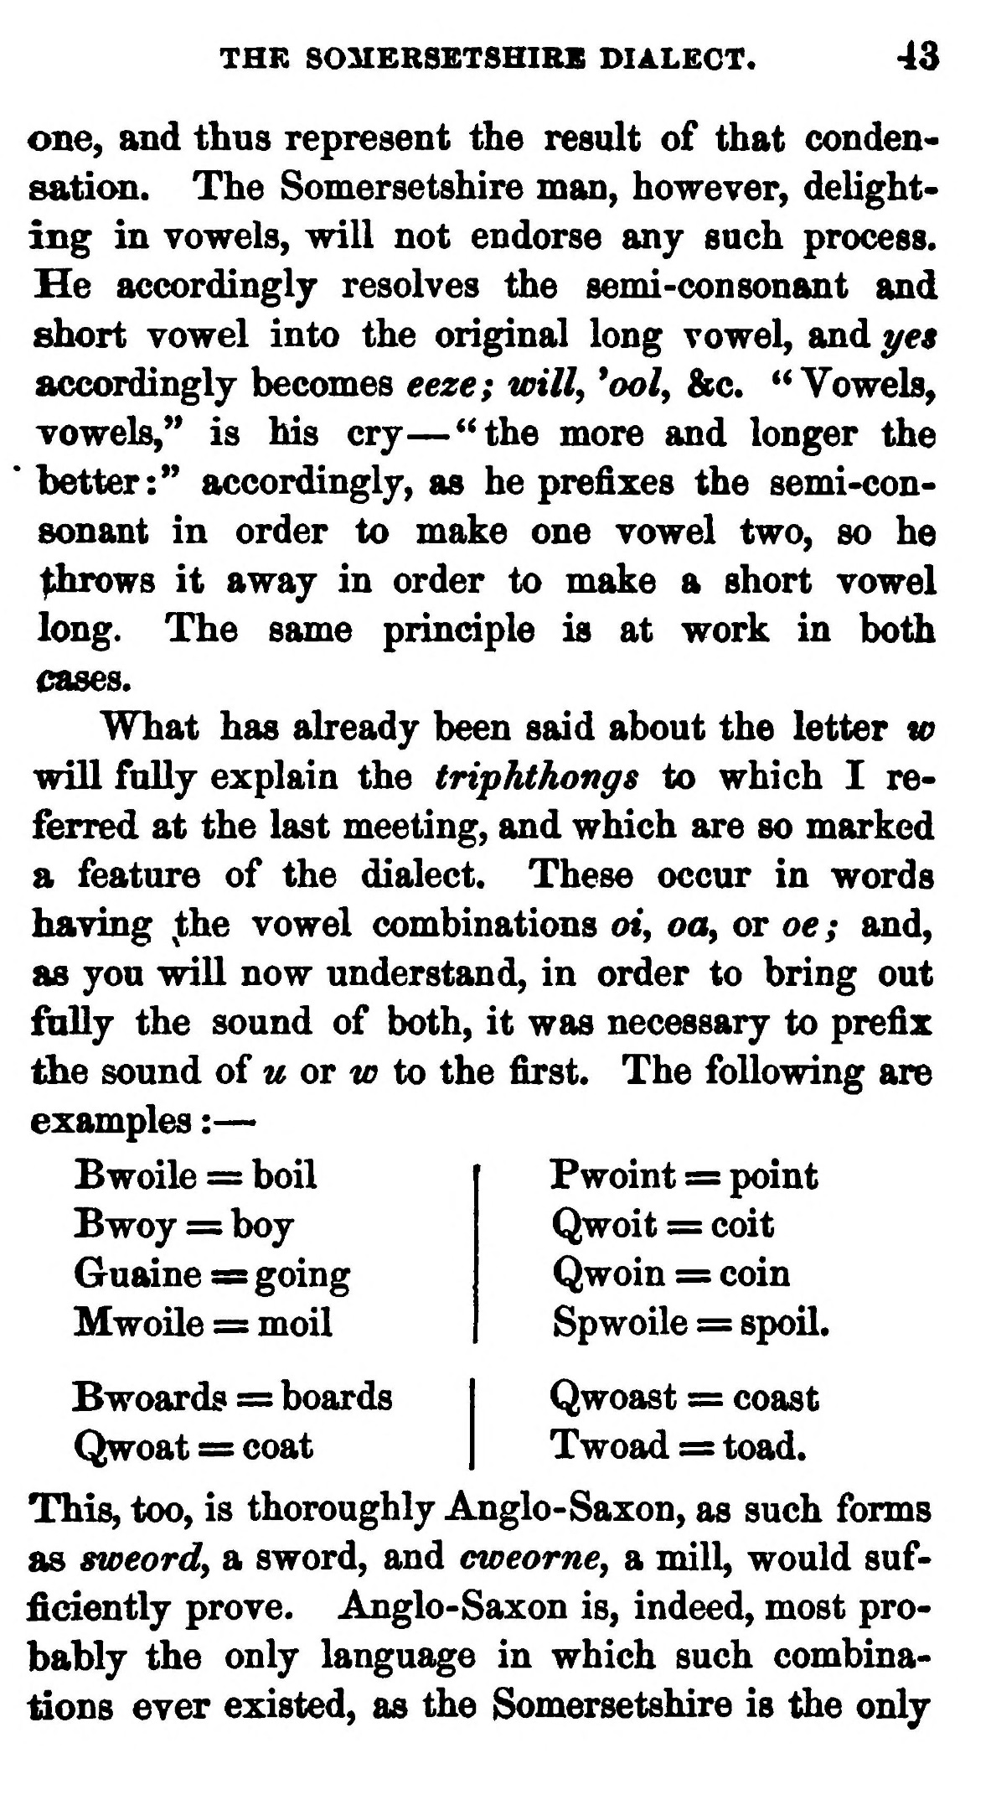  (delwedd C3707) (tudalen 043) | THE SOMERSETSHIRE DIALECT. 43  one, and thus represent the result of that condensaticm. The Somersetshire man, however, delighting in vowels, will not endorse any such process. He accordingly resolves the semi-consonant and short vowel into the original long vowel, and yen accordingly becomes eeze; will, *ool, &c. "Vowels, vowels," is his cry — "the more and longer the * better:" accordingly, as he prefixes the semi-consonant in order to make one vowel two, so he ^iirows it away in order to make a short vowel long. The same principle is at work in both cases.  What has already been said about the letter w will fully explain the triphthongs to which I referred at the last meeting, and which are so marked a feature of the dialect. These occur in words having ^the vowel combinations o«, oa, or oe; and, as you will now understand, in order to bring out fully the sound of both, it was necessary to prefix the sound of w or tr to the first. The following are examples : —  Bwoile = boil Bwoy = boy Guaine ^ going Mwoile = moil  Pwoint = point Qwoit s= coit Qwoin = coin Spwoile = spoil.  Bwoards = boards I Qwoast = coast Qwoat s= coat | Twoad = toad.  This, too, is thoroughly Anglo-Saxon, as such forms as sweordy a sword, and cweorne, a mill, would sufficiently prove. Anglo-Saxon is, indeed, most probably the only language in which such combinations ever existed, as the Somersetshire is the only
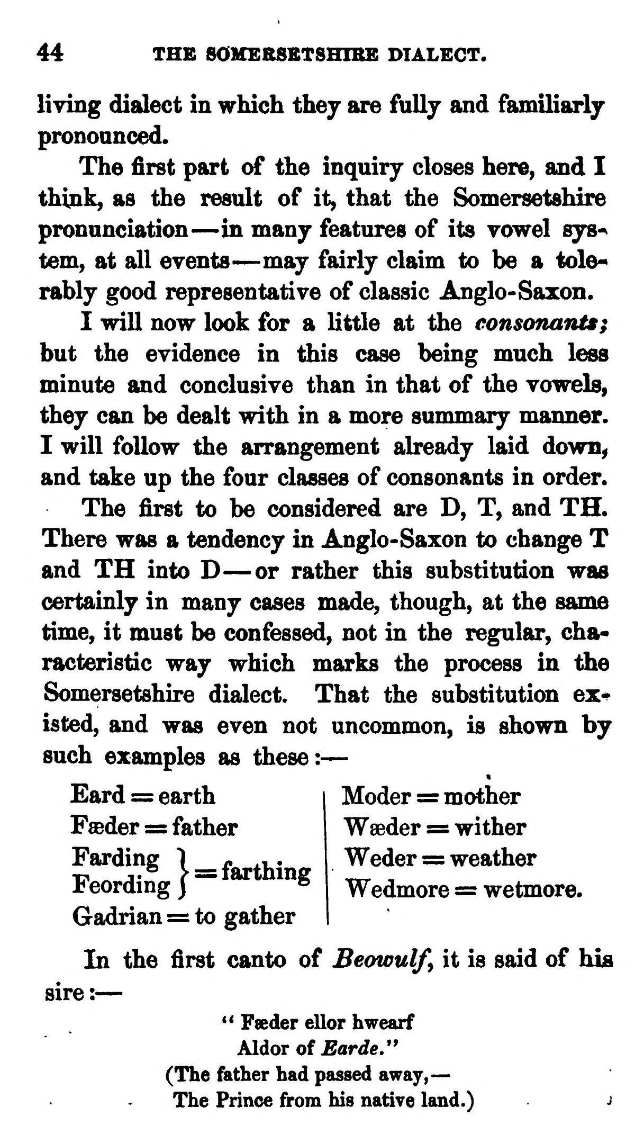  (delwedd C3708) (tudalen 044) | 44 THE 80MEBSSTSHIBE DIALECT.  living dialect in which thej are fuUj and famiHarlj pronoanced.  The first part of the inquiry closes here, and I think, as the result of it, that the Somersetshire pronunciation — in many features of its vowel sys^ tern, at all events — may fairly claim to be a tolerably good representative of classic Anglo-Saxon.  I will now look for a little at the consonants; but the evidence in this case being much less minute and conclusive than in that of the vowels, they can be dealt with in a more summary manner. I will follow the arrangement already laid down^ and take up the four classes of consonants in order. The first to be considered are D, T, and TH. There was a tendency in Anglo-Saxon to change T and TH into D — or rather this substitution was certainly in many cases made, though, at the same time, it must be confessed, not in the regular, characteristic way which marks the process in the Somersetshire dialect. That the substitution existed, and was even not uncommon, is shown by such examples as these: —  Eard = earth  Feeder =s father  Gadrian = to gather  In the first canto of Beowulf y it is said of hia sire : —  ** Fseder ellor hwearf AldoT of Earde.'* (The father had passed away,— The Prince from his native land.) j  Moder := mother Waeder = wither Weder = weather Wedmore = wetmore.
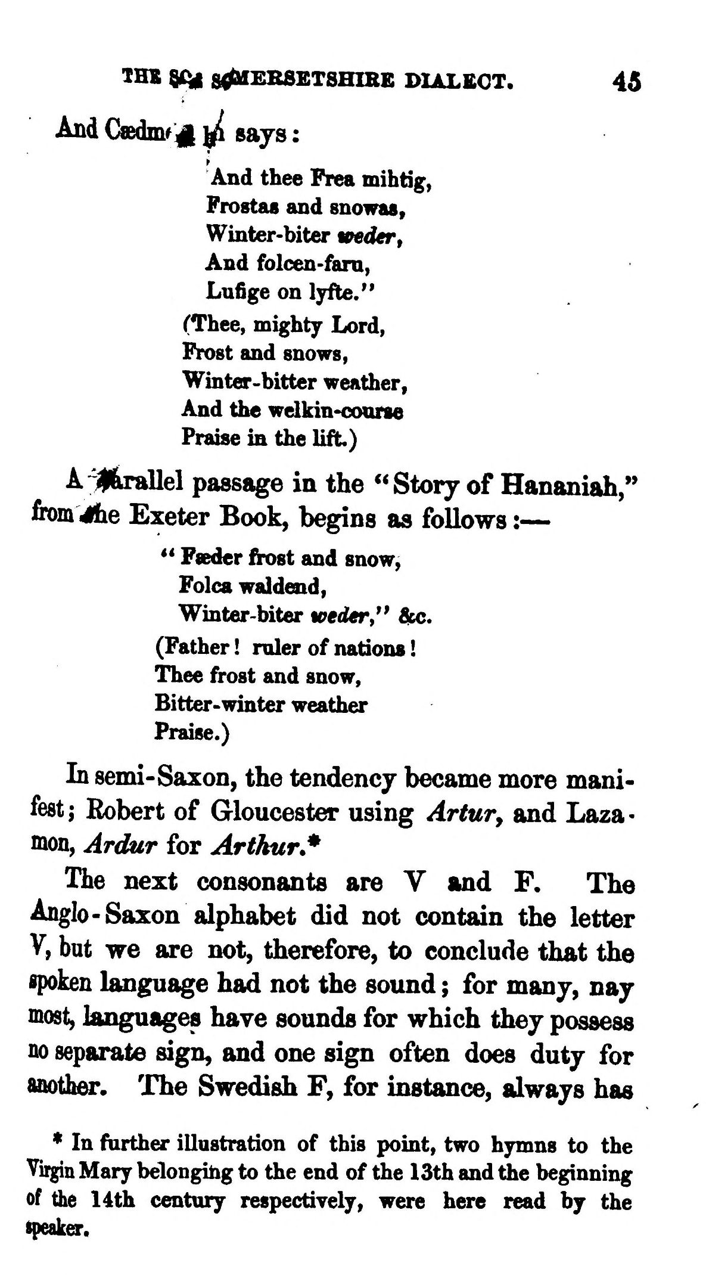  (delwedd C3709) (tudalen 045) | IHE ^ S^EBSBTSHIRB DIAL£OT. 45  And Csedmf ^ y^ says :  ^And thee Frea mihtig, ' Frostat and snowas, Winter-biter wedert And folcen-fani, Lufige on lyfte." (Thee, mighty Lord, Frost and snows, , r ^ Winter-bitter weather, t^ And the welkin-course ' j / Praise in the lift.)  A~^irallel passage in the "Story of Hananiah," from 4iie Exeter Book, begins as follows : —  ** Feder frost and snow,  Folca waldend,  Winter-biter veder," 6mj. (Father ! ruler of nations ! Thee frost and snow. Bitter- winter weather Praise.)  In semi- Saxon, the tendency became more manifest; Robert of Gloucester using Artuvy and Laza< mon, Ardur for Arthur.*  The next consonants are V and F. The Anglo-Saxon alphabet did not contain the letter V, but we are not, therefore, to conclude that the spoken language had not the sound ; for many, nay most, languages have sounds for which they possess no separate sign, and one sign often does duty for anoth^. The Swedish F, for instance, always has  * In frirther illustration of this point, two hymns to the Virgin Mary belonging to the end of the 13th and the beginning of the 14th century- respectiyely, were here read by the speaks.
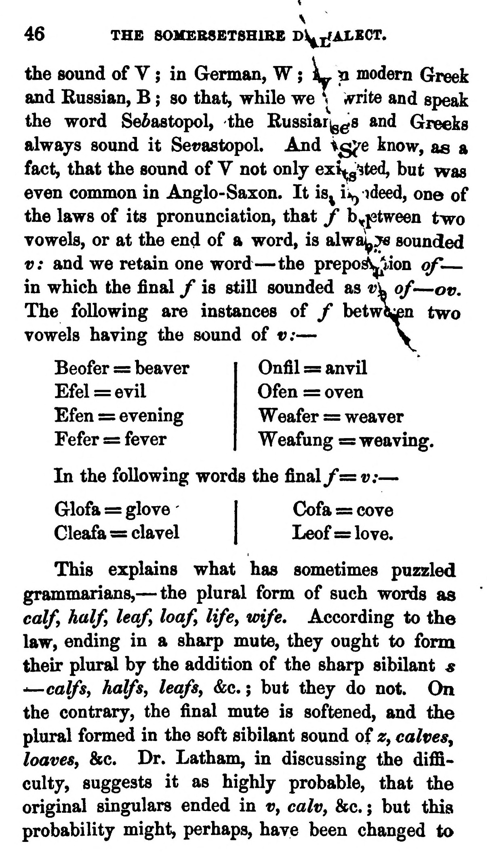  (delwedd C3710) (tudalen 046) | V 46 THB SOHEBSETSHIBE Dl^jliXECT.  the sound of V ; in German, W ; L, ji modern Greek and Russian, B ; so that, while we \ i^rite and speak the word Sevastopol, the Russiar^^s and Greeks always sound it Sevastopol. And igj^e know, as a fact, that the sound of Y not onlj exL^^ted, but was even common in Anglo-Saxon. It is^ ii^ ideed, one of the laws of its pronunciation, that Jf by^tween two vowels, or at the end of a word, is alwa!|^;^ sounded v: and we retain one word — the preposition of — in which the final / is still sounded as t?]k of — or. The following are instances of f between two vowels having the sound of v: — y  Beofer = beaver Efel = evil Efen = evening Fefer = fever  Onfil = anvil Ofen := oven Weafer = weaver Weafung = weaving.  In the following words the final /= v: —  Glofa = glove I Cofa = cove  Cleafa = clavel | Leof = love.  This explains what has sometimes puzzled grammarians, — the plural form of such words as calfy half, leaf loaf life, wife. According to the law, ending in a sharp mute, they ought to form their plural by the addition of the sharp sibilant s "—calfsy halfs, leafs, &c. ; but they do not. On the contrary, the final mute is softened, and the plural formed in the soft sibilant sound of z, calves^ loaves, &c. Dr. Latham, in discussing the difilculty, suggests it as highly probable, that the original singulars ended in v, calv, &c. ; but this probability might, perhaps, have been changed to
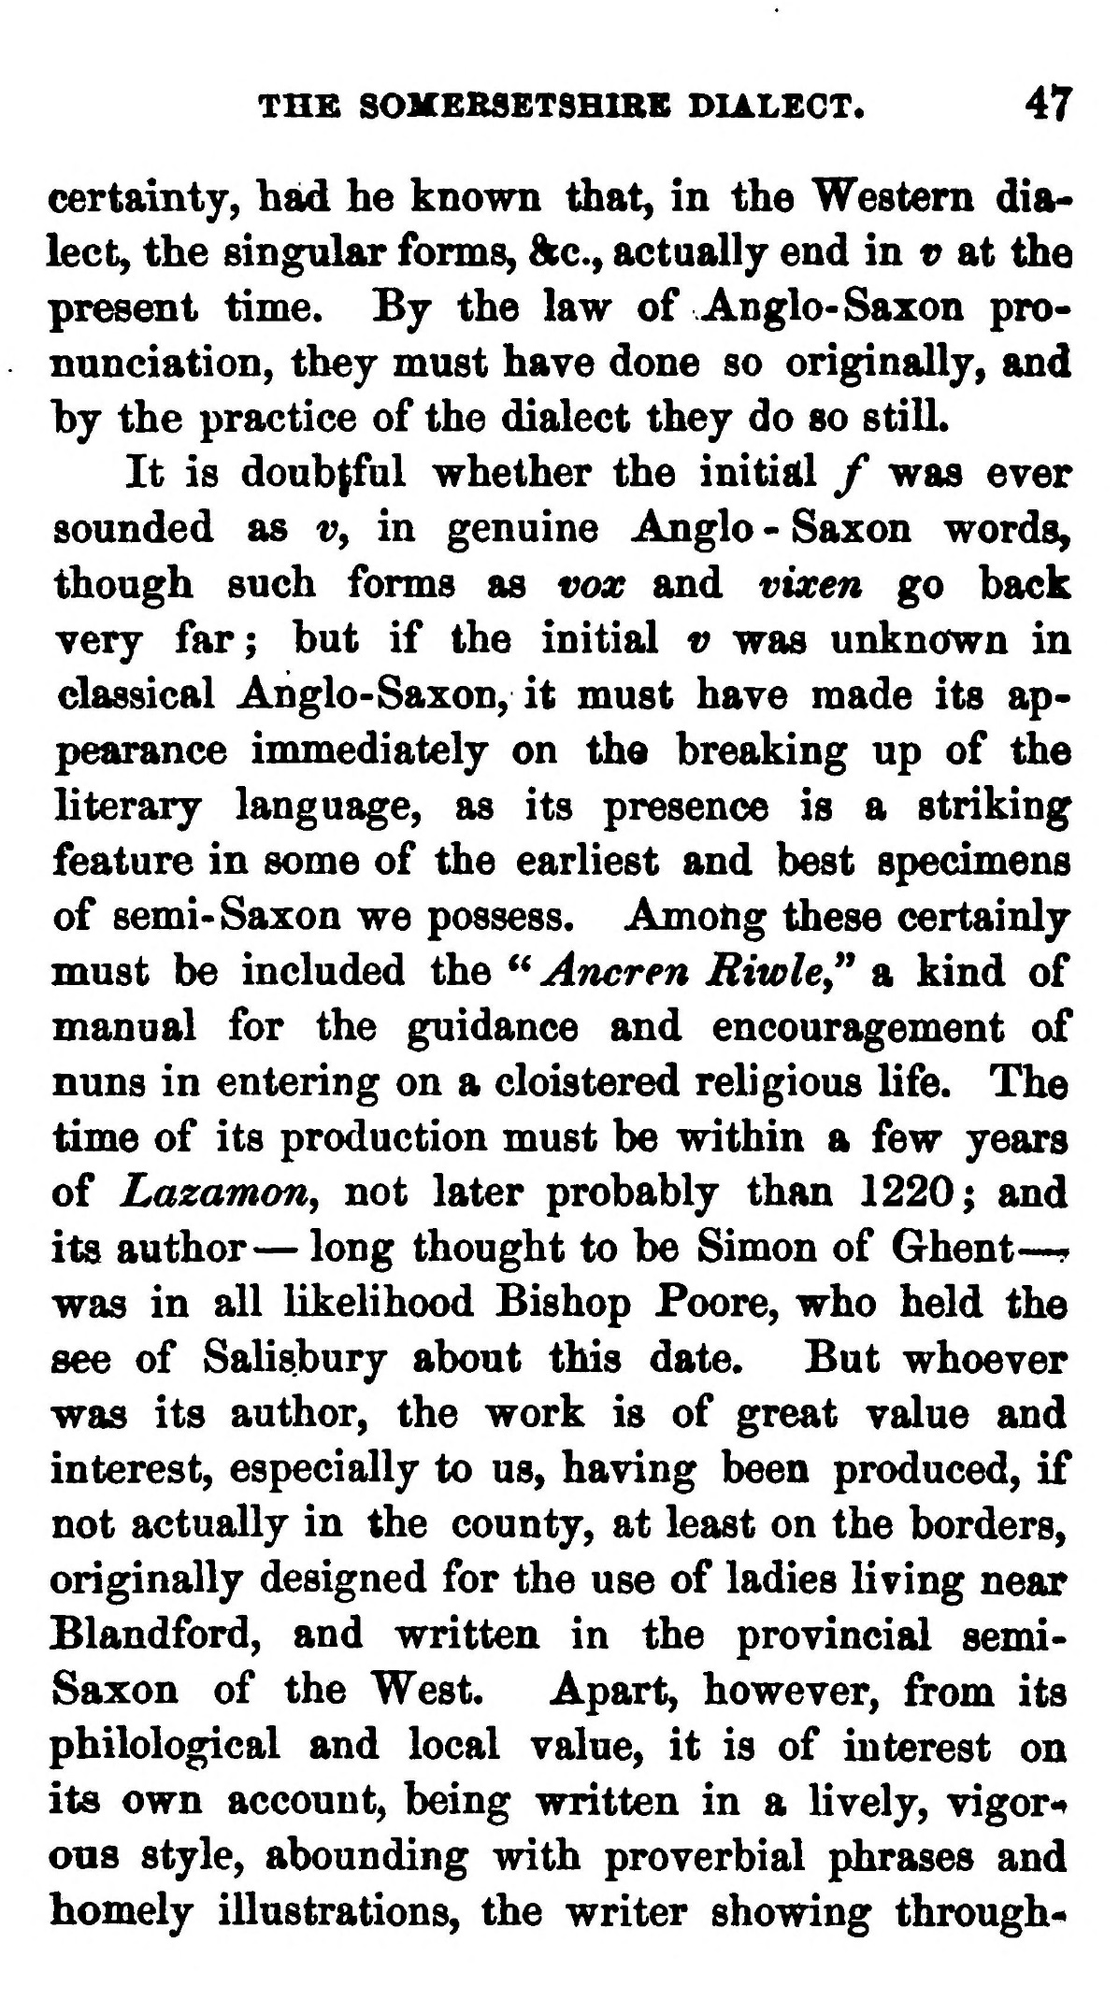  (delwedd C3711) (tudalen 047) | THB SOMERSETSHIBE DIALECT. 47  certainty, had he known that, in the Western dialect, the singtilar forms, ftc, actually end in v at the present time. By the law of Anglo-Saxon pronunciation, they must have done so originally, and hy the practice of the dialect they do so still.  It is doubtful whether the initial / was ever sounded as t?, in genuine Anglo - Saxon words^ though such forms as vox and vixen go back very far; but if the initial v was unknown in classical Anglo-Saxon, it must have made its appearance immediately on the breaking up of the literary language, as its presence is a striking feature in some of the earliest and best specimens of semi- Saxon we possess. Amotig these certainly must be included the ^^Ancren Riwle," a kind of manual for the guidance and encouragement of nuns in entering on a cloistered religious life. The time of its production must be within a few years of Lazamon^ not later probably than 1220; and its author — long thought to be Simon of Ghent — ? was in all likelihood Bishop Foore, who held the see of Salisbury about this date. But whoever was its author, the work is of great value and interest, especially to us, having been produced, if not actually in the county, at least on the borders, originally designed for the use of ladies living near Blandford, and written in the provincial semi-Saxon of the West. Apart, however, from its philological and local value, it is of interest on its own account, being written in a lively, vigor*^ ous style, abounding with proverbial phrases and homely illustrations, the writer showing through-
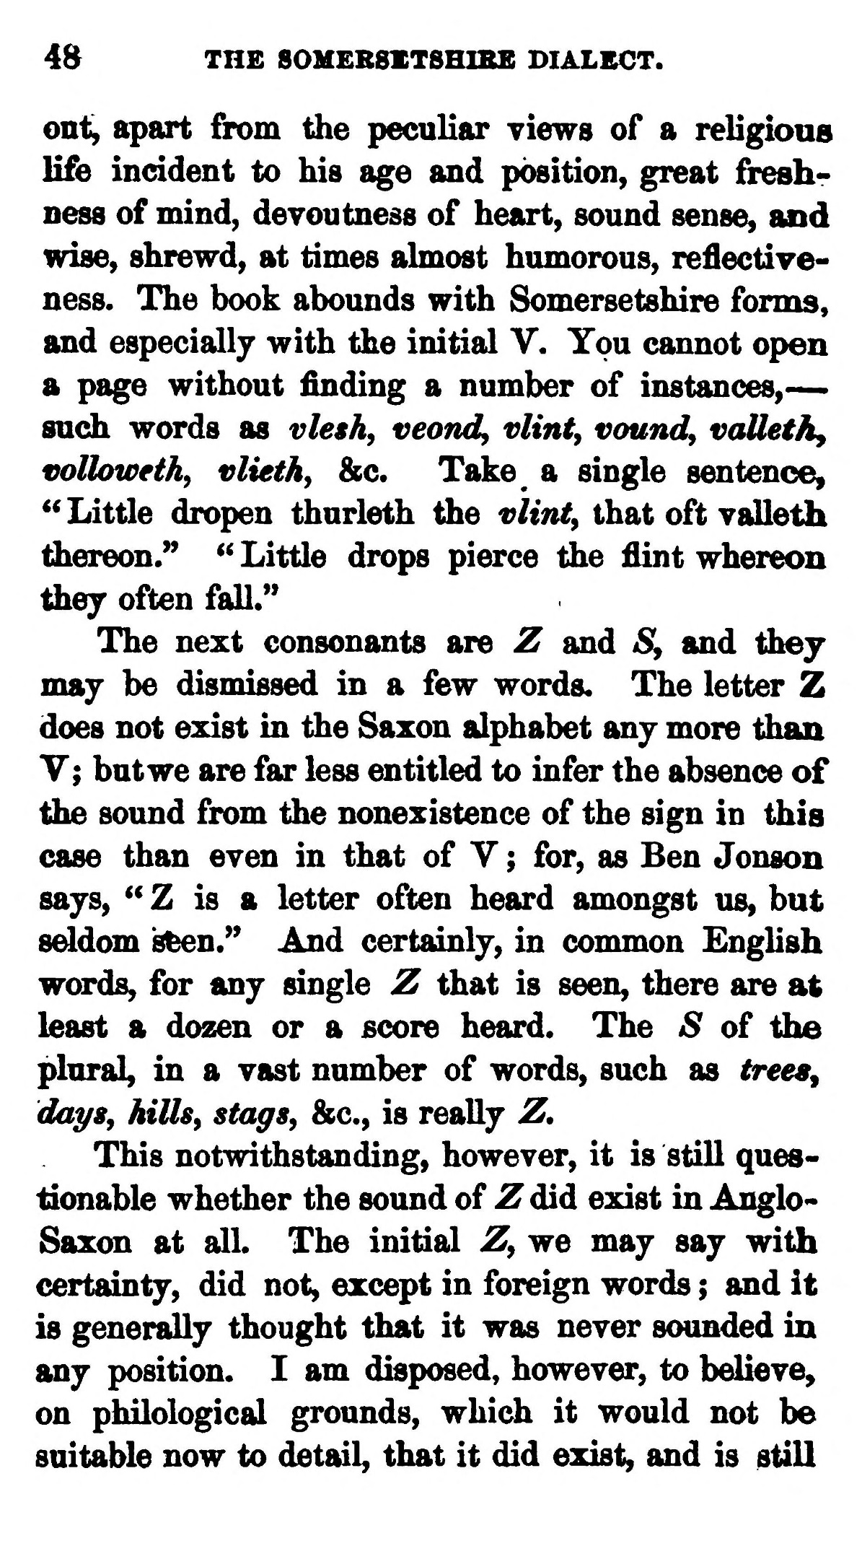  (delwedd C3712) (tudalen 048) | 48 THE 80MEBSXT8HIBB DIALECT.  onl^ apart from the peculiar views of a religious life incident to his age and position, great freshness of mind, devoutness of heart, sound sense, and wise, shrewd, at times almost humorous, reflectiyeness. The book abounds with Somersetshire fonns, and especially with the initial V. You cannot open a page without finding a number of instances, — such words as vle$h, veondy vlinty vaundy vaUethy vollowethy vliethy &c. Take a single sentenoe, ^^ Little dropen thurleth the vlinty that oft valleth tliereon." <' Little drops pierce the flint whereon they often faU."  The next consonants are Z and Sy and they may be dismissed in a few words. The letter Z does not exist in the Saxon alphabet any more than V; but we are far less entitled to infer the absence of the sound from the nonexistence of the sign in this case than even in that of Y ; for, as Ben Jonson says, ^^ Z is a letter often heard amongst us, but sddom s^n." And certainly, in common English words, for any single Z that is seen, there are at least a dozen or a score heard. The S of the plural, in a vast number of words, such as trees^ days, hillsy stags, &c., is really Z.  This notwithstanding, however, it is still questionable whether the sound of Z did exist in Anglo-Saxon at all. The initial Z, we may say with certainty, did not, except in foreign words ; and it is generally thought that it was never sounded in any position. I am disposed, however, to believe, on philological grounds, which it would not be suitable now to detail, that it did exist, and is still
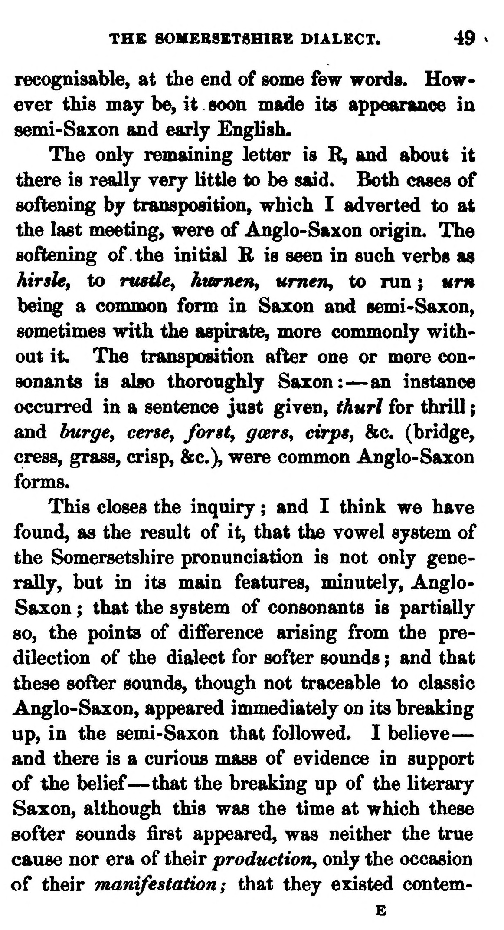  (delwedd C3713) (tudalen 049) | THE 80MERSSTSHIBE DIALECT. 49  recognisable, at the end of some few words. However this may be, it soon made its appearance in semi-Saxon and early English.  The only remaining letter is R^ and about it there is really very little to be said. Both cases of sofitening by transposition, which I adverted to at the last meeting, were of Anglo-Saxon origin. The softening of the initial B is seen in such verbs as hirsle, to rusde^ hiwnen^ umeuy to run ; um being a common form in Saxon and semi-Saxon, sometimes with the aspirate, more commonly without it. The transposition afler one or more consonants is also thoroughly Saxon: — an instance occurred in a sentence just given, thurl for thrill ; and hurgCy cerse^ forsty goers, cirps, &c. (bridge, cress, grass, crisp, &c.), were common Anglo-Saxon forms.  This closes the inquiry ; and I think we have found, as the result of it, that the vowel system of the Somersetsliire pronunciation is not only generally, but in its main features, minutely, Anglo-Saxon ; that the system of consonants is partially so, the points of difference arising from the predilection of the dialect for softer sounds ; and that these softer sounds, though not traceable to classic Anglo-Saxon, appeared immediately on its breaking up, in the semi-Saxon that followed. I believe — and there is a curious mass of evidence in support of the belief — that the breaking up of the literary Saxon, although this was the time at which these softer sounds first appeared, was neither the true cause nor era of their productioUy only the occasion of their manifestation; that they existed contem-  E
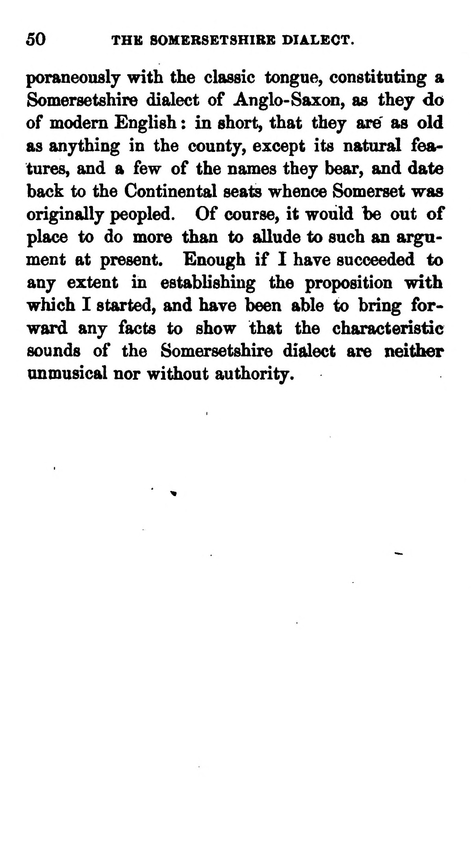  (delwedd C3714) (tudalen 050) | 50 THK SOMERSETSHIBB DIALEOT.  poraneonsly with the classic tongue, constituting a Somersetshire dialect of Anglo-Saxon, as they do of modem English : in short, that thej are' as old as anything in the county, except its natural features, and a few of the names they bear, and date back to the Continental seats whence Somerset was originally peopled. Of course, it would be out of place to do more than to allude to such an argument at present. Enough if I have succeeded to any extent in establishing the proposition with which I started, and have been able to bring forward any facts to show that the characteristic sounds of the Somersetshire dialect are neither unmusical nor without authority.

